Royal Oak Primary School,
Chandler Ave
Royal Oak,
Auckland 1023
New Zealand
Ph: 09 624 2800
Mob: 021966199
Email: manager@rtlbcluster8.ac.nz

CLUSTER 8
Resource Teachers of Learning & Behaviour

Cluster 8 Ngā Manu Ᾱwhina Manager’s Report (Term 1, 2022)

It is my pleasure to present the Ngā Manu Ᾱwhina report covering:

- RTLB Staffing
- RTLB Team in Red
- Strategic Engagement with the National Education Learning Priorities
- Cluster 8 Requests for Support and Outcomes
- Learning Support Fund

RTLB Team and Staffing
Royal Oak Primary Office Base | Orakei Primary Office Base | Tamaki College Office Base
Angelee Morrow | Claire Murphy | Georgia Jensen-Procter
Titania McKenzie | Michelle Grey Lamont .8 | Kylah Drake
Jill Watson | Sue Cameron .8 | Chris Bush
Owen Robyns | Wendy Florence | Vaughan Spurdle
Leslie Dresser-Tu’ugasala (leave) | Lilly Reynecke (on study leave) | Jo Turner .6
Tracey Richardson | Julie Nugent | Dianne Ley
Maree Stenberg .8 | Sandiyao Sebestian | Michele Hucker
Emily Marurai | Druinie Perera | Robert Rasmussen
Beverley D’Souza | David Blazey | Michael White (leave)
Debbie Saxon | Claire Scopas .8
Mark Larkin
Sarah Pearse
Based at Royal Oak Primary | Specialists | Resource Assistant
Barbara Hannant PL | Jean Parkinson (Counsellor).2 | Louis Gruebner
Chris Graham PL | Kimberly Walker (Counsellor) .2 | Relieving
Catherine Alpe PL |  | Donna Southworth
Roseanne Gibson Manager

Over term 1, 2022 Cluster 8 is made up of Lead School Principal Megan Clotworthy, 1 Manager, 3 Practice Leaders, 29 RTLB, 2 Specialists and a resource assistant. The RTLB are grouped into 3 office bases, Ōrākei, Tāmaki and Royal Oak. The RTLB in each office base are responsible for providing service to designated schools and Kāhui Ako however depending on workload, RTLB with specific required expertise are able to work across the cluster. Project and case work are ‘needs driven’ and based on requests for support (R4S) received, presented and discussed at a review and intake meetings.
Staffing Changes
It is with great sadness and sincere sympathies to the family that we acknowledge the passing of Margaret Muir on 12 March 2022.
New RTLB 2022
- Sarah Pearce: new permanent position.
- Mark Larkin: fixed study leave position.
- Wendy Florence: fixed sick leave relieving position.
- Donna Southworth: day relieving.
The following RTLB have study awards and are undertaking their second year of study towards completing the mandatory Post Graduate Diploma in Specialist Teaching (Learning and Behaviour). This study is completed whilst working as an RTLB over 2 years with study days allocated.

- Michele Hucker
- Emily Marurai
- Julie Nugent
- Tracey Richardson
- Vaughan Spurdle

Lilly Reynecke is on study award leave from 1 March to 22 November 2022.
Once the mandatory vaccination requirements are removed on April 4, 2022, any employment processes which are underway because an RTLB is not vaccinated, cease.

Cluster Wide Project Initiatives and Project Leads

The Cluster 8 website provides information and showcases what the cluster and RTLB can offer in tiered individual and systemic support, and professional development to our cluster also providing access to a range of resources. A key contact person for specific support (for e.g., ASD, dyslexia etc) is listed and there is the opportunity for MoE, RTLB and our cluster’s teachers to engage in a community of practice in areas of expertise and interest. Project leads and ‘Connect’ people can be located and are accessible for additional support on the connect tab.
RTLB with Additional Responsibilities

- Mentors: Claire Murphy; Angelee Morrow; Michele Hucker.
- Cultural Support: Chris Graham; Michael White; David Blazey; Tracey Richardson; Angelee Morrow; Robert Rasmussen.
- Psychological Practice, Supervision and Assessment: Barbara Hannant. Assessment co-lead: Titania McKenzie
- I.T. Leadership and Support Team: Angelee Morrow; Vaughan Spurdle; Claire Murphy
- SchoolGate Database: Angelee Morrow; Catherine Alpe; Chris Graham; Barbara Hannant
- Website: Catherine Alpe; Angelee Morrow
- Organisation Manual Editor: Claire Murphy
- General Library, Accessit and Resources: Catherine Alpe and Accessit Team
- NZEI Rep: Claire Murphy
- Gateway: Chris Bush

RTLB in Red: The Traffic Lights (COVID-19 Protection Framework)

As RTLB work across 51 schools, the Cluster 8 RTLB service is set up to minimise risk and transmission across multiple schools, agencies and settings, and to facilitate contact tracing if an outbreak occurred in any of our schools. Cluster 8 processes and protocols are revised regularly re changes to the framework and requirements.

Key liaison RTLB work with schools re what approach and support would work best for their school setting and the students. When onsite, RTLB are responsive to that particular school’s processes and requirements and follow the health measures that apply to that school.

The multi-tiered system of support (MTSS) incorporating tiered support (RTI) as a framework to provide service and support provides a foundation for our service, whilst continuing to adapt practice and work a hybrid workplace model to be responsive and provide the best support and casework to any changing requirements. The Cluster 8 RTLB service has continued to focus on the wellbeing of our schools, students, team and individual RTLB using our values in action as a framework, also ensuring health and safety protocols are updated and relevant to changing mandates and public health orders.

Selected Strategic Engagement with the Priorities

The Cluster 8 strategic goals align with the Statement of National Education and Learning (the NELP) and the Learning Support Delivery Model and Action Plan Priorities. Please see the attached summarised, integrated and synthesised Cluster 8 working document of the Strategic and Annual Plan.

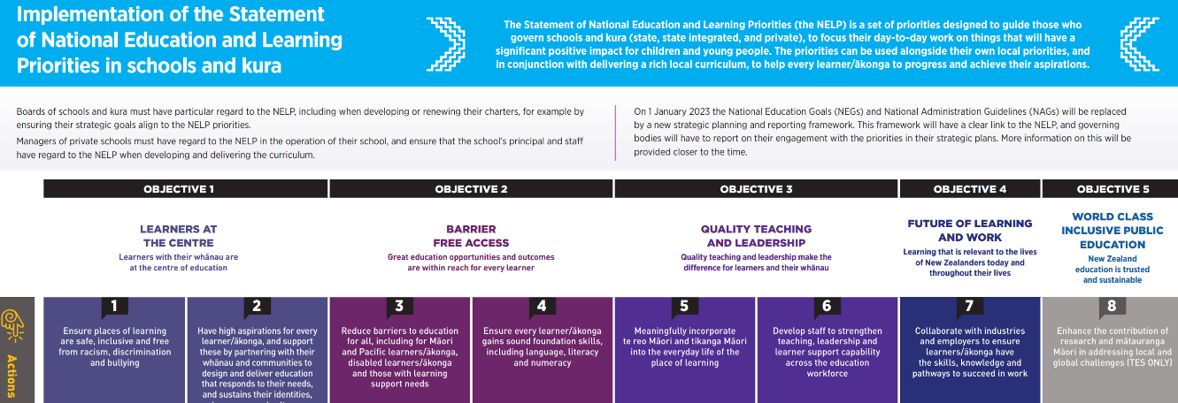

Annual Plan Key Tasks and Actions: Selected Current Engagement and Initiatives

Team cultural capacity building within Māori and Pacific case work through:
- Mana Potential.
- Te Pikinga ki Runga
- Ka Hikitia and cultural self-review
- Te reo, ngā tikanga, Tātaiako, Ka Hikitia and Tapasā opportunities within R4S and wananga.
Continue to explore develop and provide opportunities to deepen our team values of Manaakitanga, Hauora, whakawhanaungatanga, ako, tikanga and Kotahitanga.
RTLB Practice Leader Chris Graham as one of the Pouwhirinakitanga Māngai (Speakers for RTLB Māori) has continued as the National RTLB Māori representative and a leader of Ngā Pouwhirinakitanga. Ngā Pouwhirinakitanga works alongside the Ministry of Education on projects that have included: He Pikorua, The School Entry Assessment Kite, The Learning Support Coordinators Guidelines, Te Kotahitanga, and The Journey to Tino Rangatiratanga. Recently, Chris Graham has also provided a comprehensive submission for the ‘Inquiry into learning support for ākonga Māori’ and within that submission requested the opportunity for Māori to legitimately share the navigation of this waka.
This term Chris has reconvened the series of weekly RTLB team Wānanga begun last year. These wānanga focus on exploring tikanga in our contexts, as RTLB, but include opportunities to practice pronunciation and explore some aspects of Te Reo. In conjunction with this wānanga, several RTLB are also undertaking Te Ahu o te Reo Māori with Takatū.
Gateway
RTLB service expectations include children and young people who are in the care of Oranga Tamariki. Gateway data and service is rigorously analysed, and a full annual Gateway report provided by RTLB Gateway Leader Chris Bush to inform decisions on support provisions and required professional learning. The Gateway Programme provides an ecological assessment profile for Children and Young People who are involved with Oranga Tamariki services for care and protection reasons and who are either in care, entering care or the family is going to be having a Family Group Conference (FGC). This assessment looks at health, mental health, education, dental, trauma, clinical therapy, functional family therapy and parenting capacity and recommends a pathway forward. Resource Teachers of Learning and Behaviour (RTLB) are responsible for supporting schools to complete education profiles for Children and Young People who have received a Gateway referral and to be part of the recommendations outlined at the multi-disciplinary meetings held fortnightly. Chris Bush the Gateway project leader provides a report on the work Resource Teachers of Learning and Behaviour Cluster 8 Gateway Leaders, schools and RTLB undertook in 2021 as part of the Gateway project.
79 Educational Profiles were completed over 2021 comprising of:
- 6 Identified Entry to Care profiles
- 7 Already in Care
- 66 Family Group Conference.
2022 Request for Support (R4S) and Outcomes to 25.3.2022
Total R4S to 25.3.2022: 227 individual Students, 69 Projects, 4 Gps of Schools, 18 Gps of Students, 38 Individual Schools = 356 R4S
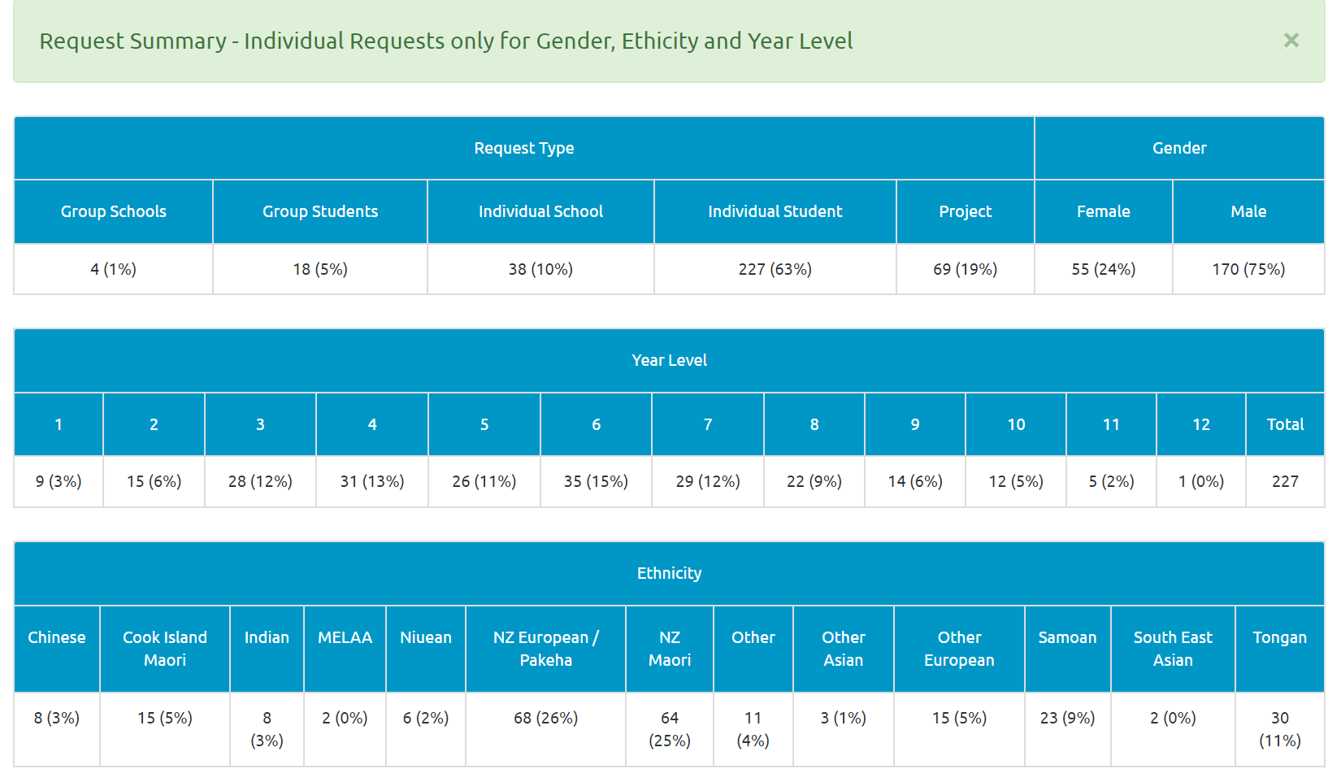

Average Student Outcomes 1.1.2022-25.03.2022

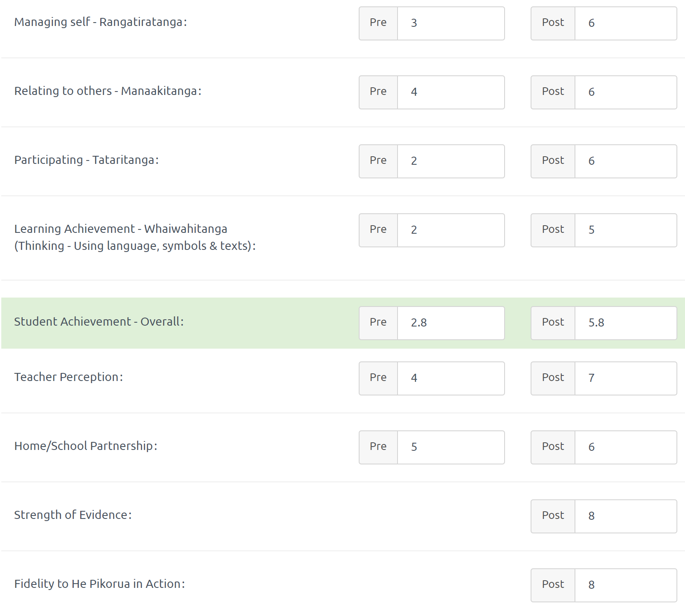

Learning Support Funding

Learning Support Fund (LSF) “supports interventions developed collaboratively with RTLB, targeting students in Years 0-10. It must be used equitably and can be used innovatively.” Learning Support Funding applications are within the context of current active referrals (individual, group, project etc.) and the He Pikorua practice framework. A range of support and/or resources can be applied for dependent on the case/project needs, analysis, goals and plan (if these services/resources are not available from any other source). Learning Support Funding (LSF) for 2022 is $199,101 (GST excl) of which $49,775 has been received in January. As of 25 March 2022, total LSF expenditure YTD stands at approximately $15,248 allocated to support students, projects and to employ our specialists.
----------------------------------------------------------------------------------------------------------------------------------------------

