Student: Year: DOB:

Date: | 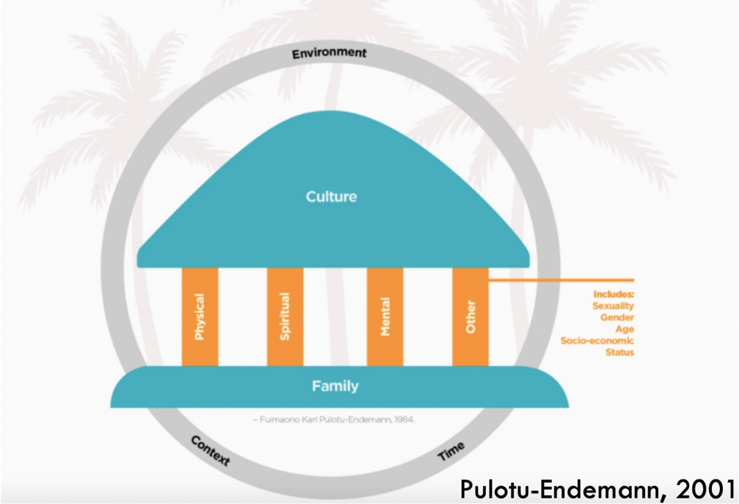
Date of Review:

Attended by:
Name / Role

Apologies:

Culture values/ Family – Safe place to be

Looking Ahead – Where do we hope to be?

Physical Wellbeing
How your body grows, feels and moves, and how you care for it / Physical growth and development

Strengths / Recommendations from family / School / Supporting Agencies

Goal

How | Resources / Approaches | Who | When | How will we know we are successful

Mental Wellbeing
Mind, heart, conscience, thoughts and feelings / Communication, thinking and feeling

Strengths / Recommendations from family / School / Supporting Agencies

Goal

How | Resources / Approaches | Who | When | How will we know we are successful

Spiritual Wellbeing
Beliefs, values, traditions and practices that support self-awareness and identity / human connection to environment

Strengths / Recommendations from family / School / Supporting Agencies

Goal

How | Resources / Approaches | Who | When | How will we know we are successful

Other: Social and Identify
Who makes you feel like you belong, who you care about and who you share your life with, how you identify yourself

Strengths / Recommendations from family / School / Supporting Agencies

Goal

How | Resources / Approaches | Who | When | How will we know we are successful

Points for Further Consideration

Resources / Approaches | Focus | Who | When

