Royal Oak Primary School,
Chandler Ave
Royal Oak,
Auckland 1023
New Zealand

CLUSTER 8
Resource Teachers of Learning & Behaviour

Cluster 8 Ngā Manu Ᾱwhina Manager’s Report (Term 2, 2022)

It is my pleasure to present the Ngā Manu Ᾱwhina report covering:

- RTLB Staffing
- Strategic Engagement with the National Education Learning Priorities
  - Cultural Engagement
  - He Pikorua
  - Communities of Practice
  - Workshops
  - Service Expectations
- Cluster 8 Requests for Support and Outcomes
- Learning Support Fund

RTLB Team and Staffing
Royal Oak Primary Office Base | Orakei Primary Office Base | Tamaki College Office Base
Angelee Morrow | Claire Murphy | Georgia Jensen-Procter
Titania McKenzie | Michelle Grey Lamont .8 | Kylah Drake
Jill Watson | Sue Cameron .8 | Chris Bush
Owen Robyns | Wendy Florence | Vaughan Spurdle
Leslie Dresser-Tu’ugasala | Lilly Reynecke (on study leave) | Jo Turner .6
Tracey Richardson | Julie Nugent | Dianne Ley
Maree Stenberg .8 | Sandiyao Sebestian | Michele Hucker
Emily Marurai | Claire Scopas .8 | Robert Rasmussen
Beverley D’Souza | David Blazey | Michael White
Sarah Pearse
Mark Larkin
Based at Royal Oak Primary | Specialists | Resource Assistant
Barbara Hannant PL | Jean Parkinson (Counsellor).2 | Louis Gruebner
Chris Graham PL | Kimberly Walker (Counsellor) .2 | Relieving
Catherine Alpe PL |  | Donna Southworth
Roseanne Gibson Manager

Cluster 8 RTLB team is currently made up of Lead School Principal Megan Clotworthy, 1 Manager, 3 Practice Leaders, 28 RTLB, 2 Specialists and a resource assistant. The RTLB are grouped into 3 office bases, Ōrākei, Tāmaki and Royal Oak.
Staffing Changes
Druinie Perera resigned effective 2 May 2022.
Beverley D’Souza has resigned effective 5 August 2022.
Leslie Dresser-Tu’ugasala returned from parental leave.
Michael White returned from long term sick leave.

Selected Strategic Engagement with the Priorities

The Cluster 8 strategic goals align with the Statement of National Education and Learning (the NELP) and the Learning Support Delivery Model and Action Plan Priorities. Please see the alignment and engagement with the Strategic and Annual Plan with excerpts from the plan followed by the associated actions below.

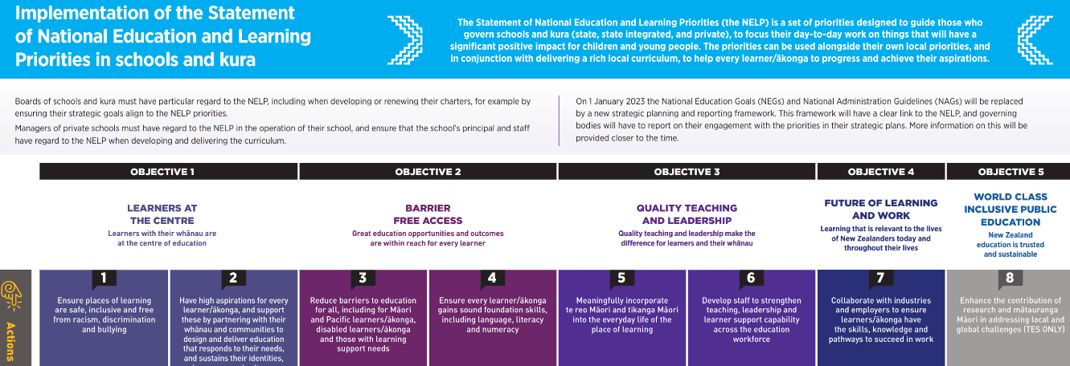
Team cultural capacity building within Māori and Pacific case work through:
- Mana Potential.
- Te Pikinga ki Runga
- Ka Hikitia and cultural self-review
- Te reo, ngā tikanga, Tātaiako, Ka Hikitia and Tapasā opportunities within R4S and wananga.
Continue to explore develop and provide opportunities to deepen our team values of Manaakitanga, Hauora, Whakawhanaungatanga, Ako, Tikanga and Kotahitanga.

Annual Plan Key Tasks and Actions: Selected Current Engagement and Initiatives

Cultural Engagement
RTLB Practice Leader Chris Graham as one of the Pouwhirinakitanga Māngai (Speakers for RTLB Māori) has convened the 2022 Hui-ā-tau, with Cluster 8 RTLB supporting this event. Our sympathies go out to the whanau and Māori RTLB nationally on the sad passing of Hariata Louise Green on the 29th of May 2022. Hariata and Chris have for many years together led Nga Pouwhirinakitanga and her passing is a great loss to many in education and beyond.
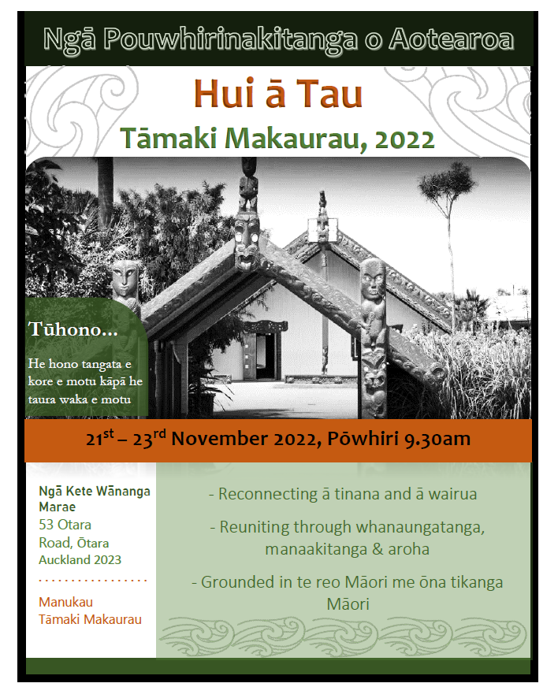
The series of weekly RTLB team Wānanga continue with several RTLB also undertaking the Te Ahu o te Reo Māori programme being delivered by Takatū Associates. As the Matariki constellation appeared in the east, Cluster 8 RTLB came together to honour this event with a Whakatau and some kōrero around the significance of Matariki, including shared lunch that had a reflective time of remembrance and aspects of farewell to those who have passed this past year.
He Pikorua
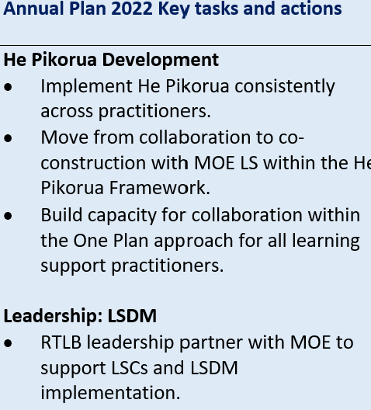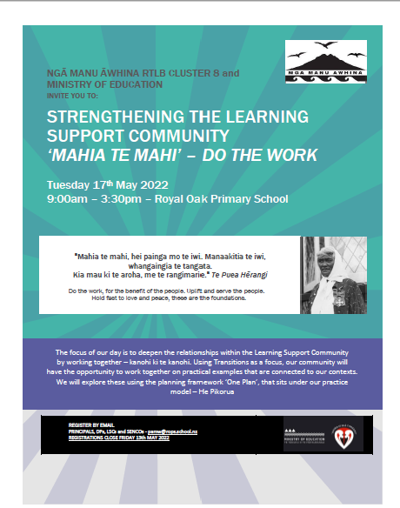
He Pikorua is the one practice framework for all practitioners who work across learning support guiding our practices so we can work together to provide a coherent approach. On the 9th, 13th and 15th June, Cluster 8 Practice Leaders Chris Graham and Barbara Hannant joined the He Pikorua National Team to deliver workshops on updates to almost 1,000 participants. Chris and Barbara have also on request supported adjoining clusters to facilitate collaborative MoELS and RTLB professional learning on the He Pikorua framework. Chris and Barbara are the only RTLB from across the country who have been involved since the inception and development of He Pikorua who are still part of the National Team assisting with the regional and national delivery.
The Cluster 8 Mahia te Mahi event brought together all in our Cluster 8 school community: - Principals, SENCos, DPs, MoE LS, LSCs, Kāhui Ako, agencies, other specialist and school staff and RTLBs. This provided an opportunity to add voice, hopes and dreams to the kōrero about how we work together to meet the needs of our learners and to share best practice. At this event the He Pikorua Framework was used to explore the relationships and roles of people in our cluster learning support community. Examples were provided of best practice and activities engaged in together, applying understandings and strengths to a series of practical scenarios.
Joining us at this event were MoE National representatives Vonnie Jones (Specialist Service Lead, Te Pae Aronui) and Anna Priestley (Principal Advisor, Te Pae Aronui) as well as our regional Auckland MoE LS colleagues and the Cluster 8 RTLB team. Gemma Adcock, Associate Principal/SENCO of Te Papapa School also presented with stories of how she has navigated the learning support community space.
Communities of Practice (COPs)
The Cluster 8 Communities of Practice have hosted cluster-wide professional learning opportunities in Literacy, Foundation Skills and Maths this term as well as bringing educators together to share best practice.
The Maths Community of Practice has widespread interest from our Cluster 8 educators. As a result of the workshop last year, there is growing interest in Spring into Maths- a programme that helps students with low numeracy skills, with RTLB supporting schools with implementing this intervention. In May, there was very strong attendance at the Cluster 8 hosted hui, The Problem with Maths, presented by Maths Advisor Lisa-Marie Heap. Common problems students face, how to identify them and how to support these students was unpacked and appropriate resources shared. In June, Massey University's Associate Professor Dr Jodie Hunter presented a workshop on DMIC (Developing Mathematical Inquiry Communities) it’s development, implementation and how RTLB can support learners within the framework.
In May our Cluster 8 Effective Literacy COP arranged for Liz Kane (https://www.lizkaneliteracy.co.nz/) to present a day-long workshop on the science of reading and the assessments and resources that support literacy teaching. Schools that were working with RTLB on the layers of literacy support for children were invited to attend.
The Foundation Skills COP current focus is on how a stronger link can be created between ECE’s and schools so that early skills are fostered, and new entrants are school-ready. One of the COP’s aims is to help schools support their junior students to develop critical foundation skills for learning and wellbeing. Over term 2, hui were organised inviting educators from within the Cluster 8 group of schools with RTLB firstly presenting the Ready Steady project – an early maths assessment and intervention approach. Secondly, paediatric occupational therapist Josie Tait presented to a large number of participants who attended either in person or by Zoom. Josie shared her insights into the barriers in writing, what works and classroom activity ideas.
Face-to-Face and E-Workshops
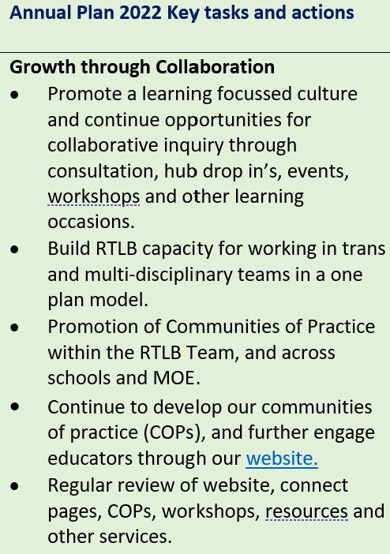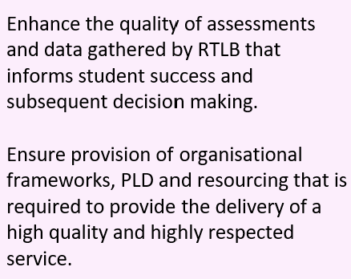
Over Term 2 workshops were offered to Cluster 8 school community and educators on: -
  - Zones of Regulation - an introduction to this effective self-regulation strategy
  - Mediated Learning - how teachers can bring metacognitive strategies into the classroom
  - Teacher Aides and Learning Assistants who work with struggling writers
  - Bounce Back: a programme for developing resilience in children
  - Escalation Profiles
  - Phonological Awareness - the first workshop in a series of six on effective literacy understandings
  - CAS2 Brief Assessment training and a refresher for the SENCo and LSC in our Cluster
  - Feuerstein FIE Basic Level One.
RTLB, SENCos and LSCs from across Cluster 8 completed the Brick-by-Brick programme (formerly known as LEGO-based therapy). This is an evidence-based social skills programme for individuals on the autism spectrum and related social skills difficulties. The Brick-by-Brick programme is highly structured and uses children’s own natural interests in LEGO to promote development of social communication and play. This training is suitable for psychologists, teachers, RTLBs, social workers, counsellors, play therapists, SLTs, OTs and other professionals who work with individuals on the autism spectrum or related social difficulties. Upon completion of this one-day workshop delegates were accredited by Play Included, endorsed by Autism Research Centre, University of Cambridge, and have access to downloadable resources to set up their own Brick Clubs.
Service Expectations
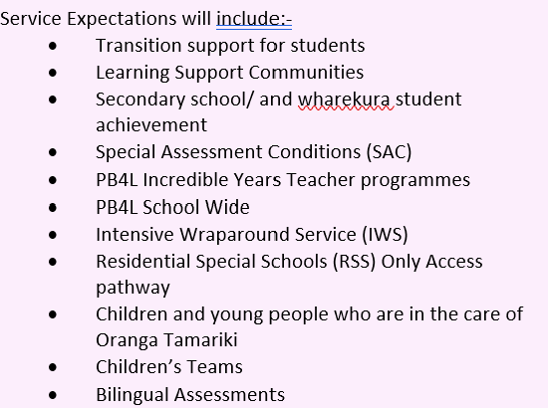
- In negotiation with MoE for additional bilingual assessment (BAS) training Cluster 8 now has ten bilingual assessors. Those who are newly trained have been supported by our experienced assessors and the previous student waiting list has now been addressed with all assessments expected to be completed by end of the term.
- RTLB are working with their schools to support their special assessment applications.
- A One Day Incredible Years (IYT) Programme Overview was facilitated for Cluster 8 schools and educators. Two IYT programmes are scheduled for term 3 and 4 as well as one with the possibility of two programmes for IYA (Autism) with further Cluster 8 IYA facilitators being trained in November.
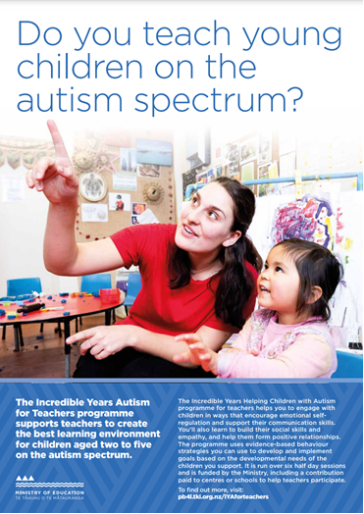
- Gateway
As we reset after the disruptions over the last few years, many of the tamariki coming through the Gateway process are presenting with complex and multi-faceted needs. Identified themes and trends suggest dis-connection from school, higher anxiety, substance abuse and reliance. The educational profiles reflect the additional stress for schools who are trying to support engagement in learning with students who no longer see ‘learning’ as important to them, who have gone backwards from their previous learning and are now struggling with the relevance of school to them, with some preferring to continue the freedom of being at home.
To support schools with these students, a ‘Gateway Transition’ process is being piloted. Gateway students with complex issues can access additional RTLB service and support for 6 weeks-3 months. After this, the school can make an RTLB R4S (request for support) through the usual RTLB process. This pilot concentrates on a wraparound systematic approach, working closely with other agencies such as Oranga Tamariki, ADHB, police (when appropriate) and local agencies including the marae.

- The Education and Health Initiative Project
Several streams of work have come out of The Education and Health Initiative Project. RTLB Titania McKenzie is working with and alongside several schools and a Kāhui Ako to develop innovative localised responses to absenteeism in schools that may be useful to schools in their work in re-engaging learners. Another stream is the development and pilot of a support services database with six interested schools and RTLB in term three. This database has been designed by Louis Gruebner, Cluster 8 resource assistant. The database aims to bring supporting agencies to the tip of educators’ fingers.
2022 Request for Support (R4S) and Outcomes to 1.7.2022
Total R4S to 1.7.2022: 272 individual Students, 83 Projects, 4 Gps of Schools, 22 Gps of Students, 45 Individual Schools = 426 R4S
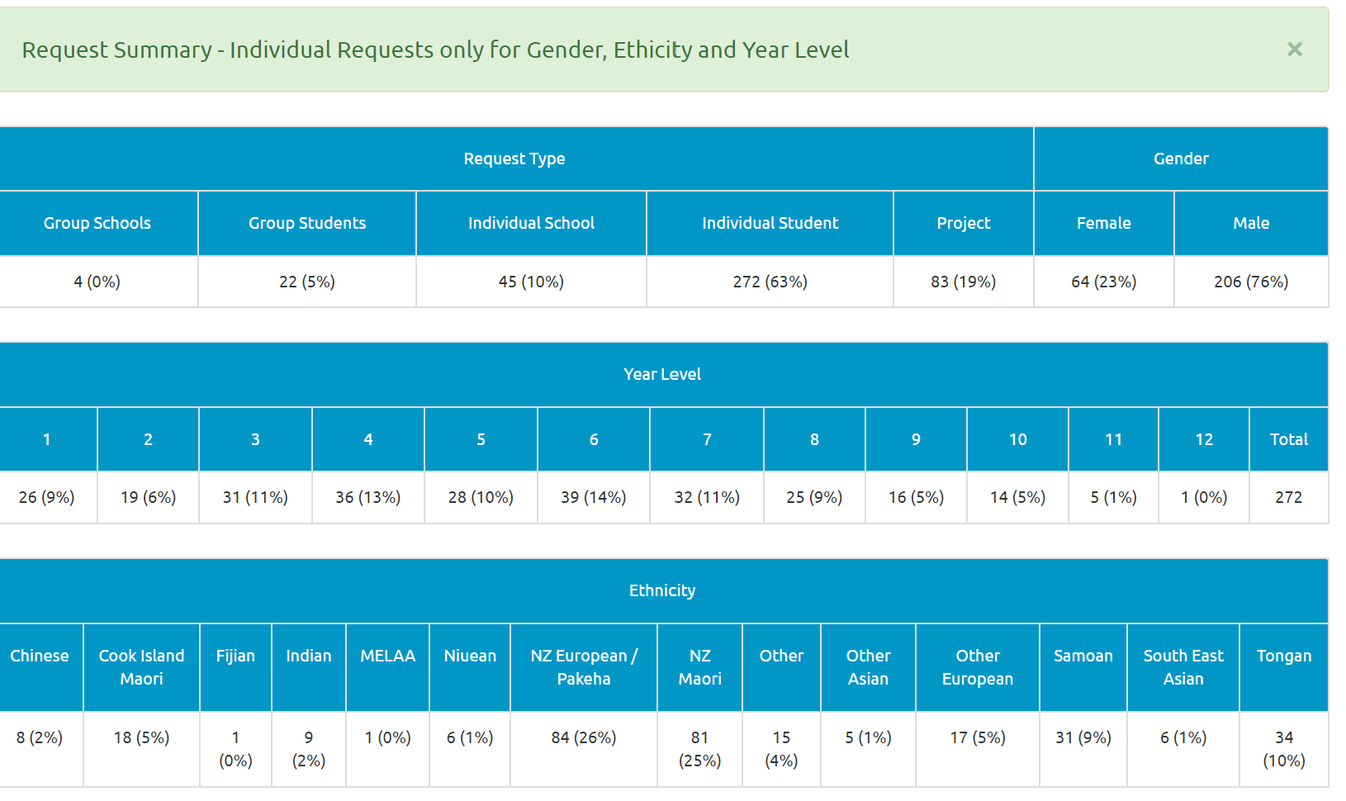

Average Student Outcomes 1.1.2022-1.07.2022

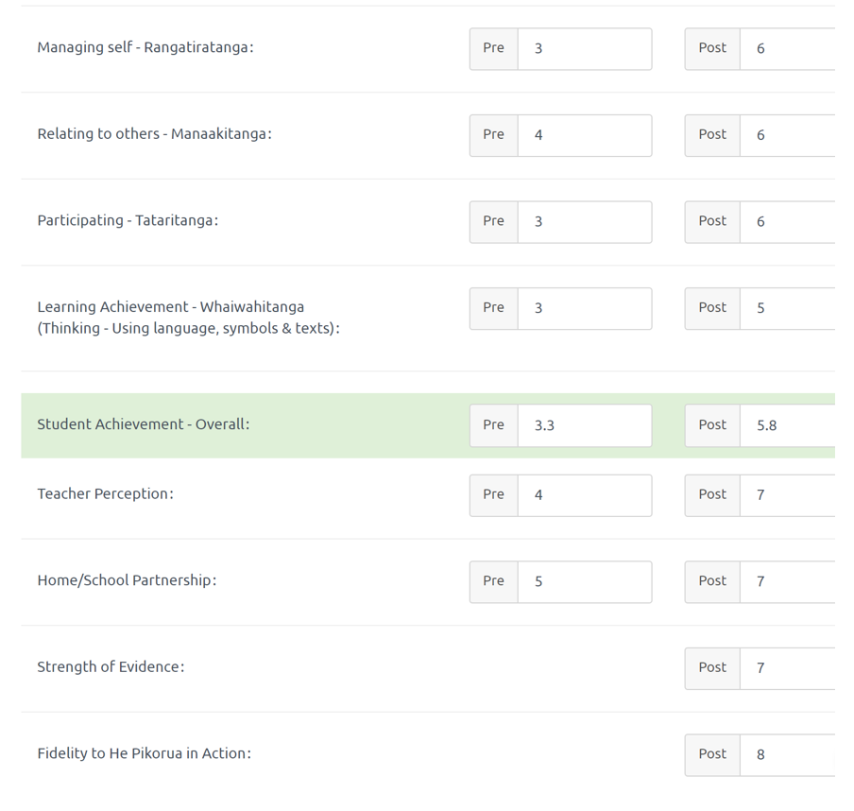

Learning Support Funding

Learning Support Fund (LSF) “supports interventions developed collaboratively with RTLB, targeting students in Years 0-10. It must be used equitably and can be used innovatively.” Learning Support Funding applications are within the context of current active referrals (individual, group, project etc.) and the He Pikorua practice framework. A range of support and/or resources can be applied for dependent on the case/project needs, analysis, goals and plan (if these services/resources are not available from any other source). Learning Support Funding (LSF) for 2022 is $199,101 (GST excl). As of 31 May 2022, total LSF expenditure YTD stands at approximately $74,266 allocated to support students, projects and to employ our specialists.
----------------------------------------------------------------------------------------------------------------------------------------------

Other matters

Georgia Jenson Procter has forthcoming surgery that will most likely require a substantial amount of recovery sick leave and may require additional discretionary leave.

