Royal Oak Primary School,
Chandler Ave
Royal Oak,
Auckland 1023
New Zealand
Ph: 09 624 2800
Mob: 021966199
Email: manager@rtlbcluster8.ac.nz

CLUSTER 8
Resource Teachers of Learning & Behaviour

Cluster 8 Ngā Manu Ᾱwhina Manager’s Report (Term 1, 2023)

It is my pleasure to present the Ngā Manu Ᾱwhina report covering:

- Cluster 8 Ngā Manu Ᾱwhina 2023 Annual and Strategic Plan and Report
- RTLB Team and Staffing
- Strategic Engagement with the National Education Learning Priorities
- Professional Learning and Workshops
- Cluster 8 Requests for Support and Outcomes
- Learning Support Fund

RTLB Team and Staffing
Royal Oak Primary Office Base | Orakei Primary Office Base | Tamaki College Office Base
Vaughan Spurdle | Michelle Grey Lamont .8 | Georgia Jensen-Procter
Jill Watson | Michele Hucker | Chris Bush
Owen Robyns | Jennie Burt | Lilly Reynecke .6
Leslie Dresser-Tu’ugasala | Cecilia Tian | Jo Turner .6
Tracey Richardson | Sandiyao Sebestian | Dianne Ley .8
Maree Stenberg .8 | Claire Murphy (leave) | Michael White
Wendy Florence |  | Robert Rasmussen
Maryanne Manuyag |  | David Blazey
Julie Nugent |  | Kylah Drake (leave)/Ruth Milburn .6 reliever
Sarah Pearse
Cynthia Borne .6
Leadership |  | Specialist RTLB
Barbara Hannant |  | Titania McKenzie (Psychologist) .7
Chris Graham |  | Lilly Reynecke (Counsellor) .4
Catherine Alpe |  | Specialist
Emily Marurai |  | Jean Parkinson (Counsellor).2
Roseanne Gibson Manager

The RTLB team, leadership and staffing over term 1, 2023: Lead School Principal Megan Clotworthy, 1 Manager, 2 Practice Leaders, 1 Partnership Leader, 1 Pastoral Leader, 26 RTLB and 3 Specialists. The RTLB are grouped into 3 office bases, Ōrākei, Tāmaki and Royal Oak. The RTLB in each office base are responsible for providing service to designated schools and Kāhui Ako, however depending on workload, RTLB with specific required expertise are able to work across the cluster. Project and case work are ‘needs driven’ and based on requests for support (R4S) received, presented and discussed at review and intake meetings.
Staffing
New permanent positions term 1, 2023
  - Maryanne Manuyag
  - Cecilia Tian (Wong)
  - Jennie Burt
- Fixed relieving positions.
  - Cynthia Borne .6
  - Ruth Milburn .6
- Vaughan Spurdle resigned effective 7 April 2023. We wish him well in his future endeavours.
- One new permanent RTLB position appointed beginning term 2
  - Sarah Mariu
Owen Robyns and Kylah Drake have RTLB have study awards and are undertaking their first year of study towards completing the mandatory Post Graduate Diploma in Specialist Teaching (Learning and Behaviour). This study is completed whilst working as an RTLB over 2 years with study days allocated.

A number of RTLB were impacted by the weather events, particularly those living in Muriwai, Piha and Karekare. In response to individual’s specific unfolding circumstances, leave, remote working and support was offered.
Cluster Wide Project Initiatives and Project Leads

The Cluster 8 website provides information and showcases what the cluster and RTLB can offer in individual and systemic support, and professional development to the cluster, also providing access to a range of resources. A key contact person for specific support (for e.g., ASD, dyslexia etc) is listed and there is the opportunity for MoE, RTLB and the cluster’s teachers to engage in a community of practice in areas of expertise and interest. Project leads and ‘Connect’ people can be located and are accessible for additional support on the connect tab.
RTLB with Additional Responsibilities

- Cultural Support: Chris Graham; Michael White; David Blazey; Tracey Richardson; Robert Rasmussen.
- RTLB Specialist Psychologist: Titania McKenzie
- RTLB Specialist Counsellor: Lilly Reynecke
- Hub Kai Manaaki are in place across the 3 hubs to support RTLB who are new to a hub
- Psychological Practice, Supervision and Assessment: Barbara Hannant. Assessment co-lead: Titania McKenzie
- I.T. Leadership and Support Team: Barbara Hannant, Emily Marurai and Vaughan Spurdle
- SchoolGate Database: Emily Marurai, Catherine Alpe; Chris Graham; Barbara Hannant
- Website: Catherine Alpe; Emily Marurai
- Organisation Manual Editor: Emily Marurai
- General Library, Accessit and Resources: Catherine Alpe and Accessit Team
- NZEI Rep: Michelle Hucker whilst Claire Murphy is on leave
- Gateway: Chris Bush

Selected Strategic Engagement with the Priorities

The Cluster 8 strategic goals align with the Statement of National Education and Learning (the NELP) and the Learning Support Delivery Model and Action Plan Priorities. Please see the attached summarised Annual Plan.

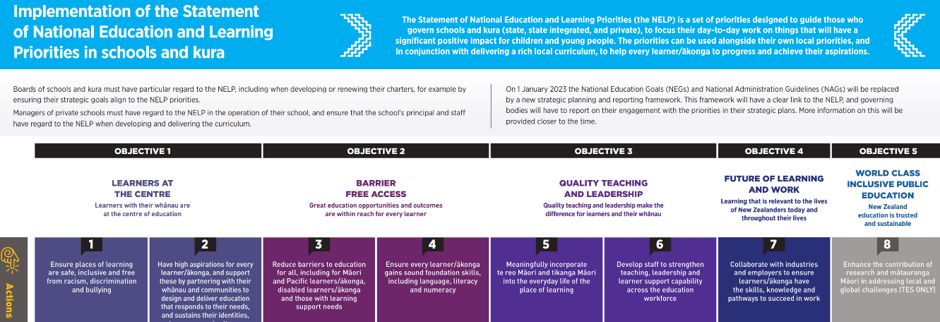

Annual Plan Key Tasks and Actions: Selected Current Engagement and Initiatives

The year started with an RTLB Pōwhiri welcoming the new RTLB and a Whakawhanaungatanga team day. RTLB Partnership Leader Chris Graham as one of the Pouwhirinakitanga Māngai (Speakers for RTLB Māori) has continued to work alongside the Ministry of Education on a range of projects including: He Pikorua, The School Entry Assessment Kite, and The Journey to Tino Rangatiratanga. Over this term Chris has facilitated team professional learning on He Urunga Tū and the alignment with He Pikorua as the one practice framework, and also introduced the team to the Journey to Rangatiratanga mokopuna support pack.
He Urunga Tū – is an entrance to engagement framework that contains key phases that align well with He Pikorua. The He Urunga Tū framework enables RTLB to be effective, inclusive, culturally responsive, and safe in their practice. It guides and supports RTLB to facilitate the process in a manner that is respectful and professional and maintains positive working relationships. The Journey to Tino Rangatiratanga builds onto the Te Pikinga ki Runga (Sonja MacFarlane) professional learning that the team has previously engaged in. Te Pikinga ki Runga is an assessment, analysis and programme-planning framework specifically intended to guide education professionals in their interactions when working with Māori students and their whānau.The Tino Rangatiratanga instructional manual and recording sheets and cards have been designed to support interactions, engagement and collaborative conversation with mokopuna and whanau, and facilitate aspirational decisions of pertinent goals.
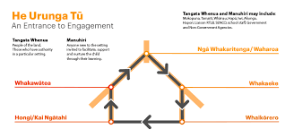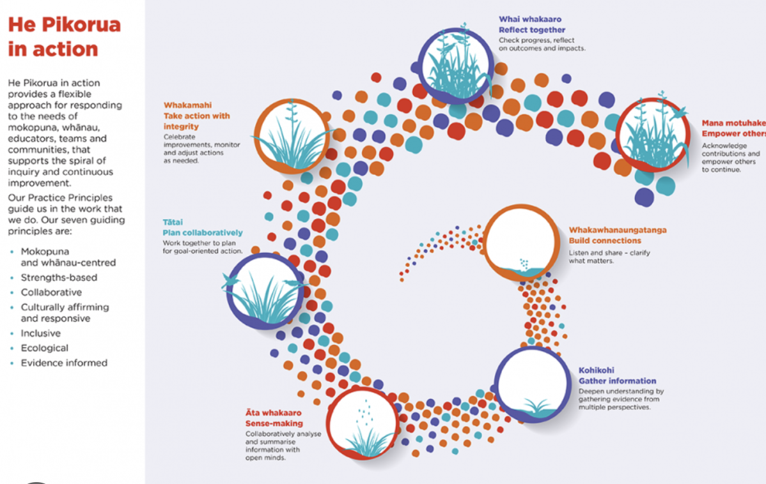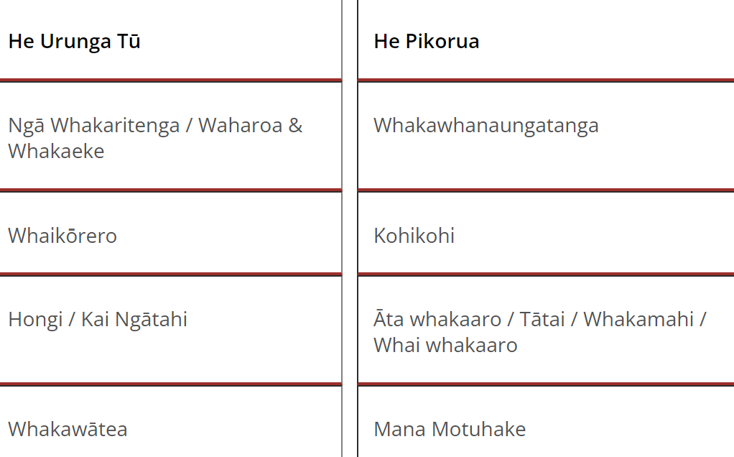
Cluster 8 Practice Leader Barbara Hannant and Chris Graham continue to be part of the National Team assisting with He Pikorua regional and national delivery. As part of the national implementation of He Pikorua, Barbara Hannant was selected to be part of a national MoE working party to write a position paper about kohikohi (gathering information to deepen understanding). The last position paper was written in 2010 and was titled Assessment (Analysis and Reporting) in Special Education and was written from a Ministry perspective based on the then service standards. The new position paper update will reflect He Pikorua’s bicultural, inclusive and ecological approach to kohikohi and will be relevant for Learning Support practitioners, RTLB, Ministry Managers and stakeholders, including health-based practitioners. It will also have relevance for mokopuna and their whānau and is expected to be publicly available and hosted on the He Pikorua site. As part of this mahi it is intended that clarity will be provided on the use of formal assessments such as psychometric assessments, through the lens of He Pikorua.
It is timely that a new position paper is written to reflect the unique history of Aotearoa New Zealand and the educational imperatives of today, namely, the obligations to Te Tiriti o Waitangi/The Treaty of Waitangi, which has been interwoven through policies, frameworks and codes that guide professional practice; Ka Hikitia and Kahāpaitia- (The Māori Education Strategy); the Learning Support Action Plan: 2019–2025 and He Pikorua, the practice framework.
New RTLB who were not party to the previous Mana Potential training were able to complete this with Cluster 6 who kindly opened their team training up to them. The Mana Potential Model and tool employs a culturally centred framework for a strengths-based conversation that explores who we are, where we come from, our sources of strength and resources, and how we face life's challenges.
On March 15, Cluster Manager Roseanne Gibson was re-welcomed to the RTLB Lead Principals Executive in Wellington for the first meeting of this cycle of the Cluster Manager appointment.
Professional Learning and Workshops

Wendy Baker from the Coaching and Mentoring Centre facilitated a Peer Supervision training workshop for the RTLB Teacher Only Day to support Professional Growth Cycles. The team were reintroduced to this team-based approach to supervision, provided skills training and shown tools in action. A toolkit of processes was provided to enable the team to set up and run peer supervision groups that provide high quality supervision for themselves and their colleagues.
RTLB Julie Nugent led and facilitated a team professional practice session aimed at Effective Literacy Practices including structured literacy approaches. This session supported the Literacy and Communication Curriculum refresh aims and implementation of the curriculum refresh roadmap and timeline.
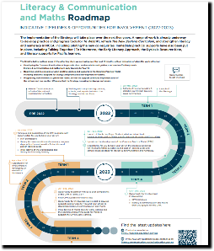
RTLB Sarah Pearce who is a Seasons for Growth Trainer ran a companion training session for 12 Cluster 8 RTLB. Seasons for Growth is an innovative, evidence-based change, loss and grief education program. The programme builds on the knowledge and skills necessary to strengthen social and emotional wellbeing following significant loss. Seasons for Growth programmes explore the impact of change and loss, with participants learning that they are not alone in their experience of change, loss and grief, also learning about effective ways to respond and adapt. Participants are able to build their communication, decision making and problem solving skills within the context of a safe and supportive peer group learning environment.
On 23 March, RTLB Bilingual Assessors (BAS) attended the first MoE facilitated training for the year. There are now MoE Senior Advisors Refugee & Migrant Support, covering particular areas. More information on this service is available here.
2023 Request for Support (R4S) and Outcomes to 24.3.2023
Total of 295 R4S to 24.3.2023: 186 individual Students, 55 Projects, 11 Gps of Students, 43 Individual Schools
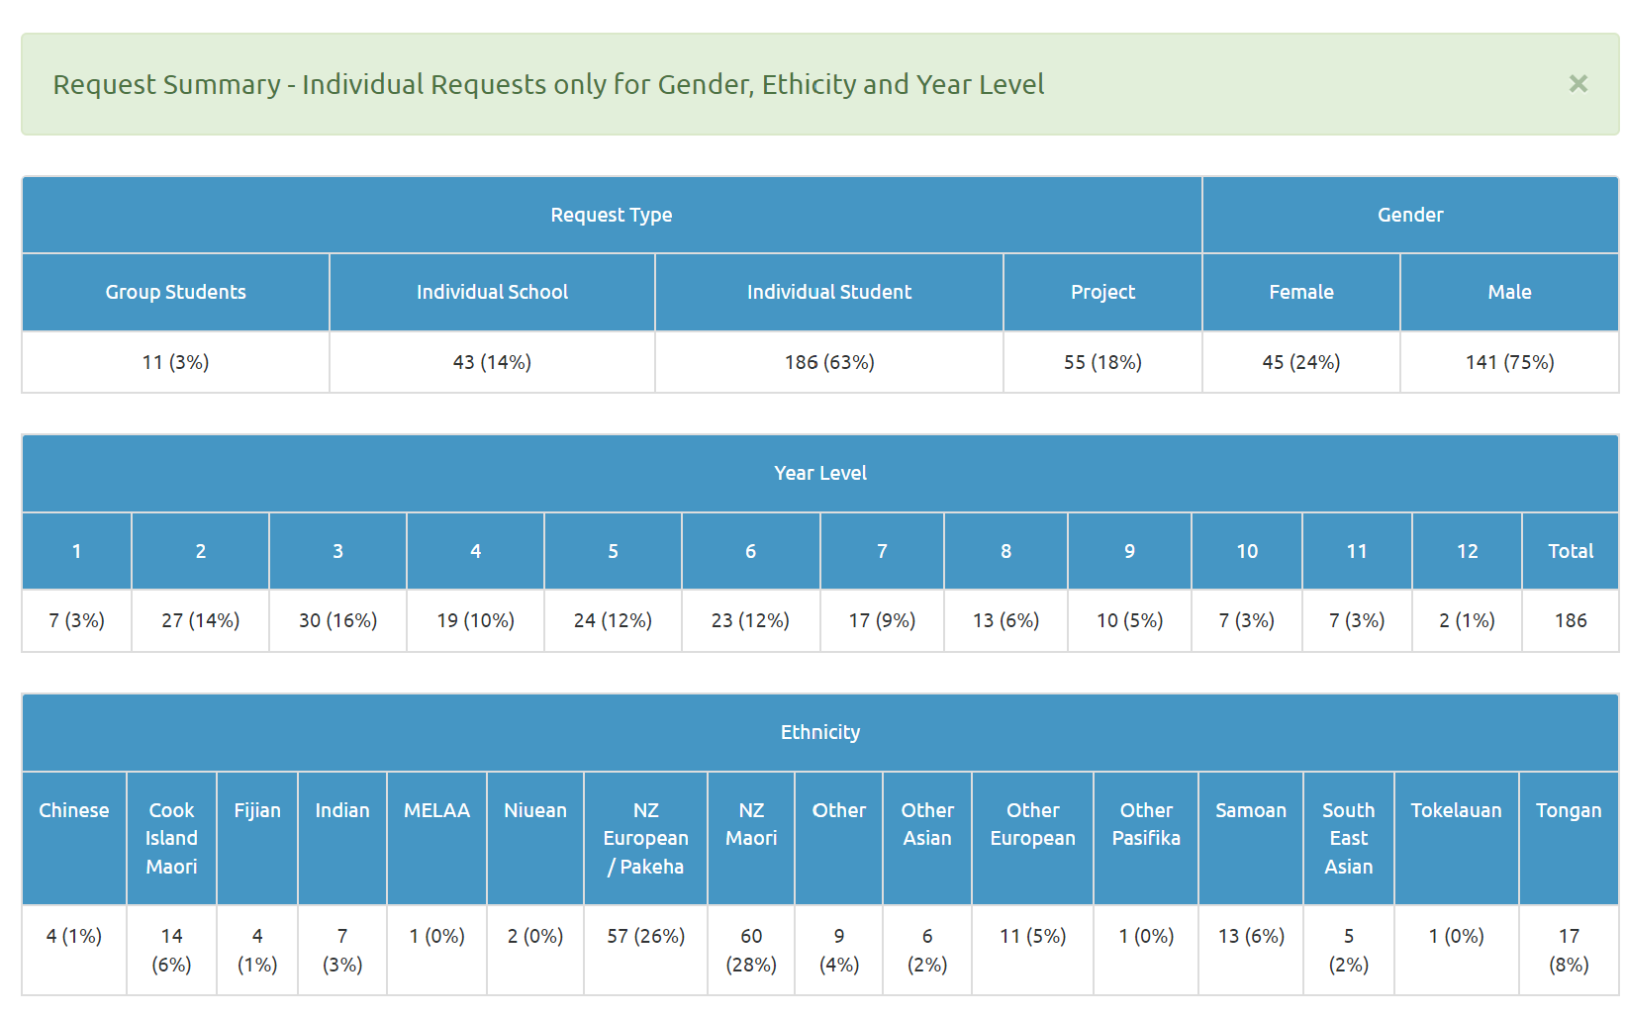
Average Student Outcomes 1.1.2023-24.03.2023

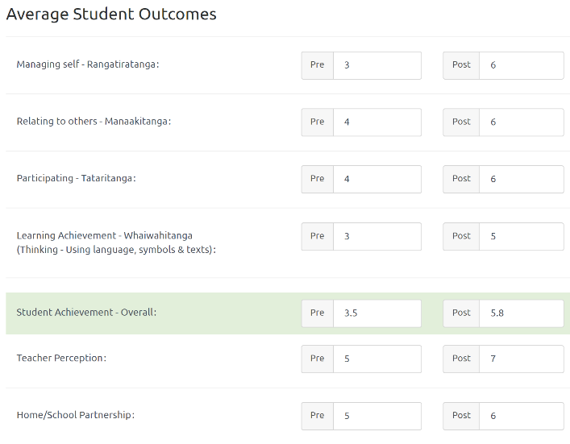

Learning Support Funding

Learning Support Fund (LSF) “supports interventions developed collaboratively with RTLB, targeting students in Years 0-10. It must be used equitably and can be used innovatively.” Learning Support Funding applications are within the context of current active referrals (individual, group, project etc.) and the He Pikorua practice framework. A range of support and/or resources can be applied for dependent on the case/project needs, analysis, goals and plan (if these services/resources are not available from any other source). Learning Support Funding (LSF) for 2023 is $198759 (GST excl). Please see the financial report for current LSF expenditure YTD allocated to support students, projects and to employ specialists.
----------------------------------------------------------------------------------------------------------------------------------------------

