Royal Oak Primary School,
Chandler Ave
Royal Oak,
Auckland 1023
New Zealand
Mob: 021966199
Email: manager@rtlbcluster8.ac.nz

Ngā Manu Ᾱwhina RTLB Cluster 8 Manager’s Report (Term 2, 2021)

It is my pleasure to present the Ngā Manu Ᾱwhina report covering:

RTLB Staffing
Strategic Engagement with the National Education Learning Priorities
Selected Current Initiative Presentation: Mana Potential
Cluster 8 Requests for Support and Outcomes
Learning Support Fund
Other Matters

RTLB Team and Staffing
Royal Oak Primary Office Base | Orakei Primary Office Base | Tamaki College Office Base
Angelee Morrow | Claire Murphy | Georgia Jensen-Procter
Emily Marurai | Michelle Grey Lamont .8 | Kylah Drake /Ruth Milburn
Jill Watson | Sue Cameron .8 | Chris Bush
Owen Robyns | Claire Scopas .6 | Vaughan Spurdle
Leslie Dresser-Tu’ugasala/ Debbie Saxon | Lilly Reynecke | Jo Turner .6
Beverley D’Souza | Julie Nugent | Dianne Ley
Maree Stenberg | Sandiyao Sebestian | Michele Hucker
Titania McKenzie | Druinie Perera | Robert Rasmussen
Tracey Richardson | (David Blazey on study leave) | Michael White
Rebecca Robinson
Margaret Muir .8
Leadership
Barbara Hannant PL | Specialists
Chris Graham PL | Jean Parkinson (Counsellor).2 | Resource Assistant
Catherine Alpe PL | Kimberly Walker (Counsellor) .2 | Louis Gruebner
Anne Roborgh .2(Partnership Leader)
Roseanne Gibson Manager

  - Miriam Kauders, Educational Psychologist Specialist (.4) retired at the end of term 1. We acknowledge and thank Miriam for her years of RTLB service.
  - We congratulate Beverley D’Souza on gaining a permanent RTLB position in Cluster 8 effective 16 June 2021. Beverley was previously in a Cluster 8 fixed term position for David Blazey whilst he is on study award leave.
- Kylah Drake: parental leave 29 March 2021 to 18 October 2021. Reliever Ruth Milburn.
- Margaret Muir .8 is on long term sick leave. Reliever Claire Scopas.
- Leslie Dresser-Tu’ugasala: parental leave 26 July 2021 to 29 April 2022. Reliever Debbie Saxon.
  - Catherine Skudder resigned effective 3 May 2021 to take up the Principal’s position at St Joseph’s School Grey Lynn.
  - Rebecca Robinson has been on sick leave from 7.5.21. Rebecca may require further discretionary sick leave.

Strategic Engagement with the Priorities

The Cluster 8 strategic goals are designed to align with the Statement of National Education and Learning (the NELP) and the Learning Support Delivery Model and Action Plan Priorities.

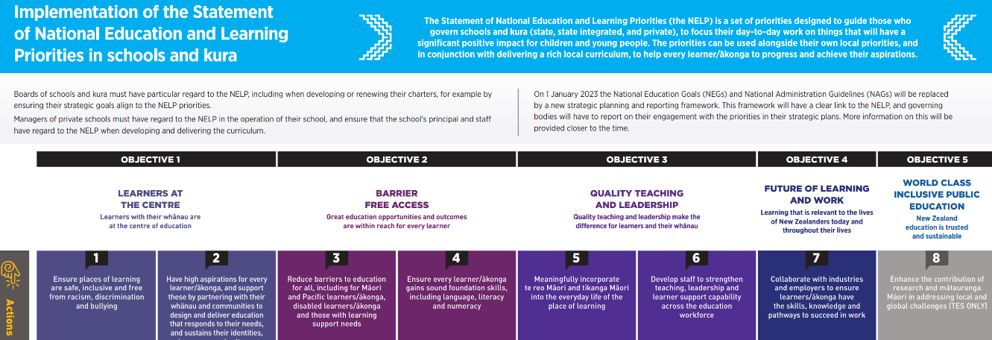

Objectives | Strategic Engagement with the Priorities
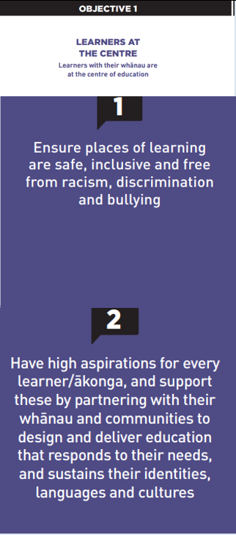 | The team, Partnership Leader and Practice Leaders are working collaboratively with MoE LS and Kāhui Ako to support the implementation of the LSDM, also attending and participating in relevant Kāhui Ako SENCo and LSC meetings and multi-agency panels.  Chris Graham and Barbara Hannant are involved at a National level in the ongoing development and implementation of He Pikorua to develop capacity across all Learning Support Practitioners in collaboration of a One Plan approach. This is supporting the development and understanding of working in trans and multi-disciplinary teams.  There is the continued implementation of He Pikorua (one practice framework) consistently across practitioners with database alignment and team PLD. RTLB Practice Leaders and MoE LS Service Managers are collaboratively planning PLD and collaborative inquiry for the cluster in term 3 on He Pikorua, tiered support, one plan and trans and multidisciplinary support.  The focus on RTI: Tiered Support in conjunction with the sLSR (Standardised Learning Support Register) and Te Rito has continued with key RTLB leaders attending a MoE session, and the RTLB team and MoE LS working to support implementation with key stakeholders.  Our 3 RTLB hubs: - Royal Oak Primary, Tamaki College and Orakei School had the termly Collaboration and Support Drop In morning so that RTLB, DPs, SENCos, MoE LS, teachers and LSCs can kōrero, inquire, collaborate, provide support and guidance, access and share expertise and tiered project work.  Mana Potential PLD was provided for the cluster and team to build capacity to meet the needs of Maori students. Mana Potential provides a culturally appropriate strength-based tool for behaviour change.  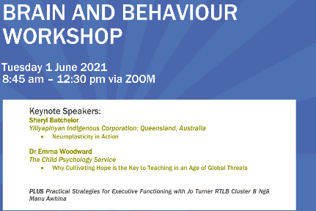  As part of the termly learning and networking event days the Cluster 8 Brain and Behaviour E-Event was on 1 June 2020 with approximately 170 attendees. Guest speakers Emma Woodward spoke on Hope and Managing Big Emotions using Strengths and Sheryl Batchelor from Yiliyapinya Indigenous Corporation spoke on Neuroplasticity in Action.  Cluster 8 has provided a range of pop-up workshops facilitated and presented by Cluster 8 RTLB and open to educators across our cluster: -  - Working as a Teacher Aide Part 1 and 2  - Understanding Autism Spectrum Disorder  - Let’s Talk about Autism  - The Joyful work of Play  - Understanding Auditory Processing Disorder  - Practical strategies for Executive Function Skills  - A Rising Tide Lifts all Ships  - Understanding and Developing Wellbeing  - Adverse Childhood Experiences: It’s not the end of the story.  In addition, there is the importance of recent RTLB work with RTLB PL Barbara Hannant offering staff professional learning sessions to the cluster schools on Developing Understanding of Cognitive Behaviour Therapy and Anxiety. Addressing anxiety is an area highlighted and requested by schools and an area identified in the cluster needs analysis. Complementary to this PLD, RTLB have introduced schools to Zones of Regulation strategies as a support for learning self-regulation.  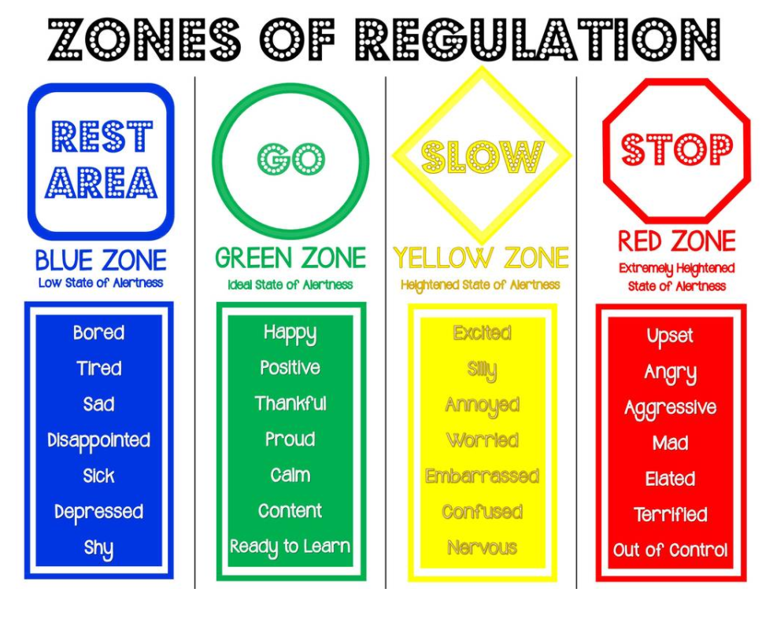  RTLB continue to develop and lead communities of practice (COPs) further engaging educators across the cluster in: - Foundation Learning, Feuerstein, Play-based Learning, Secondary Educators, Dyslexia, Inclusive Practices, ASD, Behaviour, Neuroscience and SEL.
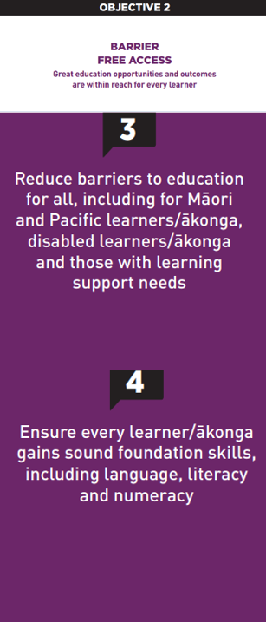 | RTLB presented curriculum assessment PLD workshops for the cluster and team developing team and school capabilities in assessment, analysis and subsequent planning. Assessments included: -  - The Piers-Harris 3 which quickly measures self-concept in children, adolescents, and young adults, and identifies individuals who need further testing or treatment.  - Devereux Student Strengths Assessment (DESSA) which assesses eight social and emotional competencies and is intended to help educators plan instruction, document students' strengths and areas of need.  - The TAPS-4 provides information about language processing and comprehension skills across three intersecting areas: phonological processing, auditory memory and listening comprehension. These areas underpin the development of effective listening and communication skills and are critical to the development of higher order language skills, including literacy skills.  - The Cognitive Assessment System Brief (CAS2 Brief) is a valid and reliable tool to help examine children and adolescents' strengths and weaknesses in important areas of cognitive processing.  RTLB and secondary educators attended a SAC NZQA presentation for SENCOs/LSC/RTLB on the fundamentals of SAC: -  - the reality, set up, validity and escalation in application.  - how we implement SAC at our schools….  - Successful “SAC schools” and communities shared their journey of effective SAC in schools.  After an inquiry and exploration of efficient and effective ways to collect evaluative data from whānau, students and schools in order to support service and system improvement, a survey monkey evaluative form has been developed and added to the RTLB database and casework processes.  There is ongoing regular review of the website, connect pages, Communities of Practice (CoPs), workshops, resources and other services to ensure it is current, topical and responsive to the cluster’s needs. Traffic on our website indicates 12% increase in use of our website over the past term as indicated by home page visits. Visits to the Face-to-Face and E-Workshops pages increased by 37% over the same period. Other frequently visited pages include Our People with staff bios and the Connect page which links to our areas of interest and projects.  The Wellbeing Community of Practice has reviewed the Wellbeing Connect page and updated the content. This is now arranged within four themes: Hot Tips and Strategies for SEL, Whole School Wellbeing, Calming Strategies and Covid-related Supports
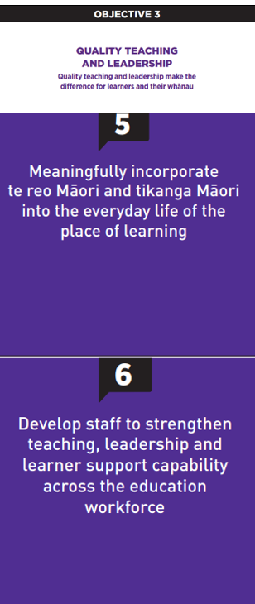 | There is on-going development of team competencies when working with Māori and Pacifica requests with the team building understanding and capacity in te reo, ngā tikanga, Tātaiako, Ka Hikitia and Tapasā. Cluster 8 Practice Leaders and the Māori roopu will be attending Hui-a-tau in Nelson.  Practice Leader Chris Graham is a National RTLB Māori representative and a leader of Ngā Pouwhirinakitanga and a contributing member on the following national working groups: He Pikorua One Practice Framework, LSC Guidelines and is currently working with the national MoE team on the School Entry Assessment and in the Curriculum Progress Map- Social Emotional Development. Chris provides support on the Massey University Learning and Behaviour panel supporting the Specialist Teaching Program.  Leadership and strength-based best practice in the team is being developed in the RTLB team through targeted PLD, coaching and mentoring, with some LSCs also accessing coaching and mentoring support from RTLB. The Professional Growth Cycle process has been revised also incorporating peer supervision structures for observation, feedback and peer mentoring and supervision in place.  New team members are introduced to Cluster 8 RTLB organisation, processes and RTLB work through a series of induction hui. Each new team member has a Hub mentor who introduces them to their schools and to Cluster 8 processes. Induction hui led by the Practice Leaders cover the integrated one practice framework He Pikorua and the processes at each juncture, as well as utilising Dynamic Ecological Analysis (DEA) to explore case studies. Adjoining clusters and some nationwide clusters and MoE LS have also accessed Cluster 8 for support and PLD in these areas.
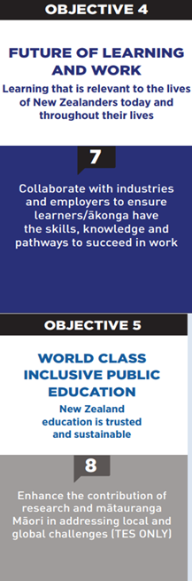 | There is ongoing development of a cluster culture of wellbeing and inclusivity valuing diverse ways of being and values in action, for e.g., RTLB participating in the Welcoming Schools Initiative, a new Refugee and Migrant initiative through RASNZ. RASNZ (Refugees as Survivors NZ) is a specialist mental health and wellbeing service for people from refugee backgrounds living in Aotearoa/New Zealand.  RTLB participated in the Te Iti Kahurangi hikoi to explore and experience the stories of our Maunga, Moana and Manawhenua, whanaungatanga, tikanga and understanding of history and kawa of Ngāti Whātua and Te Waiohua / Te Ahiwaru  A tiers of support project, ‘Improving Brain Health in Schools’ with Sheryl Batchelor, founder of the Yiliyapinya Indigenous Corporation is being developed to be implemented as a pilot. This is also developing the RTLB understandings and capabilities in project management.  Cluster 8 hosted the Wellbeing E-Event Zoom. Denise Quinlan from the NZ Institute of Wellbeing provided a morning workshop on the practicalities of whole school wellbeing, best practice and implementation. There were short presentations on school stories and additional resources and snippets with a Wellbeing Trello noticeboard linked to the Cluster 8 website.  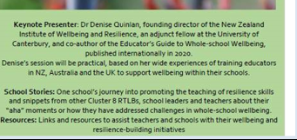

Selected Current Initiative (NELP Objectives 1 and 3, Actions 1, 2, 5, 6)
Practice Leader Chris Graham to present on Mana Potential.

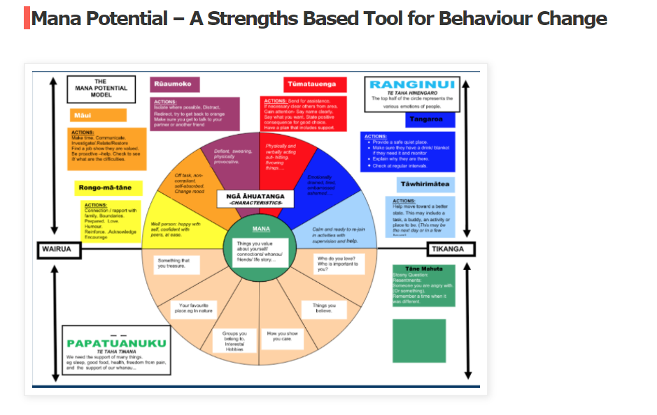
On 18 May 2021, Cluster 8 educators and the RTLB team engaged in a Mana Potential workshop at Te Kura Kaupapa Maori o Puau Te Moananui-a-Kiwa to build capacity to meet the needs of students with challenging behaviours. Mana Potential provides a culturally appropriate strength-based tool for behaviour change. It is a framework which upholds first and foremost the core values and absolute uniqueness of the individual.
2021 Request for Support (R4S) and Outcomes to 2.7.2021
Total R4S to 2.7.2021: 261 individual Students, 98 Projects, 73 Gateway, 4 Gps of Schools, 28 Gps of Students, 44 Individual Schools = 508 R4S
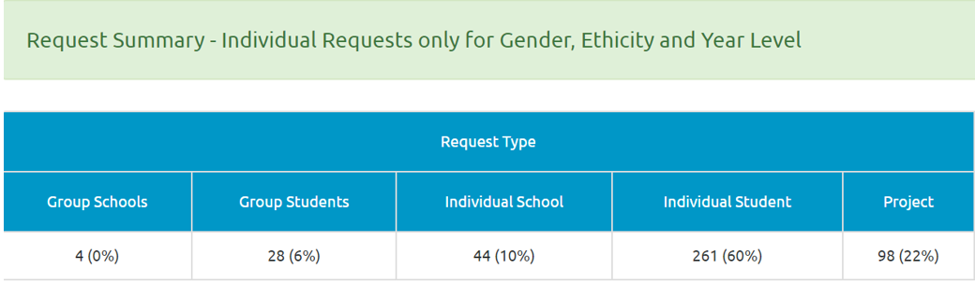
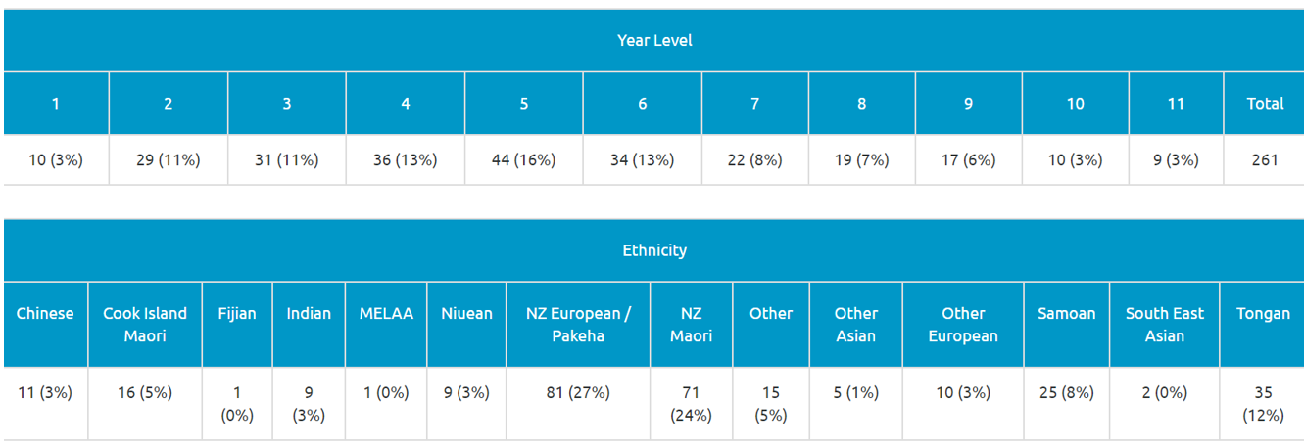
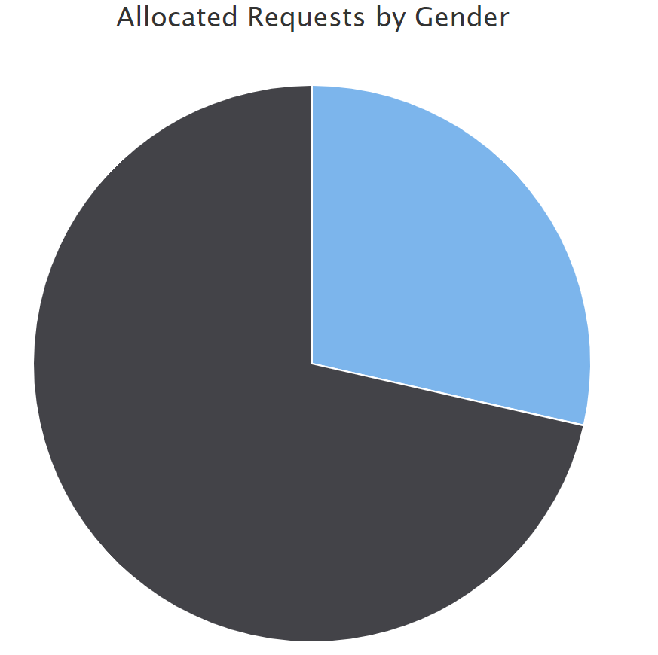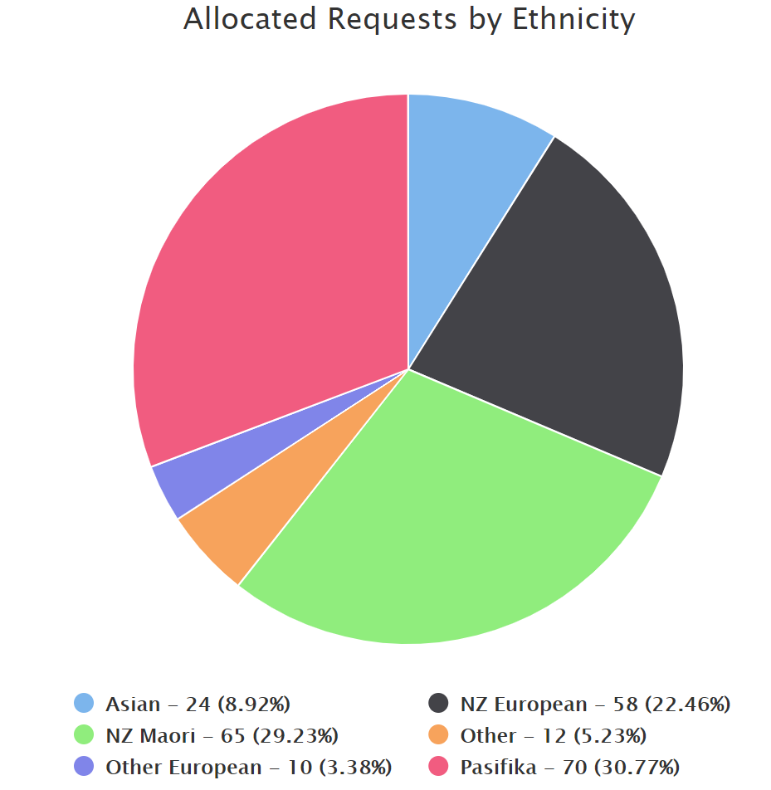
Male 73% Female 27%

Average Student Outcomes 1.1.2021- 2.7.2021
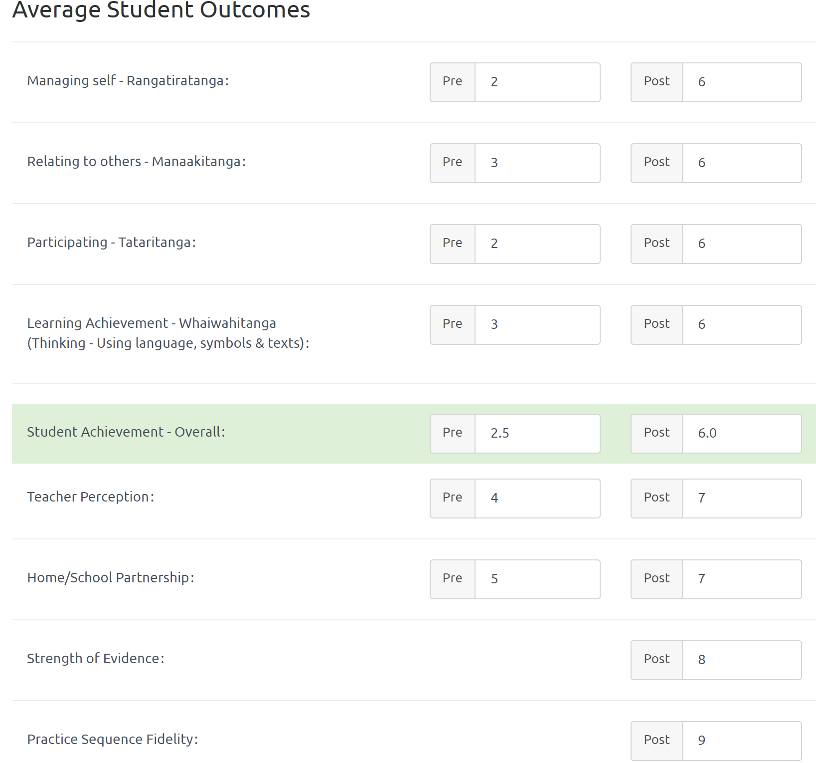

Learning Support Funding

Learning Support Fund (LSF) “supports interventions developed collaboratively with RTLB, targeting students in Years 0-10. It must be used equitably and can be used innovatively.” Learning Support Funding applications are within the context of current active referrals (individual, group, project etc.). A range of support and/or resources can be applied for dependent on the case/project needs, analysis, goals and plan (if these services/resources are not available from any other source). Learning Support Funding (LSF) for 2021 is $195,197 (GST excl). As of 31 May 2021, total LSF expenditure stands at approximately $ $75,654 allocated to support students, projects and to employ our specialists.
----------------------------------------------------------------------------------------------------------------------------------------------

Other Matters

Teachers’ Sabbatical Award Applications

