Royal Oak Primary School,
Chandler Ave
Royal Oak,
Auckland 1023
New Zealand
Mob: 021966199
Email: manager@rtlbcluster8.ac.nz

Ngā Manu Ᾱwhina RTLB Cluster 8 Manager’s Report (Term 3, 2021)

It is my pleasure to present the Ngā Manu Ᾱwhina report covering:

RTLB Staffing
Strategic Engagement with the National Education Learning Priorities
RTLB Team and Service during Changing Alert Levels
Cluster 8 Requests for Support and Outcomes
Learning Support Fund

RTLB Team and Staffing
Royal Oak Primary Office Base | Orakei Primary Office Base | Tamaki College Office Base
Angelee Morrow | Claire Murphy | Georgia Jensen-Procter
Emily Marurai | Michelle Grey Lamont .8 | (Kylah Drake) Ruth Milburn
Jill Watson | Sue Cameron .8 | Chris Bush
Owen Robyns | Claire Scopas .8 | Vaughan Spurdle
(Leslie Dresser-Tu’ugasala) Debbie Saxon | Lilly Reynecke | Jo Turner .6
Beverley D’Souza | Julie Nugent | Dianne Ley
Maree Stenberg | Sandiyao Sebestian | Michele Hucker
Titania McKenzie | Druinie Perera | Robert Rasmussen
Tracey Richardson | (David Blazey on study leave) | Michael White
Rebecca Robinson
Margaret Muir .8
Leadership
Barbara Hannant PL | Specialists
Chris Graham PL | Jean Parkinson (Counsellor).2 | Resource Assistant
Catherine Alpe PL | Kimberly Walker (Counsellor) .2 | Louis Gruebner
Anne Roborgh .2 (Partnership Leader)
Roseanne Gibson Manager

- We congratulate Lilly Reynecke on gaining a study award for 2022.
- Kylah Drake returns from parental leave in term 4.
- Margaret Muir is requesting discretionary sick leave.
- Rebecca Robinson has tended her resignation effective 15 October 2021. We acknowledge and thank Rebecca for her years of RTLB service.

Strategic Engagement with the Priorities

The Cluster 8 strategic goals align with the Statement of National Education and Learning (the NELP) and the Learning Support Delivery Model and Action Plan Priorities.

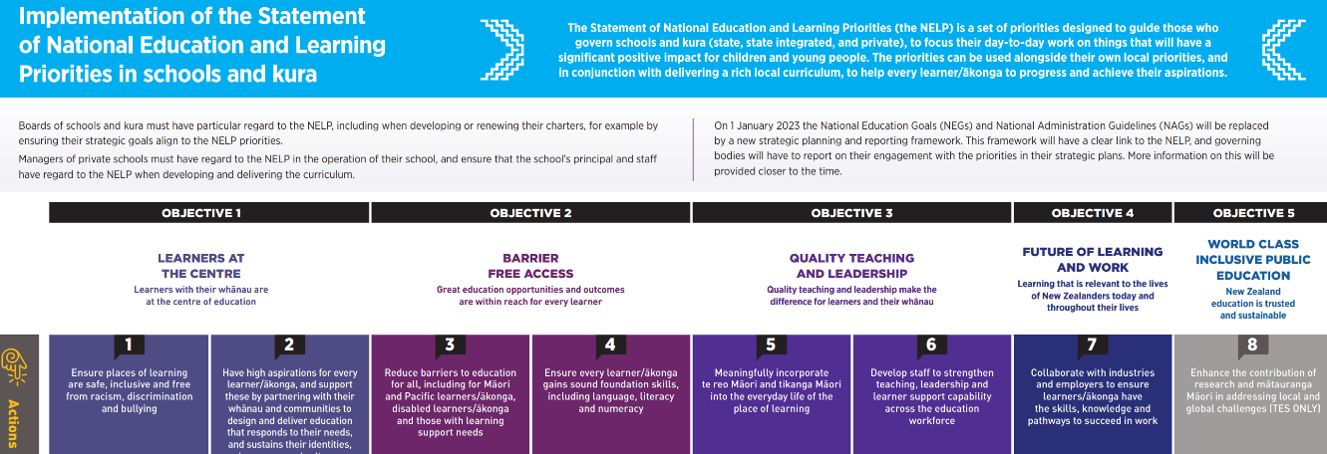

Objectives | Strategic Engagement with the Priorities
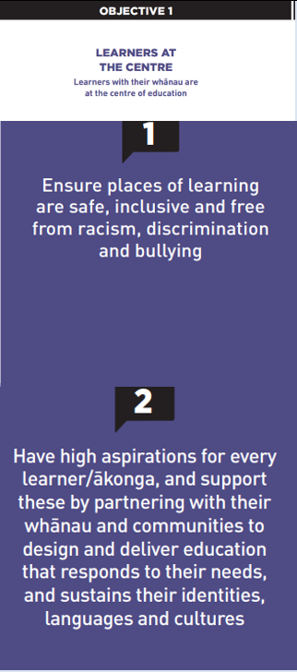 | The team, Partnership Leader and Practice Leaders continue to work collaboratively with MoE LS and Kāhui Ako to support the implementation of the LSDM, also attending and participating in relevant Kāhui Ako, SENCo and LSC meetings and multi-agency panels. RTLB leadership and the team have continued to engage with MoE, schools and Kāhui Ako to support Tiered Support in conjunction with the sLSR (Standardised Learning Support Register).  There is the continued implementation of He Pikorua (one practice framework) consistently across practitioners with database alignment and team PLD. Practice Leaders Chris Graham and Barbara Hannant continue to be involved at a national level in the ongoing development and implementation of He Pikorua to develop capacity across all Learning Support Practitioners in collaboration of a One Plan approach. Barbara presented at the Cluster Manager and Lead Principal National Forum in August on the new He Pikorua implementation indicators which are being trialled with MoELS/RTLB. RTLB Practice Leaders and MoE LS Service Managers have collaboratively planned PLD and collaborative inquiry for the cluster on He Pikorua, tiered support, one plan and trans and multidisciplinary support.  Kāhui Ako, schools and communities of interest within the cluster are increasingly requesting workshops on specific topics and themes identified through need and learning support register themes. Over term 3, Cluster 8 has provided a range of workshops facilitated and presented by Cluster 8 RTLB and open to educators across our cluster, including workshops on:  - The York Assessment of Reading for Comprehension.  - The Joy of Maths.  - Privacy Part 1 and 2.  - Escalation Profile workshops Part 1 and 2.  These workshops generated much interest with up to 50 attendees attending sessions.
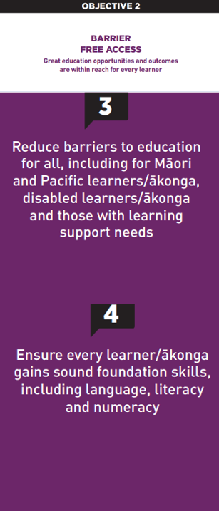 | There is ongoing regular review of the website, connect pages, Communities of Practice (CoPs), workshops, resources and other services to ensure they are responsive to the cluster’s needs and to changing alert levels. Lockdown resources and support links available through the homepage.  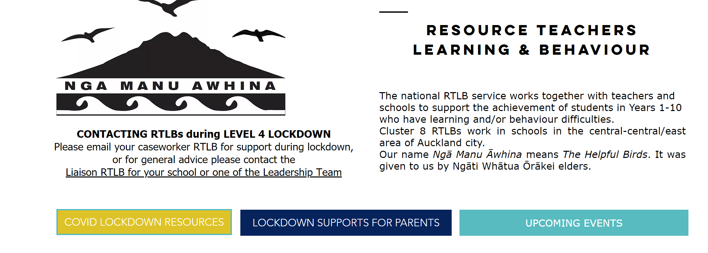  RTLB continue to develop and lead communities of practice (CoPs) further engaging educators across the cluster in: - Foundation Learning, Feuerstein, Play-based Learning, Secondary Educators, Dyslexia, Inclusive Practices, ASD, Behaviour, Neuroscience and SEL. CoPs and RTLB have supported interventions using Zones of Regulation, Reciprocal Reading, Escalation Profiles, Spring into Maths, Fast Forward and Maths Adapted Assessments. Professional development, support and/or resources have been provided around: ASD, dyscalculia, study skills, flipped classrooms, escalation profiles, transitions, play- based learning and literacy, comprehension strategies, ICS assessments and maths differentiation.
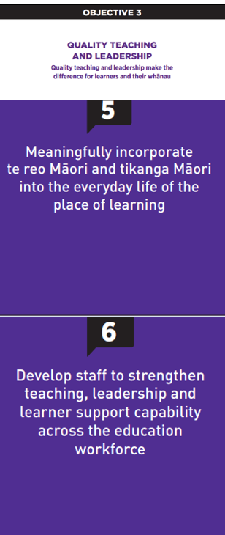 | The Revised Professional Growth Cycle process for the team is in place and appraisals running to schedule with peer supervision in process.  When alert levels allow there is a weekly face to face Te Ao Māori wānanga, for Cluster 8, facilitated by Practice Leader Chris Graham, for our team to share their pūkenga/strengths and skills with the focus on Te Ao Māori, covering: -  - Te reo- pronunciation, simple phrases, whakatauki, etc.  - Tikanga.  - Ahurea – culture.  Chris Graham has continued as the National RTLB Māori representative and a leader of Ngā Pouwhirinakitanga and a contributing member on the following national working groups: He Pikorua One Practice Framework, LSC Guidelines and is currently working with the national MoE team on the School Entry Assessment and in the Curriculum Progress Map- Social Emotional Development. Chris continues to provide support on the Massey University Learning and Behaviour panel supporting the Specialist Teaching Program.  In Class Support (ICS) Applications: - the RTLB role in 2021 has been to support our MoE colleagues with the assessment schedule for ICS applications. Owing to the timing of Covid restrictions and the stage that many schools had reached in their assessment programme, MoE has allowed alternative evidence to be used. This has meant huge demand for advice and guidance from RTLB to align the data schools have with the NZ Curriculum levels.
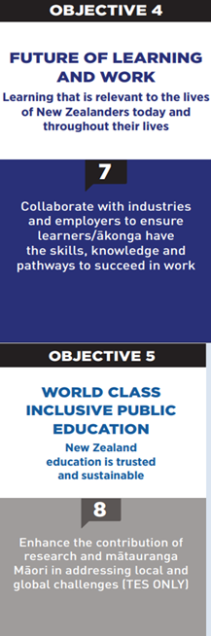 | There is ongoing development of a cluster culture of wellbeing and inclusivity valuing diverse ways of being and values in action.  The Secondary CoP (Community of Practice) led by RTLB Lilly Reynecke, hosted LSCs and SENCo to two Zoom Sessions on Privacy Awareness Training around the New Privacy Act that came into effect in December 2020: - Privacy is Precious. Protect it. Respect it. These sessions on privacy have been used as a pilot and a further rollout is currently being planned to all 40 RTLB clusters nationwide. Ministry of Education representatives, Privacy and Information Sharing Specialists, Clare Ruru and Sally Barry, presented on: -  - Changes to the Privacy Act 2020  - How these changes might impact on current work practices  - Collection, use and sharing of personal information relating to Learning Support and the Learning Support Register  A tiers of support pilot project, ‘Improving Brain Health in Schools’ with Sheryl Batchelor (Yiliyapinya Indigenous Corporation) is currently being implemented.  Roseanne Gibson in her role as a National RTLB Manager representative on the National RTLB Lead Principals’ Executive has met with Minister Tinetti as a member of the executive to discuss the potential of the RTLB service.

RTLB during Changing Alert Levels
In this latest lockdown, RTLB are drawing on their experience from and strategies employed during the 2020 COVID-19 lock down periods to help cluster schools to support students whilst remote learning is in place. Cluster 8 processes and protocols are revised regularly for the changing alert levels. Whilst Remote Procedures are in place, team and individual wellbeing is viewed as a priority with:
- Monday morning team meeting zoom.
- Daily HUB Zooms- brief and positive check ins.
- Social, support and connect opportunities offered and provided.
During changing Alert Levels, RTLB follow He Pikorua, the 6 elements of the LSDM whilst addressing MoE priorities and work to support the remote capacity and capability of the system to reach those who need it and our most vulnerable. RTLBs work to support requests from teachers and whānau including working remotely. RTLB provide flexible and adaptable support responsive to the current alert levels, context and needs. Specific strategies and interventions are tailored to individual need and vary according to that need and context. RTLB are very conscious of supporting schools, whānau, and mokopuna/akonga as they manage increased levels of anxiety. RTLB are already at work with schools to help identify those who will need additional support as they transition back to school when alert levels drop. RTLB work includes:
- identifying and addressing cluster themes that are priorities with subsequent access to support put in place for e.g., well-being and anxiety
- liaising with agencies re vulnerable students and families
- continuing to meet virtually to process new requests for RTLB support and funding applications.
- liaising with schools and clusters to identify and respond to needs including work with SENCOs and Learning Support Coordinators
- ensuring access to support as well as updated relevant resources are easily accessible, for example through the website and access to online programmes such as lexia
- contacting the teachers and whānau of students currently supported by the RTLB service to maintain service contact and establish what support is required
- linking with Ministry learning support teams and other agencies for integrated and collaborative ways of supporting families and teachers
- strategies and tasks typically include:
  - advice and guidance for teachers and families
  - adaptation of programmes and resources for remote learning
  - support for use of assistive technology and programmes for remote learning
  - reviewing and updating collaborative action plans
  - support for planning as alert levels change, particularly to support transition back to school
  - referral to and work with other agencies.
Several scheduled events and workshops requiring face-to-face have been postponed: -
- Termly Collaboration and Support Drop-In Mornings
- Incredible Years Workshops
- In Class Support (ICS) Moderation
- CAS2-Brief Assessment Workshops
- Strengthening the Learning Support Community Event.

2021 Request for Support (R4S) and Outcomes to 23.9.2021
Total R4S to 23.9.2021 = 591 R4S

310 Individual Students, 102 Projects, 92 Gateway, 6 Gps of Schools, 33 Gps of Students, 48 Individual Schools
Allocated Requests by Gender: Male 75% Female 25%

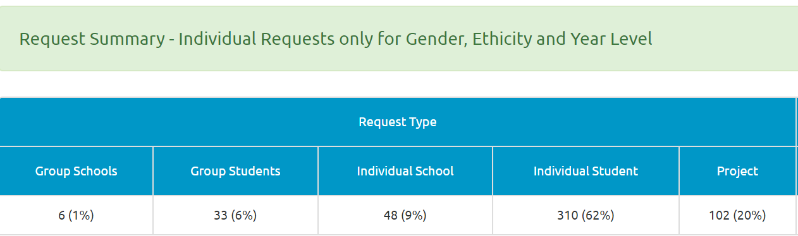
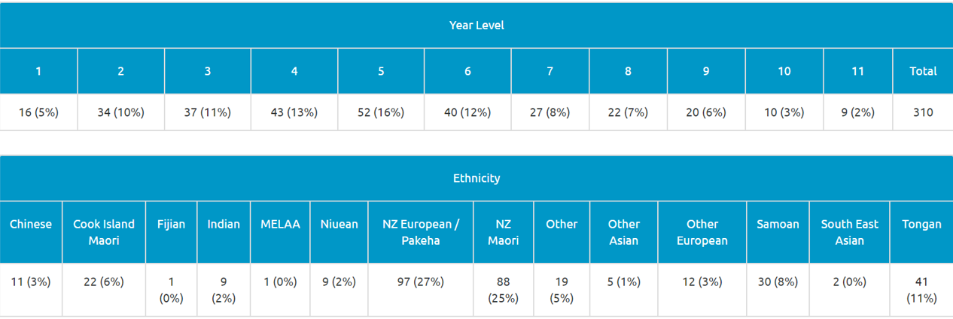

Average Student Outcomes 1.1.2021- 23.9.2021
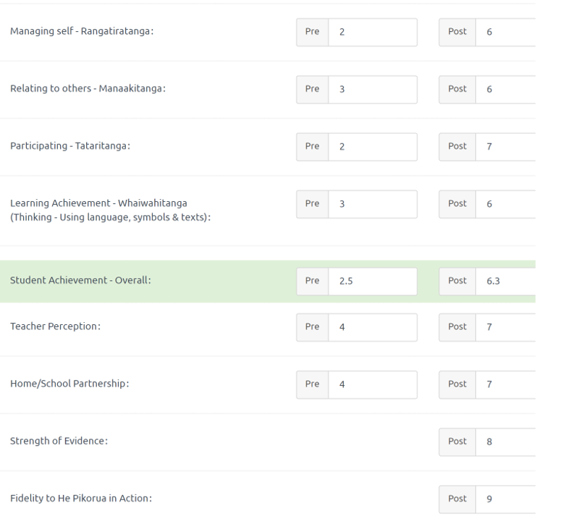

Learning Support Funding

Learning Support Fund (LSF) “supports interventions developed collaboratively with RTLB, targeting students in Years 0-10. It must be used equitably and can be used innovatively.” Learning Support Funding applications are within the context of current active referrals (individual, group, project etc.). A range of support and/or resources can be applied for dependent on the case/project needs, analysis, goals and plan (if these services/resources are not available from any other source). Learning Support Funding (LSF) for 2021 is $195,197 (GST excl). Total LSF expenditure to date stands at approximately $132,170 allocated to support students, projects and to employ our specialists.
----------------------------------------------------------------------------------------------------------------------------------------------

