Auckland Health and Ed Collaboration- facilitated by Alison Leversha
Returning to school safely- collated by Alison Leversha
 | Education staff | Parents/whānau/community | Children: Preschool/school/HS
Returning to School Safely  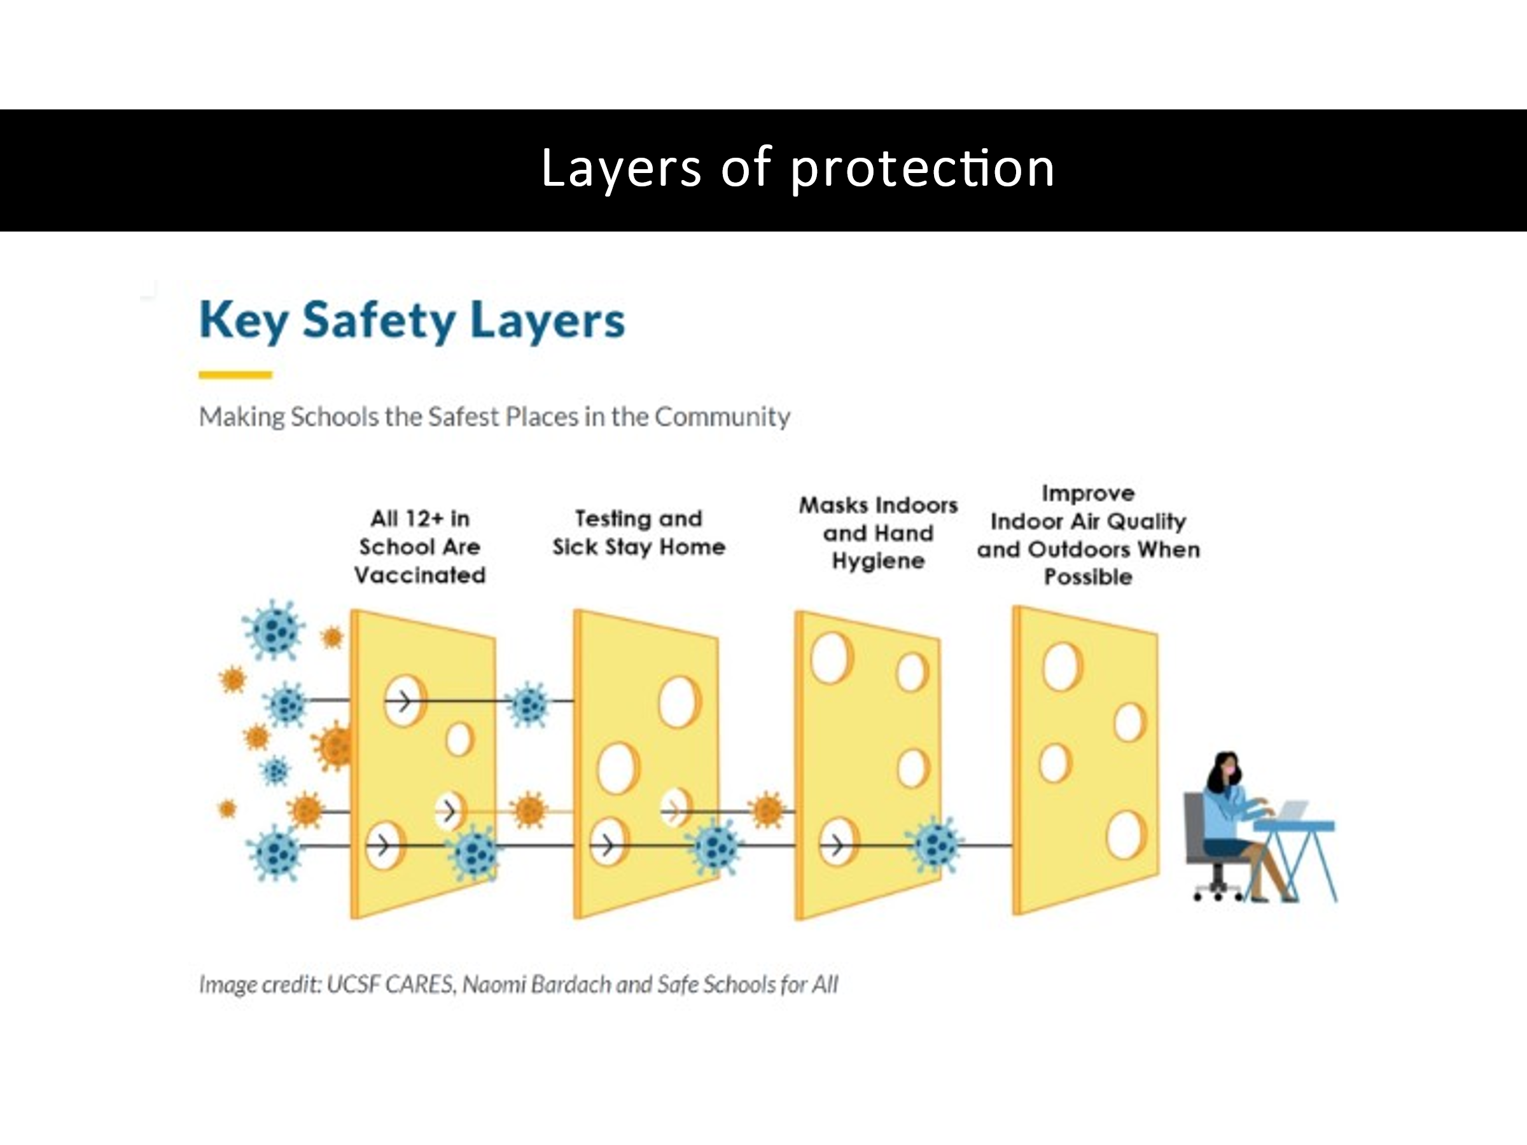 | Layers of protection  Siouxsie and Toby: Many different animations re COVID  Melbourne: Protecting children in ECEC and schools  Vaccination  Ventilation  Physical distancing  Masks  Staying home and test when unwell  Hygiene  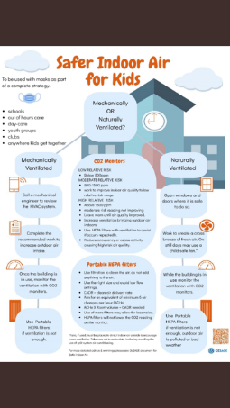  Jin and Pips presentation: https://vimeo.com/635192497/fc97589feb  Auckland paediatricians and public health specialists’ public health blog on school reopening Webb R, Russell J, Anderson P, Best E, Leversha A, Rajanaidu S. Urgent measures needed to allow the safe re-opening of Auckland schools. Public Health Expert. University of Otago. 11 October 21.  Jin Russell: How to protect our kids  Monitoring CO₂ indoors for improving ventilation in schools. Public Health expert  Reducing the risk of COVID transmission thru air purifiers. Public Health expert | Layers of protection (Siouxsie/Toby)  Unite against COVID 19: protecting yourself and others. avail in multiple languages  COVID info in Samoan: Coconut TV  COVID and Pacific children wellbeing: Moana and Pacific experts  Māori experts returning to school webinar TBD  Siouxsie and Toby: Why you should wear a mask  Samoan  Tongan  Te Reo  English  Jin Russell: How to protect our kids  Kidshealth: How to protect yourself and others against COVID  Kidshealth: coping with anxiety around COVID  Kidshealth: Anxiety  Raising children website: wearing masks children and teenagers  Raising children website: returning to school | Layers of protection  How to wear a mask  Siouxsie and Toby: Why you should wear a mask  Samoan  Tongan  Te Reo  English  How vaccines power up your body  Alternatives to handshakes  Wearing a mask for children with ASD  (Social story, video, English, Chinese, Russian, Spanish, Arabic, Burmese  Kidshealth: resources to help kids understand about COVID (including social stories)  KIdshealth: Return from Delta 2021 years 1-8 and years 9+  Nanogirl: COVID video clip (needs 2021 updating re masks)  MoH youth focused website re COVID  COVID Korero: Hahana: gen COVID advice tiktok  Royal Children’s Hospital Melbourne: Jaz talks re why everyone is wearing masks…video  Royal Children’s Hospital Melbourne: Jaz asks What is COVID 19 …video
Getting back to the routine | Te Rito Toi: Helps teachers work with children when they first return to school following major traumatic or life changing events  Mentally healthy schools: Managing the transition back to school  Sparklers: Activities and resources  MoE: Supporting student wellbeing when they return to school  Mentally healthy schools: Brain breaks. | Wellbeing Guide: Preparing for return to school  Sparklers: Activities and resources | Sparklers: Activities and resources
Emotional wellbeing | He Ara Hauora: Ka Anga Whakamua. MoE LS guide re pathways towards wellbeing recovering from COVID (2020)  Hikitea te hā: Breathing exercise in Te reo  Mentally healthy schools: Staff wellbeing  Mentally healthy schools: Supporting students’ mental health and wellbeing  Mentally healthy schools: Tools for managing emotions  Stronger Schools:  Login= Stronger  Password: TamakiM  Lots of pathways/guidelines re returning to school after COVID, wellbeing, behaviour and learning | Ngā Manu Āwhina: RTLB 8 wellbeing  Wellbeing guide: Wellbeing in uncertain times  Hikitea te hā: Breathing exercise in Te reo  Health Navigator: Looking after your child’s mental health | Health Navigator: mental health and wellbeing apps for kids/rangatahi  Including looking after your wellbeing  Sparklers: Activities and resources  Aroha: Chatbot to help re manage stress (13 yrs +)  Hikitea te hā: Breathing exercise in Te reo  Attitude: anxiety and COVID  Aroha’s Way: children’s guide to anxiety. Series of books. Link is to video clip  Whitu – seven ways in seven days is a NZ app available on the app stores. Co-designed for use during and after the pandemic, it has seven modules that teach young people (okay for intermediate and high school ages) well-being skills that they can use for life. Both google and android
Learning  Incl how learning will occur for children who don’t return. How will that be managed and return to school supported? |  | Wellbeing guide: school closures and learning from home
Behaviour | PB4L: Proactively preventing challenging behaviour  Mentally healthy schools: Reframing negative thoughts  Kidshealth: Anxiety  Stronger Schools:  Login= Stronger  Password: TamakiM  Lots of pathways/guidelines re returning to school after COVID, wellbeing, behaviour and learning | Reassuring children and young people about COVID  Child in Mind: What do we know about child anxiety  Mentally healthy schools: Reframing negative thoughts  Kidshealth: coping with anxiety around COVID
What happens if there is a COVID case in the school | Jin and Pips presentation: https://vimeo.com/635192497/fc97589feb  (will need updating given contact definition has changed)
Codes:
Red means a gap and needs developing
Education staff incl SWIS, RTLB, school staff etc
For some sites have only included one form e.g. anxiety to enable easy comparison re the same issue
Mentally strong schools: UK site
Stronger schools: Developed in chch post-earthquake and mosque shooting. Specifically, developed for schools with info and referral pathways. Same platform as health pathways. Used by Mana Ake. Free access to Auckland schools for this post COVID time
Healthpathways: Info and referral pathways for health profs. Schools don’t have access. Counsellors may be getting access
Kidshealth: Resources for parents and children re many health and wellbeing topics. Run by Katherine Lissienko and funded by NZ Paediatric Society and Starship Foundation.
Sparklers: Dev in chch post-earthquake. Resources for activities for parents and teachers
Ngā Manu Āwhina: RTLB 8 wellbeing site
Raising children network: Australian site with lots of useful info for parents and children
Royal Children’s Hospital Melbourne:

