Royal Oak Primary School,
Chandler Ave
Royal Oak,
Auckland 1023
New Zealand
Ph: 09 624 2800
Mob: 021966199
Email: manager@rtlbcluster8.ac.nz

CLUSTER 8
Resource Teachers of Learning & Behaviour

Cluster 8 Manager’s Report (Term 1, 2021)

It is my pleasure to present the Ngā Manu Ᾱwhina report covering:

- RTLB Staffing
- Cluster 8 Ngā Manu Ᾱwhina Strategic Plan
- Cluster 8 Requests for Support and Outcomes
- Learning Support Fund

RTLB Team and Staffing
Royal Oak Primary Office Base | Orakei Primary Office Base | Tamaki College Office Base
Angelee Morrow | Claire Murphy | Georgia Jensen-Procter
Catherine Skudder | Michelle Grey Lamont .6 | Kylah Drake
Jill Watson | Sue Cameron | Chris Bush
Owen Robyns | Beverley D’Souza | Vaughan Spurdle
Leslie Dresser-Tu’ugasala | Lilly Reynecke | Jo Turner .6
Margaret Muir .6 | Julie Nugent | Dianne Ley
Maree Stenberg | Sandiyao Sebestian | Michele Hucker
Titania McKenzie | Druinie Perera | Robert Rasmussen
Tracey Richardson | (David Blazey on study leave) | Michael White
Rebecca Robinson
Emily Marurai
Based at Royal Oak Primary | Specialists
Barbara Hannant PL
Anne Roborgh PL | Ann Keesing (SLT).4 | Resource Assistant
Catherine Alpe PL | Miriam Kauders (RTLB/Ed Psych) .4 | Louis Gruebner
Roseanne Gibson Manager | Jean Parkinson (Counsellor).2
Anne Roborgh .2(Partnership Leader) | Kimberly Walker (Counsellor) .2

Cluster 8 is made up of Lead School Principal Megan Clotworthy, 1 Manager, 3 Practice Leaders, 1 Partnership Leader, 28 RTLB, 4 Specialists and a resource assistant. The RTLB are grouped into 3 office bases, Orakei, Tamaki, Royal Oak. The RTLB in each office base are responsible for providing service to designated schools and Kāhui Ako however depending on workload, RTLB with specific required expertise are able to work across the cluster. Project and case work are ‘needs driven’ and based on requests for support (R4S) received, presented and discussed at a learning support facilitation meeting and office-based review and intake meetings.
Staffing changes: -
- Ann K .4 SLT Specialist: resignation effective from week 9, term 1.
- David Blazey: study award leave 1 March to 22 November 2021.
- Kylah Drake: parental leave 29 March 2021 to 18 October 2021.
The following RTLB have study awards and are undertaking study towards attaining a Post Graduate Diploma in Specialist Teaching (Learning and Behaviour). This study is completed whilst working as an RTLB over 2 years with study days allocated.

- Michele Hucker
- Emily Marurai
- Julie Nugent
- Tracey Richardson
- Vaughan Spurdle
- Jill Watson (Yr. 2)

Cluster Wide Project Initiatives and Project Leads

The Cluster 8 website provides information and showcases what the cluster and RTLB can offer in tiered individual and systemic support, and professional development to our cluster also providing access to a range of resources. A key contact person for specific support (for e.g., ASD, dyslexia etc) is listed and there is the opportunity for MoE, RTLB and our cluster’s teachers to engage in a community of practice in areas of expertise and interest. Project leads and ‘Go To’ people can be located and are accessible for additional support on the connect tab.
RTLB with Additional Responsibilities

- Mentors: Sue Cameron; Maree Stenberg; Lilly Reynecke; Dianne Ley; Angelee Morrow; Michele Hucker.
- Cultural Support: Michael White; Chris Graham; David Blazey; Tracey Richardson; Angelee Morrow; Robert Rasmussen.
- Psychological Practice, Supervision and Assessment: Barbara Hannant. Assessment co-lead: Margaret Muir
- I.T. Leadership and Support Team: Angelee Morrow; Margaret Muir; Vaughan Spurdle; Claire Murphy; Barbara Hannant
- SchoolGate Database: Angelee Morrow; Catherine Alpe; Chris Graham; Barbara Hannant
- Website: Catherine Alpe; Angelee Morrow
- Organisation Manual Editor: Claire Murphy
- General Library and Resources: Catherine Alpe
- NZEI Rep: Claire Murphy
- Gateway: Chris Bush
- LSDM Partnership Leader (P/T): Anne Roborgh.

Cluster 8 Ngā Manu Ᾱwhina Strategic Plan 2021-2025

In this new strategic cycle, the strategic goals have been designed to align with the Statement of National Education and Learning (the NELP) and the Learning Support Delivery Model and Action Plan Priorities.

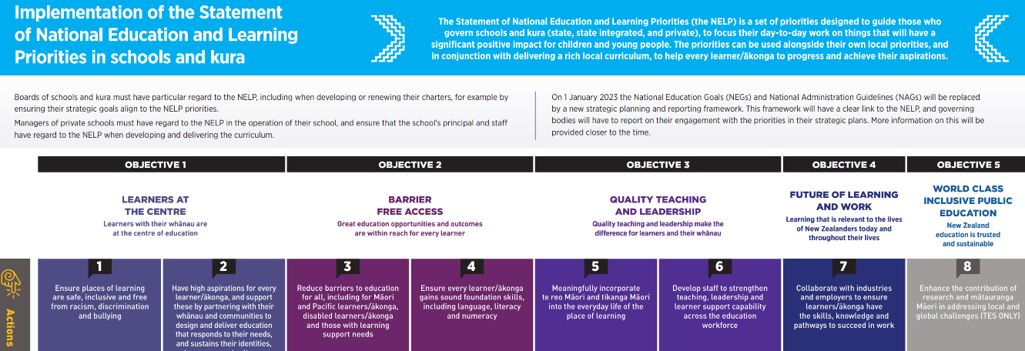

The Learning Support Action Plan includes six priorities for the period 2019 – 2025 and RTLB will work to support the implementation of these priorities:-

  - Implementation of a new Learning Support Coordinator role in schools and kura
  - Strengthening screening and the early identification of additional learning needs
  - Strengthening early intervention
  - Flexible supports and services for neurodiverse children and young people
  - Meeting the learning needs of gifted children and young people
  - Improving education for children and young people at risk of disengaging.

The Ministry is strengthening the way that learning support is provided through the Learning Support Delivery Model (LSDM). The LSDM organises learning support around what best meets the needs of all children and young people with learning support needs across a local community, bringing together groups of education providers in a community – early learning services, schools and kura – with other government agencies and service providers, to identify local needs and resources, and plan support based on the evidence – what we know works, to best support children and young people to learn. The Learning Support Delivery Model cites six elements:-

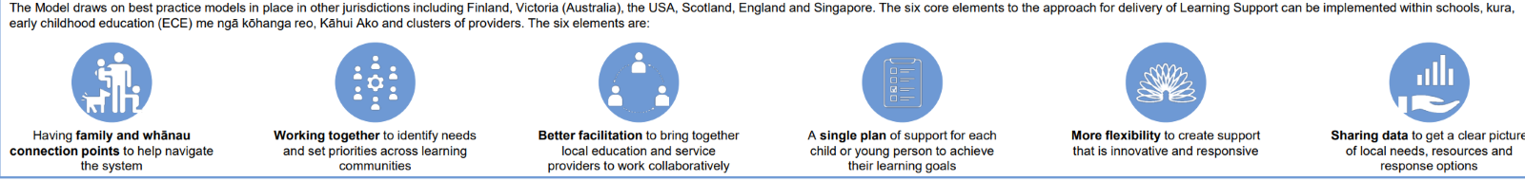
How RTLB Work

The Ministry of Education (the Ministry) and other education services, agencies and organisations including the Resource Teachers: Learning and Behaviour (RTLB) service work alongside schools and kura to provide learning support when it is needed. Services to support inclusive practices and to support the achievement of Māori and Pacific students in schools and kura are prioritised ensuring the Government’s priorities and the Ministry’s annual service priorities and service expectations are embedded in the work of the service.

The current RTLB Toolkit is the guiding document to support all RTLB clusters to deliver a high-quality service that meets the needs of all students and schools in their cluster. All RTLB clusters are expected to provide a service based on the model of professional practice outlined in the toolkit. He Urunga Tū - An Entrance to Engagement is a framework that enables RTLB to be effective, inclusive, culturally responsive and safe in their practice. It guides and supports RTLB to facilitate the process in a manner that is respectful, professional and maintains positive working relationships. He Pikorua is the one practice framework for RTLB and Ministry learning support practitioners.

RTLB provide universal, targeted and individualised support for:
• Individual students
• Groups of students
• Individual schools
• Groups of schools which could include those in Kāhui Ako

RTLB take an approach that includes and focusses on:-
- Ecological approach
- Building and growing cultural competence
- Voice, choice and agency
- Flexible, tailored model of support
- Collaborative Teaming
- Outcomes focused
Guiding Principles: -
- Mokopuna & whānau-centred
- Collaborative
- Strengths-based
- Culturally affirming
- Inclusive
- Ecological
- Evidence informed

The below details the NELP objectives of the new Strategic Cycle in conjunction with the MoE Funding Agreement success criteria.

Objectives | MoE RTLB FA Success Criteria
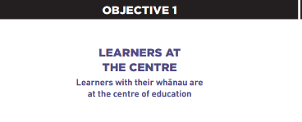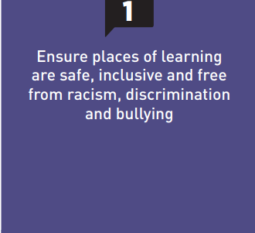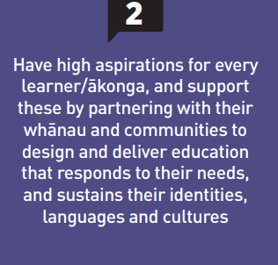 | The service works collaboratively with the Ministry and other education providers to:-  -identify local needs, including those identified through learning support registers, and think collectively about how to best use available resources to build on existing good practice and provide innovative solutions in ways that work for families and whānau and their children and young people  -plan the best way to use their resources to effectively respond to the needs of children and young people whilst strengthening the confidence and capability of adults  -take a tiered approach to support the learning needs of all children and young people including providing universal system-wide support, targeted or individualised support as needed.  Cluster schools and kura including those working in groups and Kāhui Ako:  -know how, why and when to access learning support  -have equitable access to the full range of RTLB services and funding  -use the service and value the service provided.  The service is based on a comprehensive needs analysis, is strategic and planned. The service is well-documented; service outcomes are monitored, recorded and reported.  RTLB work collaboratively with the Ministry to plan and deliver programmes to meet local needs. RTLB provide high quality and effective learning and behaviour services for schools, kura, groups of schools working collaboratively on learning support and Kāhui Ako within a cluster.  RTLB follow He Pikorua as one practice framework.  RTLB support teachers, schools, kura, groups of schools and Kāhui Ako to develop inclusive classroom environments that enhance students’ presence, participation, wellbeing, progress and achievement.  RTLB and the Ministry work together to share data through the LSDM, and accept collective responsibility for supporting the learning needs of all children and young people including those identified on learning support registers.  RTLB support the achievement of children and young people in Years 1-10. This includes actively supporting the transition of students into and out of these year levels to meet their needs.  The RTLB service work collaboratively with groups of schools and Kāhui Ako within the cluster, to identify and support those children and young people who have learning support needs.  RTLB work collaboratively with the Ministry and other providers to support schools and kura and groups of schools and Kāhui Ako to identify and address issues that would be best addressed through a systems or training approach.  Where requested, RTLB will support Kāhui Ako to identify their achievement challenges.
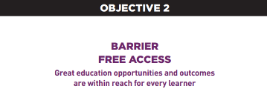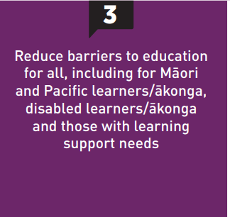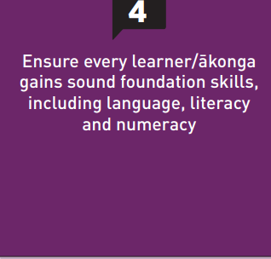 | RTLB provide high quality and effective learning and behaviour services for schools, kura, groups of schools working collaboratively on learning support and Kāhui Ako within a cluster.  RTLB support teachers, schools, kura, groups of schools and Kāhui Ako to develop inclusive classroom environments that enhance students’ presence, participation, wellbeing, progress and achievement.  Support teachers to be confident to manage the needs of students with learning support needs.  The cluster looks for opportunities to be innovative in its support provision to schools and kura.  Māori student achievement data is collected, analysed and used to inform planning and practice.  The RTLB team makes progress against Ka Hikitia Framework.  Pacific student achievement data is collected, analysed and used to inform planning and practice.  The RTLB team uses Action Plan for Pacific Education 2020–2030 to set goals to accelerate literacy and numeracy achievement for Pasifika students.  Service Expectations will include:-  - Transition support for students  - Learning Support Communities  - Secondary school/ and wharekura student achievement  - Special Assessment Conditions (SAC)  - PB4L Incredible Years Teacher programmes  - PB4L School Wide  - Intensive Wraparound Service (IWS)  - Residential Special Schools (RSS) Only Access pathway  - Children and young people who are in the care of Oranga Tamariki  - Children’s Teams  - Bilingual Assessments
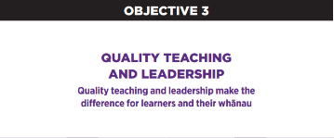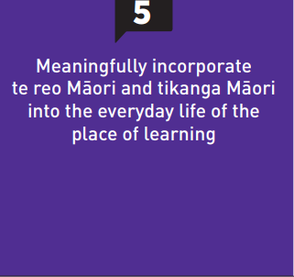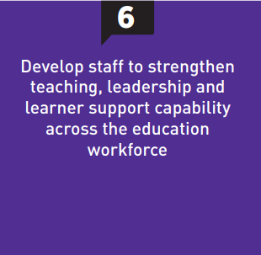 | RTLB and Ministry learning support practitioners work collaboratively with schools and kura to provide flexible, joined-up support where it is appropriate.  Schools and kura, including those working collaboratively in groups and Kāhui Ako, value the relationship they have with the RTLB service.  RTLB work closely with Learning Support Coordinators where they are in place to provide system wide, targeted or individual support to schools, their children and young people and their families and whānau.  The service is continually improving, responsive, flexible and innovative.
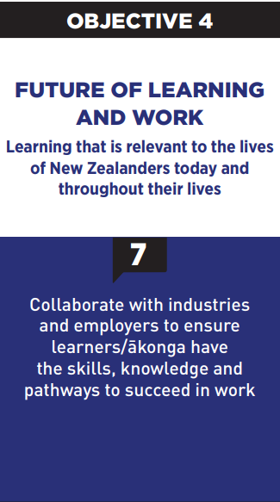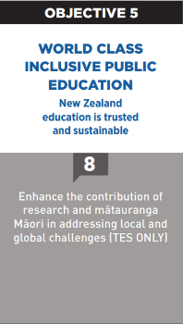 | RTLB use the practice framework to actively lead, promote and support inclusive practices in all their work with cluster schools and kura and community networks.  RTLB work to support schools and kura to partner with families and whānau to plan support for their children and young people in ways that work for them, values their contribution, and reflects their unique identity, language and culture.

Selected Current Initiatives (NELP Objective 2 Action 3)
Gateway
The Gateway Programme provides an ecological assessment profile for Children and Young People who are involved with Oranga Tamariki services for care and protection reasons and who are either in care, entering care or the family is going to be having a Family Group Conference (FGC). This assessment looks at health, mental health, education, dental, trauma, clinical therapy, functional family therapy and parenting capacity and recommends a pathway forward. Resource Teachers of Learning and Behaviour (RTLB) are responsible for supporting schools to complete education profiles for Children and Young People who have received a Gateway referral and to be part of the recommendations outlined at the multi-disciplinary meetings held fortnightly. Chris Bush the Gateway project leader provides a report on the work Resource Teachers of Learning and Behaviour Cluster 8 Gateway Leaders, schools and RTLB undertook in 2020 as part of the Gateway project.
79 Gateway Educational Profiles were completed for the 2020 period comprising of:
o 2 Identified Entry to Care profiles (12 in 2019)
o 6 Already in care (10 in 2019)
o 71 Family Group Conference (50 in 2019)

2021 Request for Support (R4S) and Outcomes to 19.3.2021
Total R4S to 19.3.2021: 203 individual Students, 79 Projects, 50 Gateway, 3 Gps of Schools, 19 Gps of Students, 31 Individual Schools = 385 R4S
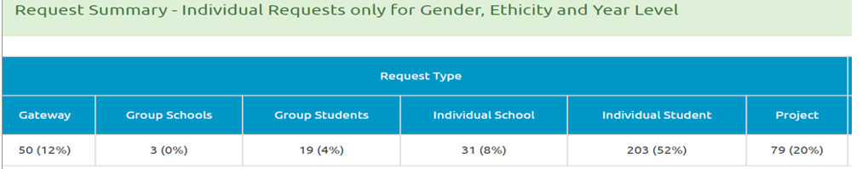
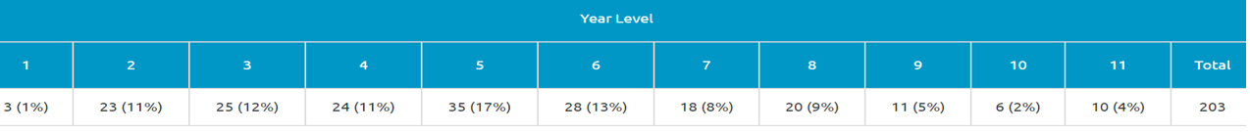
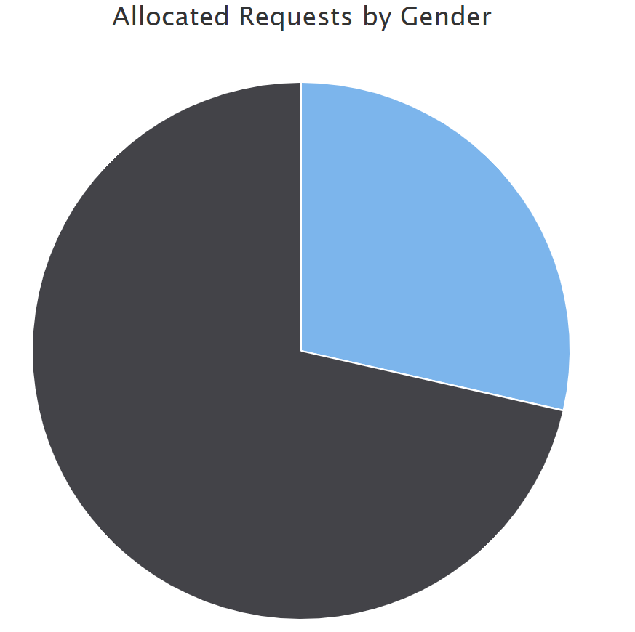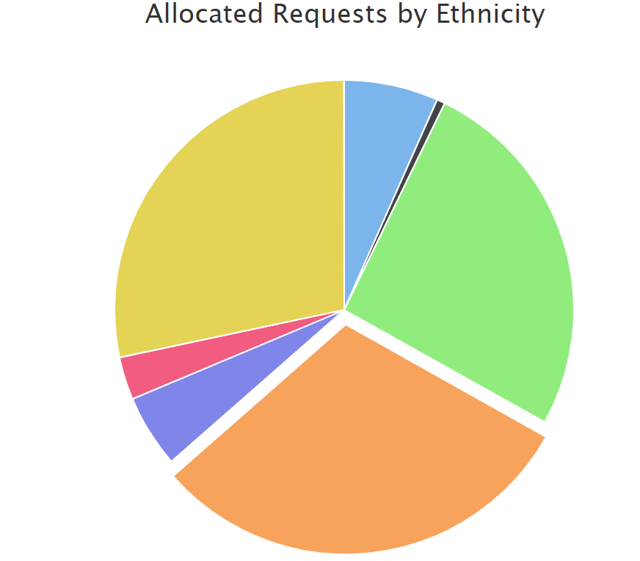
Male 71% Female 29% Maori 30.42%. Pasifika 28.31%. NZE 25.9%. Asian 6.63%. Other European, Other 5.12%. MELAA .60%.

Average Student Outcomes 1.1.2021-19.03.2021

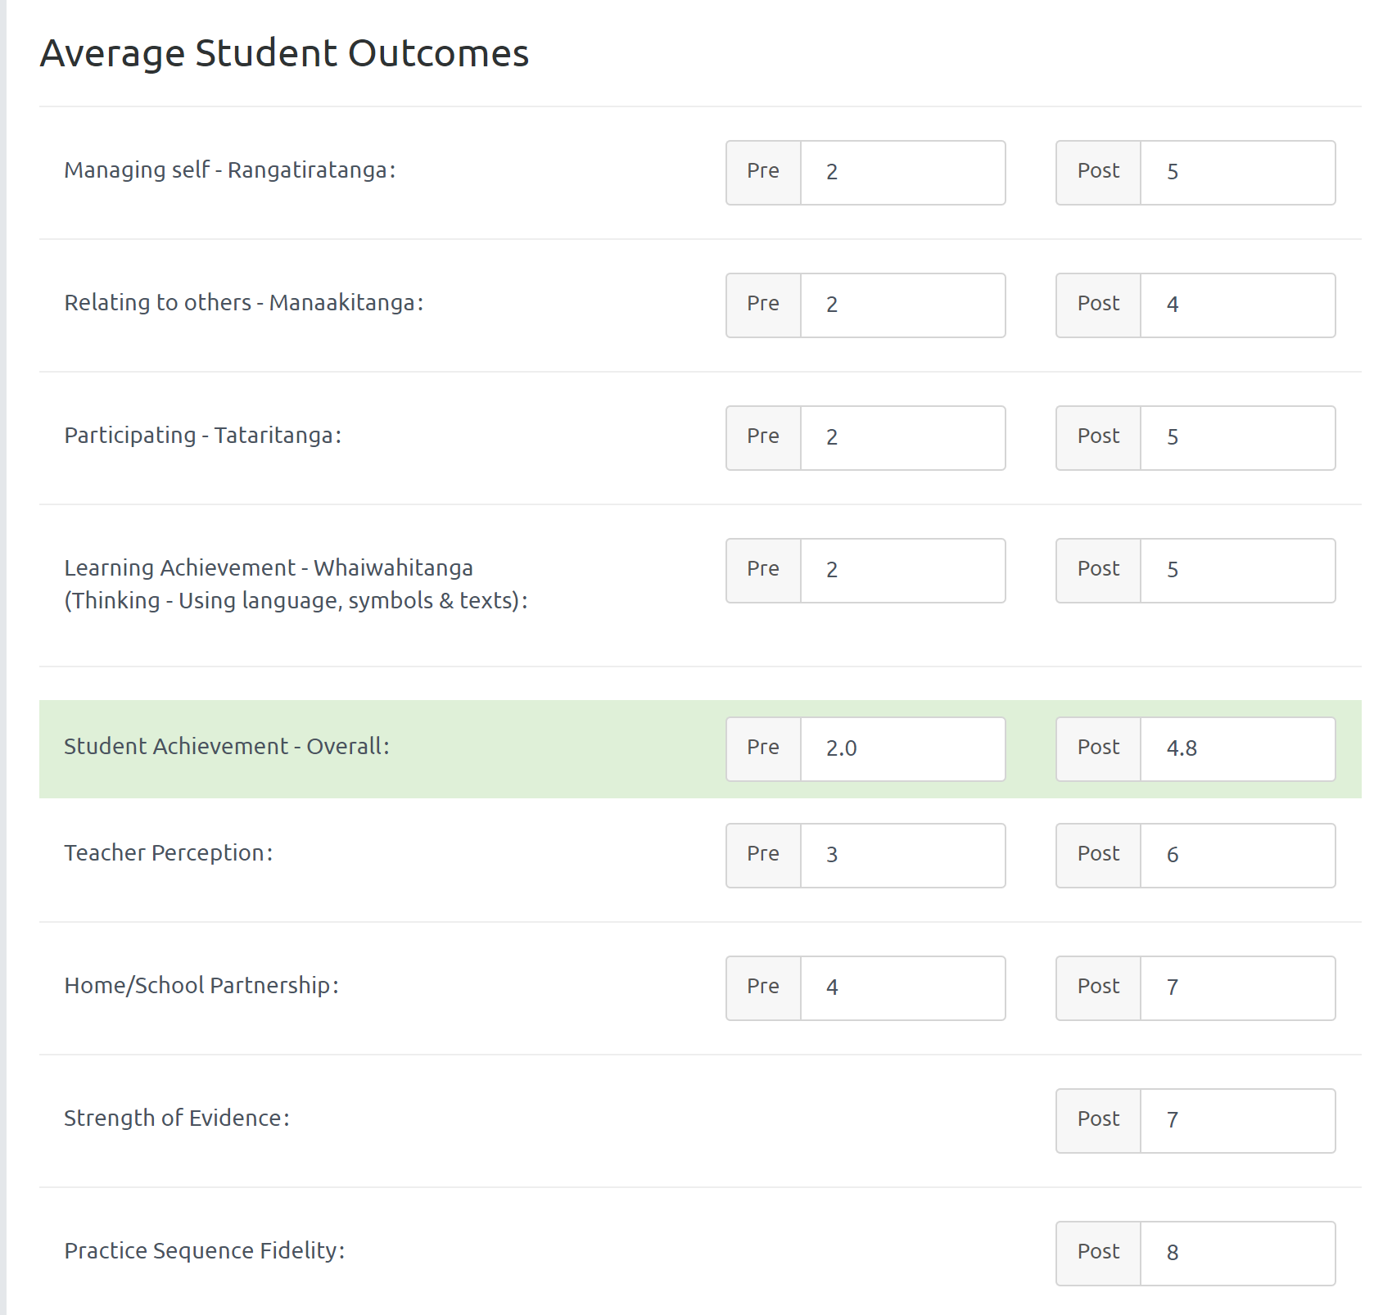

Learning Support Funding

Learning Support Fund (LSF) “supports interventions developed collaboratively with RTLB, targeting students in Years 0-10. It must be used equitably and can be used innovatively.” Learning Support Funding applications are within the context of current active referrals (individual, group, project etc.) and the practice sequence. A range of support and/or resources can be applied for dependent on the case/project needs, analysis, goals and plan (if these services/resources are not available from any other source). Learning Support Funding (LSF) for 2021 is $195,197 (GST excl). As of 28 February 2021, total LSF expenditure YTD stands at approximately $15,529 allocated to support students, projects and to employ our specialists.
----------------------------------------------------------------------------------------------------------------------------------------------

