Royal Oak Primary School,
Chandler Ave
Royal Oak,
Auckland 1023
New Zealand
Ph: 09 624 2800 Extn 817
Mob: 021966199
Email: manager@rtlbcluster8.ac.nz

CLUSTER 8
Resource Teachers of Learning & Behaviour

Cluster 8 Manager’s Report (Term 3, 2020)

It is my pleasure to present the Ngā Manu Ᾱwhina report covering:

- RTLB Staffing
- Cluster Community of Practice
- Cluster Initiatives
- Cluster 8 RTLB Service in Changing Alert Levels
- Learning Support Delivery
- Cluster 8 Requests for Support and Outcomes
- Learning Support Fund
- Other Matters

RTLB Team and Staffing

Royal Oak Primary Office Base | Orakei Primary Office Base | Tamaki College Office Base
Michael White | Claire Murphy | Georgia Jensen-Procter
Angelee Morrow | Michelle Grey Lamont .6 | Julie Nugent
Jill Watson | Sue Cameron | Chris Bush
Jan Whitham .6 | Pat Clemo .6 | Kimberly White
Kathy Reed .8 | Lil Reynecke | Jo Turner .6
Margaret Muir .6 | Christine Holland | Dianne Ley
Maree Stenberg | Sandiyao Sebestian | Michele Hucker
Titania McKenzie (study leave) | David Blazey | Robert Rasmussen
Tracey Richardson | Druinie Perera | Vaughan Spurdle
Rebecca Robinson (sabbatical leave)
Ruth Milburn .8 ( fixed reliever T3)
Catherine Skudder
Based at Royal Oak Primary | Specialists
Barbara Hannant PL | Ann Keesing (SLT).4
Anne Roborgh PL | Miriam Kauders (RTLB/Ed Psych) .4 | Resource Assistant
Catherine Alpe PL | Jean Parkinson (Counsellor).2 | Louis Gruebner
Roseanne Gibson Manager | Kim Walker ( Art Therapist/Counsellor).2

1 Manager, 3 Practice Leaders (PLs), 30 RTLB and 5 Specialists.
Cluster 8 is made up of Lead School Principal Megan Clotworthy, 1 Manager, 3 FTE Practice Leaders, 27 FTE RTLB positions (currently 30 RTLB with 2 RTLB on leave), 4 Specialists and a resource assistant. The RTLB are grouped into 3 office bases, Orakei, Tamaki, Royal Oak.
Staffing changes:-
- Delia Howard (Fourie) has resigned to pursue counselling opportunities in Australia.
- From fixed term positions Druinie Perera and Vaughan Spurdle were successful in gaining the advertised permanent positions.
- Christine Holland is on ACC leave after having an accident.
- Catherine Skudder has joined our team initially in a fixed term position relieving for Christine and begins a permanent position in term 4.
- Titania McKenzie: study award leave 24.2.20 to 15.11.20.
- Rebecca Robinson is on sabbatical leave in term 3.
- Anne Roborgh has retired effective 20.9.2020.

Cluster Community of Practice

Learning and Networking Workshops

The focus of the SENCo Meetings in 2020 has changed to include new LSC colleagues, Kāhui Ako across and in school teachers, other specialist and school staff and RTLBs. This is a series of learning and networking workshop days: -
  - Term 1: Incredible Years
  - Term 2: Wellbeing Focus (28 & 29 May)
  - Term 3: Behaviour Focus (13 & 14 August)
  - Term 4: Learning Focus (5 and 6 November)
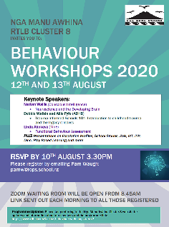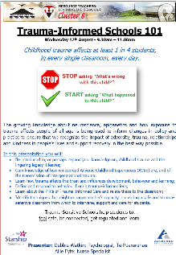
In term 3, the focus has been the organisation and delivery of the Ngā Manu Āwhina RTLB Cluster 8 on-line Behaviour event workshops and tips to assist schools. The Behaviour Day was scheduled over 2 mornings to support e-wellbeing and avoid zoom and screen fatigue. The event went ahead despite learning the night before that another lockdown was put in place on the very morning of the workshop. This impacted the numbers able to attend the first morning as schools had urgent Covid related actions to put in place however over 70 educators across our cluster attended. The keynote speakers Debbie Watkin and Allie Fyfe followed up the next day by Nathan Wallis were well received and the feedback very positive.
Nathan Wallis, a Neuroscience Educator was able to make the ever-growing body of neuroscience research accessible for us all. Nathan is an advisor for the NZ Ministry of Education, and an expert advisor for NZ Ministry of Vulnerable Children. Allie and Debbie are part of the Gateway team at Te Puararahua. Te Puaruruhau is the Child Protection service for Starship Children’s Health and is based in Puawaitahi, a multi-agency service with Police and Oranga Tamariki. Debbie has presented internationally on the theme of Trauma Informed Schools. Their presentation offered suggestions as to how we can support young people who have suffered Trauma in our schools and covered:
- Knowledge and understanding of Adverse Childhood Experiences(ACES), childhood trauma, the lingering effects , and of the transmission of intergenerational trauma.
- How trauma affects the brain and influences development, behaviour and learning.
- The 7 R's of Trauma-Informed Care and relate these to the classroom.
- Identified techniques that might enhance teachers’ capacity in creating a safe and trauma-sensitive classroom from which to intervene, support and care for students.

​
RTLB Jo Turner is the Ngā Manu Āwhina RTLB Cluster 8 Go-To-Person for Behaviour supporting colleagues and schools. Jo brings expertise in behaviour support, neuroscience and how to understand and teach the skills and strategies of self-management, executive function, emotional intelligence and interpersonal skills. Jo presented at the event on Escalation Profiles and on Bridging the Barbed Wire of Challenging Behaviour, also stepping in to present on Functional Behaviour Assessment when the PB4L MoE speaker was unwell.

At the event there were also stories and presentations from educators about their learning journeys in tiered and positive behaviour support and approaches. Additionally, there was a poster and resource e-trello noticeboard and sessions to showcase the behaviour work and programmes of Cluster 8 schools and RTLBs. ​

Wellbeing in Education Conference (WENZ)

As part of our wellbeing strategic focus and in relation to COVID wellbeing support, the RTLB team attended the two day live streamed Wellbeing in Education NZ ( WENZ) Conference. Speakers and sessions covered:
- The Purpose, Power and Promise of Culturally Responsive Practice: taking a strengths-based approach to fostering Māori success (Dr Melinda Webber)
- Relationships at the heart of changing behaviour in schools (Dr Sue Roffey)
- Why coaching should be part of your school's wellbeing strategy for students and staff (Professor Christian van Nieuwerburgh)
- Change your Brain - Change your Life! (Nathan Wallis)
- Using the Mental Health and Hauora curriculum resources in your school (Katie Fitzpatrick)
- Building Wellbeing Protects Against Burnout - An interactive session to build educator and student wellbeing (Lucy Hone and Denise Quinlan)
- Cultivating hope in the Age of Global Threats (Dr Emma Woodward)
Feuerstein Instrumental Enrichment (FIE)
Assoc Prof Mandia Mentis presented an online professional development session to the RTLB Team on FIE and mediated learning. The session provided a guide on understanding and the implementation of Professor Reuven Feuerstein's theory of mediated learning emphasising that intelligence is modifiable, and that people can change with the right kind of intervention. Mandia is one of the co-authors of two books on mediated learning using FIE: Mediated Learning and Bridging Learning.
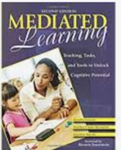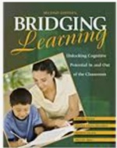

Selected Current Initiatives
Scheduled cluster professional learning opportunities, communities of practice, systemic behaviour, projects and meetings have continued using a combination of face to face, online technology and/or live streaming depending on alert levels.

Cluster 8 RTLB Pop-up Workshops Term 3

Fourteen on-line RTLB pop up workshops have been offered this term with registrations coming from 86 educators with many attending multiple sessions, including: SENCos, Learning Support Coordinators, Teachers and Teacher aides from thirty primary, intermediate and secondary schools across our cluster.
The topics covered a wide range, from effective strategies for building social skills through Circle of Friends, Social Stories and Comic Strip conversations, to whole class strategies for Circle Time and more about working with students with ASD. Other topics included teaching strategies for using graphic organisers at secondary school, implementing the Feuerstein Instrumental Enrichment approach, play-based learning and in a collaboration with MoE Assistive Technology Advisor, making applications for equipment to support students with auditory processing difficulties. Some of these workshops were repeated during the term by popular request such as those by our GoTo ASD RTLB, Margaret Muir.
Incredible Years Teacher IYT
As programmes that benefit from face to face interaction and support, changes in COVID alert levels have disrupted the delivery of one previous and two new IY programmes. It is hoped to complete the term one programme in term four. The term 3 IY programmes have now been postponed until 2021 as we are unable to deliver them in the timeframe at Level 3 and Level 2.5. It has however been an opportune time to focus on succession training and four more RTLB have trained in the IY teaching programme and two more RTLB will train in Wellington at the end of the term. The newly trained RTLB are looking forward to delivering in 2021.
Cluster 8 RTLB Service in Changing Alert Levels

Our RTLB service has continued to use a multi-tiered system of support (MTSS) incorporating tiered support (RTI) as a framework to provide service and support during all alert levels. He Pikorua has also been used as a template to support decision making and guide conversations in response to Alert Levels.
Ngā Manu Āwhina RTLB have remained connected, flexible, innovative and responsive to ensure the best service is provided to our learning communities during changing alert levels. Whilst continuing and adapting practice to provide the best support and casework in Alert Level 3, Ngā Manu Āwhina as a team had regular online daily check ins, meetings, communities of practice, supervision, team building activities and sharing of resources and links. Scheduled professional learning opportunities and meetings continued using online technology and/or live streaming. The Cluster 8 website is regularly updated with information and resources for our cluster community applicable to changing alert levels and requirements. A range of targeted individualised online learning programmes, licences and support continue to be available to students on RTLB caseloads and other students who would benefit.
In Alert Level 2 and 1, the government has highlighted we should ‘be cautious’. As RTLB work across 51 schools, our RTLB service in alert level 2 is set up to minimise risk and COVID transmission across multiple schools, agencies and settings, and to facilitate contact tracing if an outbreak occurred in any of our schools. RTLB have also ensured they are not intrusive but available and responsive to the procedures and what works for particular schools and individuals. Support for Cluster 8 RTLB includes: Cluster 8 Remote Procedures and COVID19 Living Protocol , technical support and training, the option to work remotely in conjunction with face to face casework at alert level 2 and a team wellbeing, connect and support focus and associated activities.

Learning Support Delivery

Cluster 8 RTLB continue to work with MoE Learning Support to support the new Model of Learning Support Delivery and to work with schools and school communities to implement this approach positioning our service in accordance with the Learning Support Delivery Model. The Cluster 8 staged transition LSDM and RTLB pilot and the three weekly Collaboration and Support Drop In afternoons so that SENCos, teachers and LSCs are able to access and share expertise, support and guidance have been deferred due to alert level change requirements.
He Pikorua: The New Practice Framework

The new RTLB Practice Toolkit and He Pikorua the new practice framework for MoE Learning Support Staff and RTLB are now live. He Pikorua supports the learning and wellbeing of mokopuna by aligning the practices of Ministry of Education and RTLB under one framework. He Pikorua is a co-designed collaboration between the Ministry and RTLB, to strengthen how we work together to provide learning support and to support our work with mokopuna, whānau and educators in schools, kura, early learning services and kōhanga reo. The shared practice framework has been developed to bring together existing Learning Support and RTLB practice frameworks. Our thanks to RTLB Practice Leader Barbara Hannant who has been on the national working party to collaboratively develop this new framework. Roseanne Gibson as a Cluster Manager Representative on the National RTLB Principals Executive has facilitated a nationwide Cluster Manager meeting to inquire into He Pikorua and any required changes on the RTLB database as well as required support.
RTLB continue to work towards implementing He Pikorua as an integrated practice framework that guides our RTLB practitioners and leaders in their way of working. Cluster 8 Implementation of the RTLB Toolkit and He Pikorua has included team professional practice meetings and support for the RTLB to become familiar with the framework and embed it in their work with mokopuna, whanau and educators. The template has been used to support decision making and guide conversations. An MoE LS and RTLB Team Collaboration Day has been planned in term 4 to explore how we work together to develop a shared understanding and look at further implementation of this framework in our work with mokopuna, their whānau, other educators, leaders, clusters and their communities.
He Pikorua as a flexible practice framework, positions us to respond to learning support needs in an increasingly complex and fast-moving context. Creative and adaptive local solutions can be guided by the principles of He Pikorua, using a collaborative inquiry approach. The premise of He Pikorua is that mokopuna and their whānau sit at the heart of our practice. He Pikorua reflects inclusive approaches that respond to diverse needs and strengths.
The principles, practices and guidance within He Pikorua are strongly aligned with the LSDM. The principles of He Pikorua provide a framework for us to deliver learning support more effectively, in collaborative and flexible ways. Working across universal, targeted and individualised tiers of support, using the principles of He Pikorua will help us provide the right support, at the right time, depending on specific needs and the context. He Pikorua can be accessed through the website and has embedded links to deepen practitioner understanding and provides information, shared practice examples and resources. It has three main sections: Our Principles, How We Work and He Pikorua In Action.
The Our Principles section outlines the practice principles underpinning the framework (why we work the way we do). These principles draw on Te Tiriti ō Waitangi, the United Nations Convention on Rights of Persons with Disabilities, the Learning Support Action Plan, Ka Hikitia, New Zealand Disability Strategy, and the Child and Youth Wellbeing Strategy. The seven guiding principles are:
- mokopuna and whānau-centred
- collaborative
- strengths-based
- culturally affirming
- inclusive
- ecological
- evidence informed.
The How We Work section describes the LSDM and formalises essential practice shifts, including:
- flexible, tailored model of support
- ecological and inclusive
- voice, choice and agency
- building and growing cultural competence
- collaborative teaming
- outcomes-focused
The He Pikorua in Action section provides a process to promote collaborative relationships and an inquiry approach. This practice sequence will occur when practitioners respond to an identified need for any type of support (school or cluster-wide: universal, targeted or individualised).
The He Pikorua practice sequence is:
- whakawhanaungatanga (build connections)
- kohikohi (gather information)
- āta whakaaro (sense-making)
- tātai (plan collaboratively)
- whakamahi (take action with integrity)
- whai whakaaro (reflect together)
- mana motuhake (empower others)
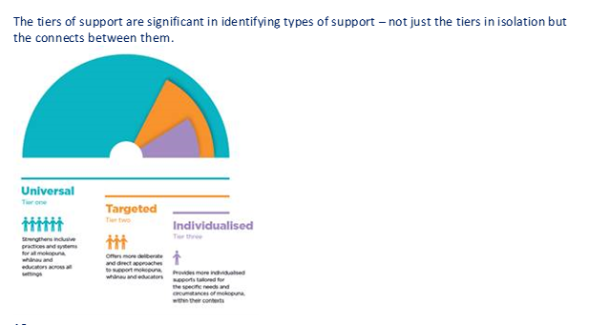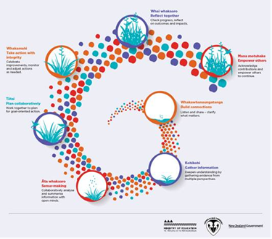

2020 Requests for Support R4S and Outcomes to 18.9.2020
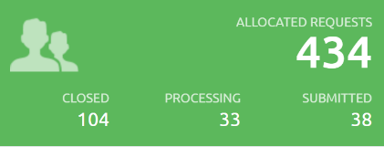
R4S 1.1.2020 to 18.9.2020: 295 Individual Students, 72 Gateway, 4 Gps of Schools, 31 Gps of Students, 35 Individual Schools, 101 Projects, = 538 R4S
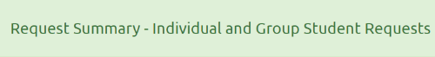
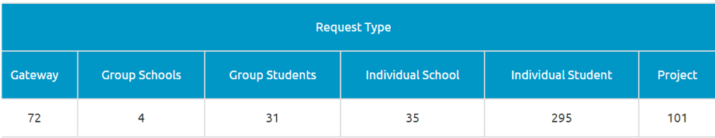
YEAR LEVELS for 295 Individual Student R4S
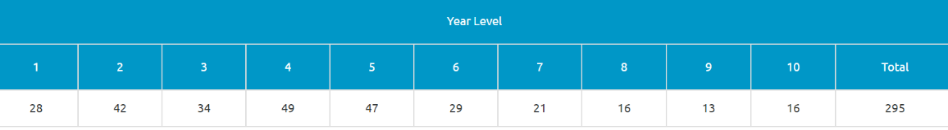
ETHNICITY: The ethnicity total is not based on total number of students as multiple ethnicities can be selected for a student.
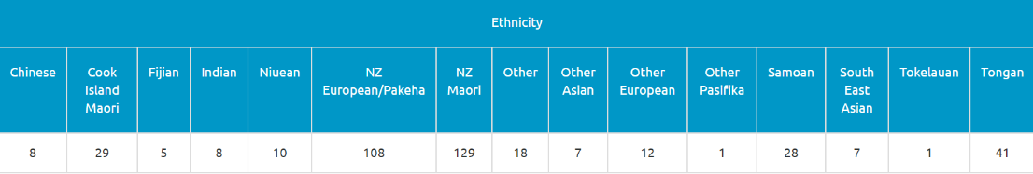
GENDER: Individual R4S 295 and Gateway 72 = 367 Student Total. Gender breakdown total of 363 differs as 4 students have no gender supplied
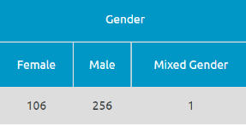

2020 Average Student Outcomes to 18.9.2020

Term 3

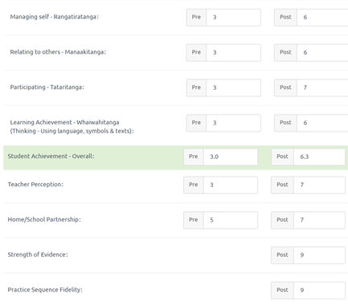

Learning Support Funding
Learning Support Fund (LSF) “supports interventions developed collaboratively with RTLB, targeting students in Years 0-10. It must be used equitably and can be used innovatively.” Learning Support Funding (LSF) received for 2020 is $193,264 (GST excl). As of 31 August 2020, total LSF expenditure YTD stands at approximately $134,737 and has been allocated to support students, projects and to employ our specialists. Learning Support Funding applications are within the context of current active referrals (individual, group, project etc.) and the practice sequence. A range of support and/or resources can be applied for dependent on the case/project needs, analysis, goals and plan (if these services/resources are not available from any other source).
----------------------------------------------------------------------------------------------------------------------------------------------

