Royal Oak Primary School,
Chandler Ave
Royal Oak,
Auckland 1023
New Zealand
Mob: 021966199
Email: manager@rtlbcluster8.ac.nz

Ngā Manu Ᾱwhina RTLB Cluster 8 Manager’s Report (Term 4, 2021)

It is my pleasure to present the Ngā Manu Ᾱwhina report covering:

RTLB Staffing
Strategic Engagement with the National Education Learning Priorities
RTLB Team and Service during Changing Alert Levels
Cluster 8 Requests for Support and Outcomes
Learning Support Fund

RTLB Team and Staffing
Royal Oak Primary Office Base | Orakei Primary Office Base | Tamaki College Office Base
Angelee Morrow | Claire Murphy | Georgia Jensen-Procter
Emily Marurai | Michelle Grey Lamont .8 | Kylah Drake
Jill Watson | Sue Cameron .8 | Chris Bush
Owen Robyns | Claire Scopas .8 | Vaughan Spurdle
(Leslie Dresser-Tu’ugasala) Debbie Saxon | Lilly Reynecke | Jo Turner .6
Beverley D’Souza | Julie Nugent | Dianne Ley
Maree Stenberg | Sandiyao Sebestian | Michele Hucker
Titania McKenzie | Druinie Perera | Robert Rasmussen
Tracey Richardson | David Blazey | Michael White
Margaret Muir .6
Leadership
Barbara Hannant -Practice Leader (PL) | Specialists
Chris Graham- Practice Leader (PL) | Jean Parkinson (Counsellor).2 | Resource Assistant
Catherine Alpe - Practice Leader (PL) | Kimberly Walker (Counsellor) .2 | Louis Gruebner
Anne Roborgh .2 (Partnership Leader)
Roseanne Gibson Manager

At the end of this term, we are again farewelling Anne Roborgh .2 (Partnership Leader) and thank her for leading the RTLB and Learning Support partnership over the last year.

New RTLB for 2021

- New permanent appointment pending
- Mark Larkin: Fully trained RTLB for the fixed study leave position.
- Wendy Florence: Fully trained and experienced RTLB for the fixed sick leave relieving position.

2020 Professional Learning Achievements

- Titania McKenzie has completed the Educational Psychology internship and is now a fully registered Psychologist.
- David Blazey has successfully completed a Masters in Educational Psychology.
- Jill Watson has successfully completed a Post Graduate Diplomas in Specialist Teaching (Learning and Behaviour).
- The following RTLB have completed the first year of the mandatory Post Graduate Diploma in Specialist Teaching (Learning and Behaviour). This study is completed whilst working as an RTLB with study days allocated.
    - Michele Jane Hucker
    - Emily Marurai
    - Julie Nugent
    - Tracey Richardson
    - Vaughan Spurdle

Strategic Engagement with the Priorities

The Cluster 8 strategic goals align with the Statement of National Education and Learning (the NELP) and the Learning Support Delivery Model and Action Plan Priorities.

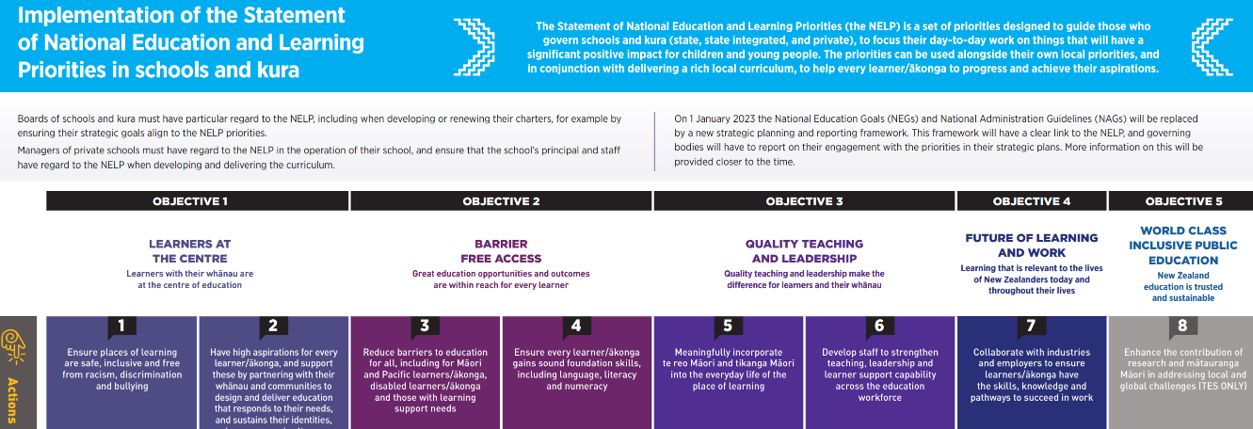

Objectives | Strategic Engagement with the Priorities
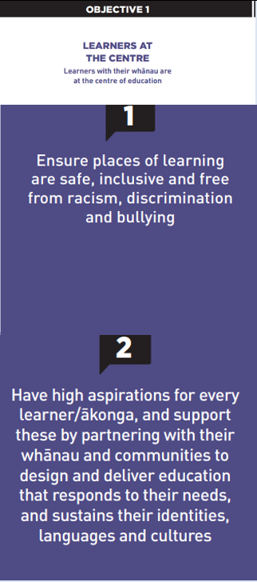 | The team, Partnership Leader and Practice Leaders continue to work collaboratively with MoE LS and Kāhui Ako to support the implementation of the LSDM, also attending and participating in relevant Kāhui Ako, SENCo and LSC meetings and multi-agency panels.  RTLB Practice Leaders and MoE LS Service Managers have engaged in a collaborative inquiry and planned PLD for the cluster on He Pikorua, tiered support, transition, one plan and trans and multidisciplinary support. Practice Leaders Chris Graham and Barbara Hannant continue to be involved at a national level in the ongoing development and implementation of He Pikorua to develop capacity across all Learning Support Practitioners.  The Whanau (Parents as Partners) is a new RTLB community of practice that is consulting with parents, also providing a key contact for parents and resources about best practice. A webinar is being developed focussing on: - parents supporting parents; resilience during crisis; best practice and successful outcomes.  Several RTLB Early Intervention Projects (EIP) were run over the year. This programme is for students entering school with little or inconsistent early childhood education and who require support to be ‘school-ready’. The programme is funded jointly by RTLB Learning Support and individual school funding and offers a structured programme focused on early literacy, number, and fine motor skills.
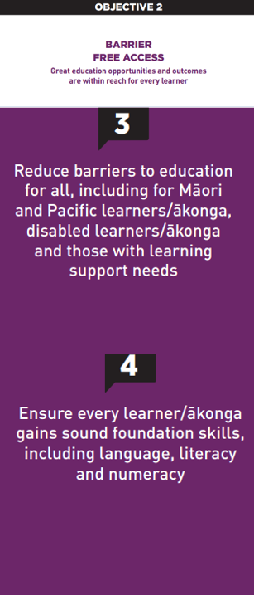 | There is ongoing regular review of the website, connect pages, communities of practice (CoPs), workshops, resources and other services to ensure they are responsive to the cluster’s needs.  RTLB continue to develop and lead communities of practice (CoPs) engaging educators across the cluster in: - Foundation Learning, Feuerstein, Play-based Learning, Secondary Educators, Dyslexia, Inclusive Practices, ASD, Behaviour, Neuroscience and SEL. CoPs and RTLB have supported interventions using Zones of Regulation, Reciprocal Reading, Escalation Profiles, Spring into Maths, Numicon, Fast Forward and Maths Adapted Assessments etc.  Professional development, support and/or resources have been provided around: ASD, ‘The Joy of Maths’, ‘Anyone Can Do Maths’, dyscalculia, study skills, flipped classrooms, escalation profiles, transitions, play- based learning and literacy, comprehension strategies, bilingual assessments, ORS applications, BASICS assessments and maths differentiation.  The Incredible Years programmes have been disrupted by COVID lockdowns, however the RTLB team completed three programmes over 2021 and newly IYT trained RTLB have been co presenting with accredited facilitators.  The Play-Based Learning CoP is a teacher-focused COP to provide support to those involved in their play-based journey. Termly meetings are hosted by a different school to showcase their Play Based Learning journey, model aspects of their journey and provide discussion around topics of interest. These have included: the Structured Literacy and Better Start Approaches; Ready to Read Phonics Plus and the Colour Wheel; The Magic Play Box; JOST Assessment; Social and Emotional development using He Maapunate Tamaiti, and embedding literacy and numeracy into play. RTLB Lilly Reynecke delivered zoom workshops on: The Joyful Work of Play and The Playing Fields.  Ministry of Education initiatives are re-focusing the way that reading is taught and the important skills of decoding text within balanced language and text-rich teaching programmes has led Cluster 8 to engage in this work and to further inquire. A comprehensive array of assessment and teaching strategies are being collated and professional learning opportunities for the cluster and team are being explored for 2022.
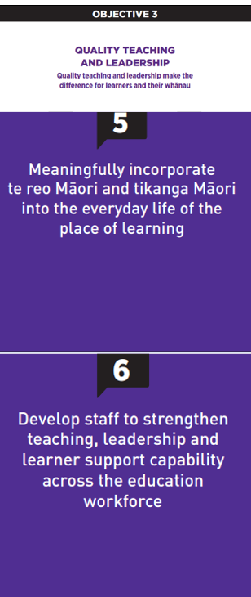 | While this year has had its interruptions, it has offered a number of opportunities and experiences for Cluster 8 to deepen its connection with the community in a culturally responsive way. RTLB Practice Leader Chris Graham as one of the Pouwhirinakitanga Māngai (Speakers for RTLB Māori) has continued as the National RTLB Māori representative and a leader of Ngā Pouwhirinakitanga and a contributing member on the following national working groups: He Pikorua in Action, Journey Towards Rangatiratanga (with Sonya MacFarlane), LSC Toolkit Te Rourou and is currently working with the national MoE team on the School Entry Assessment and in the Curriculum Progress Map- Social Emotional Development. Chris continues to provide support on the Massey University Learning and Behaviour panel supporting the Specialist Teaching Program and as a presenter on the Massey University expert panel, supporting the RTLB Training.  Professional development at the Kura Kaupapa Māori ō Puau on the Mana Potential programme facilitated by Angeline McDonald was offered to RTLB and Kaiako who were teaching in either Rumaki or Bi- Lingual settings. When alert levels have allowed there is a weekly face to face Te Ao Māori wānanga, for Cluster 8, facilitated by Chris Graham. This year RTLB also participated in the Cultural Tour with Te Iti Kahurangi Kāhui Ako. This offered the opportunity to come together and allowed us a window into some of the local places and histories.  Chris Graham also held the AGM and presented at the Ngā Pouwhirinaki Hui-ā-tau 2021 (virtually), alongside: -Dr Angus Hikairo Macfarlane, Dr David Wales (National Director of Special Education) and Dr Melanie Riwai-Couch. The Cluster 8 Māori roopu participated in Hui-ā-tau.  The RTLB role in supporting our Ministry of Education colleagues with the In-Class Support (ICS) application process took an intensive turn this year as lockdown constraints made the gathering of assessment data especially challenging. Flexibility with alternative evidence and assessments was shown by all during this time so that the applications could present the clearest possible picture of each student's needs. In addition to the 144 ICS places, the Re-engaging Ākonga Fund has provided supports for a further 25 students this year.  The Revised Professional Growth Cycle process for the team is in place and appraisals running to schedule with peer supervision in process.
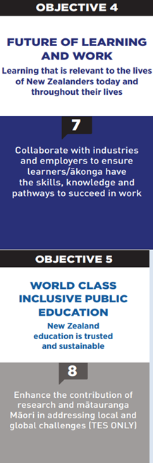 | There is ongoing development of a cluster culture of wellbeing and inclusivity valuing diverse ways of being and values in action. For example, the Secondary CoP (Community of Practice) led by RTLB Lilly Reynecke, meets termly together and also with educators, LSCs (Learning Support Co-Ordinators) and SENCo to build working relationships, provide opportunities for sharing successes, supporting each other’s areas of interest and current interventions while showing a responsive RTLB team to their needs and areas of interest. These meetings have been well attended and have been instrumental in generating discussion around RTLB support for secondary schools and subsequent professional development opportunities and strategy implementation with successful provision in the areas of:- Zones of Regulation, Reciprocal Reading, Spring into Maths, Escalation Profile, YORK assessments, Math’s Differentiation Workshop, Resources for Study Skills and workshops for Comprehension Strategies, Transition Support with virtual transition tours. In collaboration with MoE, two zoom sessions on Privacy Awareness Training around the New Privacy Act Privacy were provided this year.  Roseanne Gibson has continued in her role as a National RTLB Manager representative on the National RTLB Lead Principals’ Executive and more recently on a Health and Education Collaboration Working Party which includes MoE Directors, Health, Paediatricians, Mental Health and APPA Principal Reps that have come together to discuss a collective proactive approach re social and emotional wellbeing and behaviour upon return to school. This group has been working to develop a gold standard for kids to return safely to school after lockdown. A plan for re-entry to schooling was developed quickly given what we experienced last year and the need to intervene earlier, also given increasing anxiety now as COVID is endemic. As part of this Auckland wide response Roseanne has engaged the 11 Auckland Cluster Managers to meet regularly and share best practice. Also engaging the National RTLB Network of Expertise to look at how they support this collaboration and work.  In conjunction with the above working party. the team has worked on a range of wellbeing support given COVID. The pandemic is part of the need base but also additional wellbeing, behaviour and learning support needs: -  - Looking at pathways, proactive and preventative tiered support and links to resources, required PLD and psychoeducation for parents, teachers and students and what needs to be in place currently but also as we move forward.  - Exploring and building the universal primary mental health within schools, SWIS SENCO/RTLBs/NGOs.  - Looking at referrals to secondary services and health/mental health/developmental/trauma and support for students, some of whom had to drop out of school to support their family or have additional needs which were not met/acerbated during lockdown.  - Building partnerships with our primary agencies.

RTLB During Changing Alert Levels Over 2021
As RTLB work across 51 schools, the Cluster 8 RTLB service is set up to minimise risk and transmission across multiple schools, agencies and settings, and to facilitate contact tracing if an outbreak occurred in any of our schools. Cluster 8 processes and protocols are revised regularly for the changing alert levels and requirements. The multi-tiered system of support (MTSS) incorporating tiered support (RTI) as a framework to provide service and support during all alert levels has provided a foundation for our service, whilst continuing to adapt practice to be responsive and provide the best support and casework in changing alert levels.
Key liaison RTLB worked with schools re what approach and support would work best for their school setting and the students. When onsite, RTLB are responsive to that particular school’s processes and requirements and follow the health measures that apply to that school. At Alert Level 3 RTLB continued to minimise, as much as possible, RTLB working face to face across multiple schools and groups/classes of students, seeking to keep all safe and minimise risk and transmission. A vaccination and testing register are kept for RTLB and schools have been assured that RTLB who will be working onsite in schools are fully vaccinated and will have had a negative covid test result prior to returning onsite.
Over the year, the Cluster 8 RTLB service has continued to have a focus on the wellbeing of our team and individual RTLB using our values in action as a framework, also ensuring health and safety protocols relevant to changing alert levels. Ngā Manu Āwhina as a team had regular check ins and updates, meetings, communities of practice, supervision, team building activities, sharing of resources and links, also the option of additional one to one support and or counselling support.
Platforms for online learning and support were essential and provided for our tamariki and whānau through the latest lockdown levels. Specific literacy and numeracy programs like Symphony Maths and Lexia were extended for allocated cases, siblings and Cluster 8 schools if required. The RTLB team have been creative in finding ways to engage with learners through tele-practice, zooms and other online hangouts over the last two terms and have continued to establish positive relationships with students and whanau through this challenging time.
The RTLB Resource Library has been transferred to the Accessit system. This new system for searching and issuing our resources has opened up the possibility for people outside of our organisation to access document resources online and to find our preferred web links to helpful resources. Our team of Bookit List librarians have been in training during the lockdown and hope to have the system up and running well by the start of 2022.
In term 4, the Wellbeing Community of Practice focused on wellbeing in the return to school after lock-down. Cluster 8 counselling specialists have been part of the conversations providing helpful tips around therapeutic approaches and relaxation strategies The Cluster 8 website Covid-response page has been updated as new resources come in, and in the wider RTLB team there has been constant updating and sharing of effective strategies for reducing anxiety, worries and strategies to support resilience and flourishing. Several scheduled events and workshops requiring face-to-face were postponed over 2021, but Cluster 8 is looking forward to hosting these events and workshops in 2022 in the new Covid Protection Framework.

2021 Request for Support (R4S) and Outcomes to 3.12.2021

Total R4S to 3.12.2021 = 620 R4S

319 Individual Students, 104 Projects, 108 Gateway, 6 Gps of Schools, 34 Gps of Students, 49 Individual Schools

Gateway casework and numbers have been impacted by the pandemic.

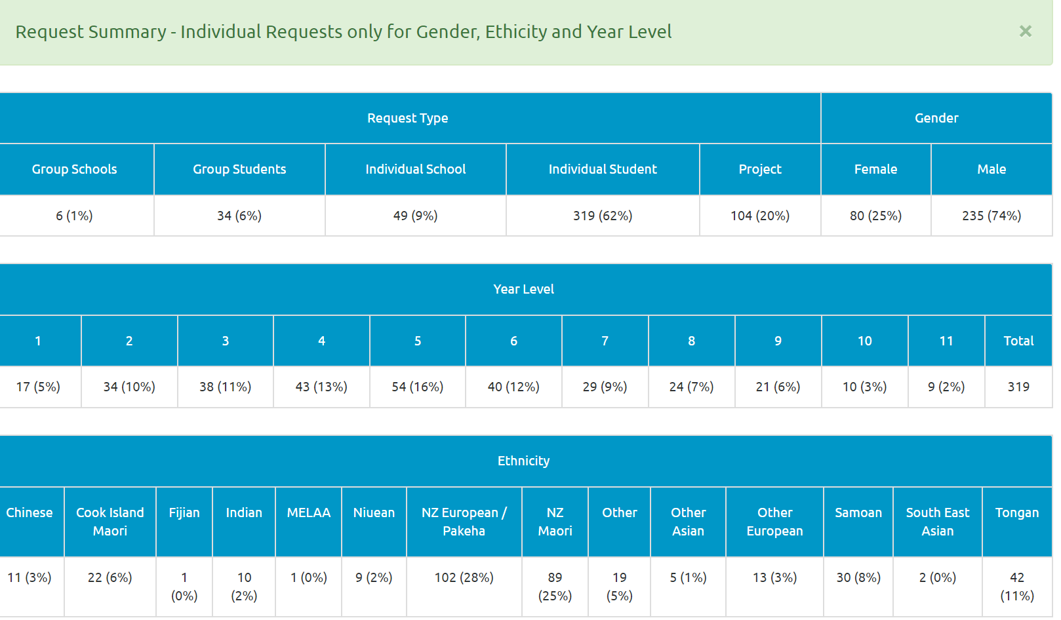

Average Student Outcomes 1.1.2021- 3.12.2021

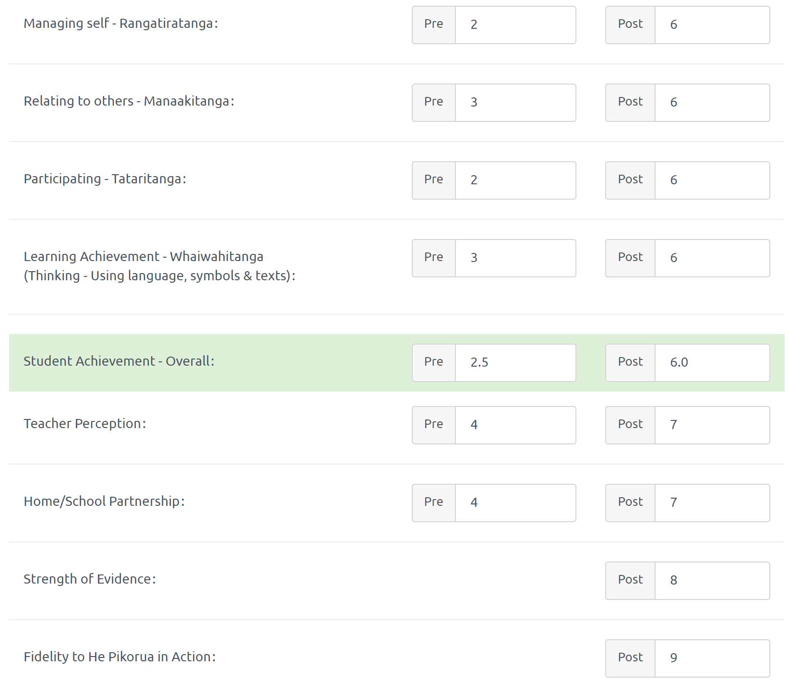

Outcomes for Māori Students 1.1.2021- 3.12.2021
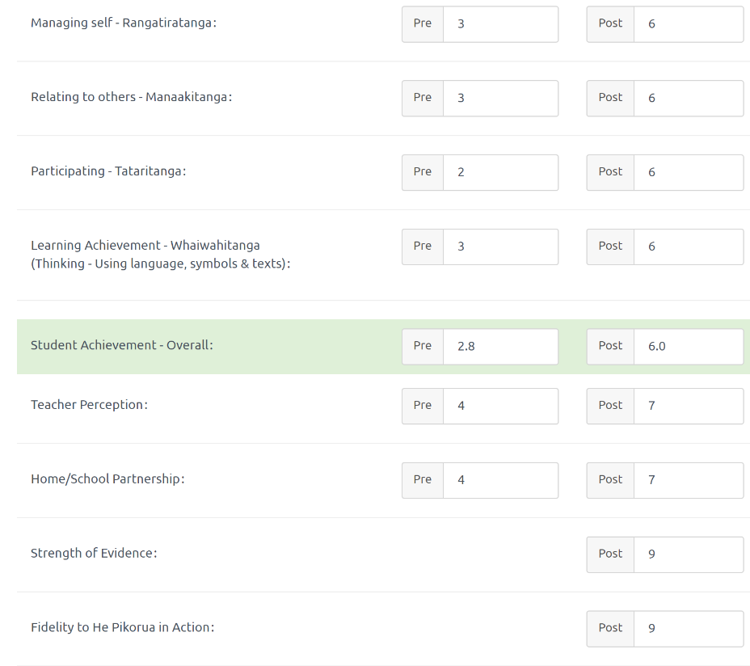
Outcomes for Pasifika Students 1.1.2021- 3.12.2021

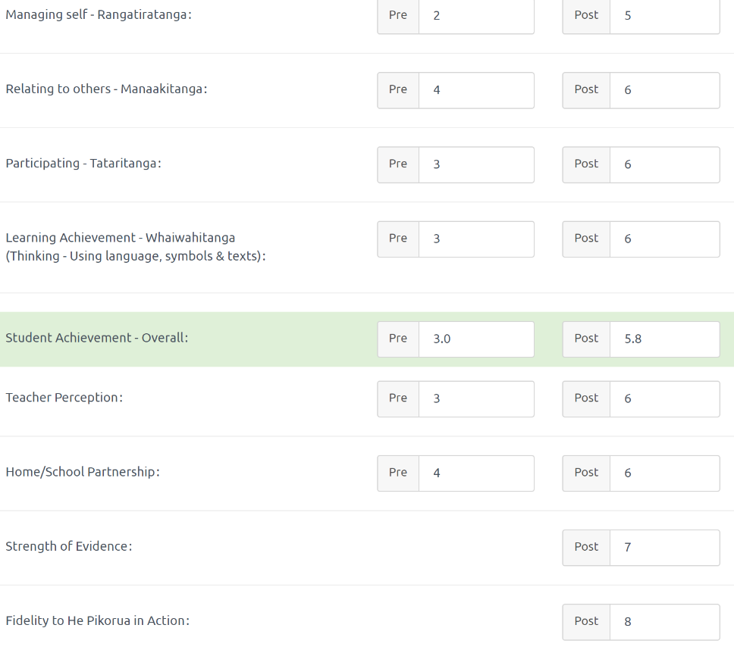

Learning Support Funding
Learning Support Fund (LSF) “supports interventions developed collaboratively with RTLB, targeting students in Years 0-10. It must be used equitably and can be used innovatively.” Learning Support Funding applications are within the context of current active referrals (individual, group, project etc.). A range of support and/or resources can be applied for dependent on the case/project needs, analysis, goals and plan (if these services/resources are not available from any other source). Learning Support Funding (LSF) for 2021 is $195,197 (GST excl). Total LSF expenditure to 31 October 2021 stands at approximately $159,485 allocated to support students, projects and to employ our specialists.

