Royal Oak Primary School,
Chandler Ave
Royal Oak,
Auckland 1023
New Zealand

CLUSTER 8
Resource Teachers of Learning & Behaviour

Cluster 8 Ngā Manu Ᾱwhina Manager’s Report (Term 3, 2022)

It is my pleasure to present the Ngā Manu Ᾱwhina report covering:

- RTLB Staffing
- Strategic Engagement with the National Education Learning Priorities
  - Cultural Engagement
  - He Pikorua and Te Tūāpapa
  - Communities of Practice and Workshops
  - Service Expectations
- Learning Support Fund
- Cluster 8 Requests for Support and Outcomes

RTLB Team and Staffing
Royal Oak Primary Office Base | Orakei Primary Office Base | Tamaki College Office Base
Angelee Morrow | Claire Murphy | Georgia Jensen-Procter
Titania McKenzie | Michelle Grey Lamont .8 | Kylah Drake/Ruth Milburn .6
Jill Watson | Sue Cameron .8 | Chris Bush
Owen Robyns | Wendy Florence | Vaughan Spurdle
Leslie Dresser-Tu’ugasala | Lilly Reynecke (on study leave) | Jo Turner .6
Tracey Richardson | Julie Nugent | Dianne Ley
Maree Stenberg .8 | Sandiyao Sebestian | Michele Hucker
Emily Marurai | Claire Scopas | Robert Rasmussen
Mark Larkin | David Blazey | Michael White
Sarah Pearse
Cynthia Borne .6
Based at Royal Oak Primary | Specialists | Resource Assistant
Barbara Hannant PL | Jean Parkinson (Counsellor).2 | Louis Gruebner
Chris Graham PL |  | Relieving
Catherine Alpe PL |  | Donna Southworth .6
Roseanne Gibson Manager

Cluster 8 RTLB team is currently made up of Lead School Principal Megan Clotworthy, 1 Manager, 3 Practice Leaders, 29 RTLB, 1 counsellor and a resource assistant. The RTLB are grouped into 3 office bases, Ōrākei, Tāmaki and Royal Oak.
Staffing Changes
- Cynthia Borne .6 fixed position for Term 3 and 4.
- Kylah Drake is on parental leave 25 September 2022 until 24 April 2023. Ruth Milburn .6 relieving in the position.
- Georgia Jensen-Procter is on discretionary sick leave from 31 August 2022 to 30 September 2022

Selected Strategic Engagement with the Priorities

The Cluster 8 strategic goals align with the Statement of National Education and Learning (the NELP) and the Learning Support Delivery Model and Action Plan Priorities. Please see the alignment and engagement with the Strategic and Annual Plan with excerpts from the plan followed by the associated actions below.

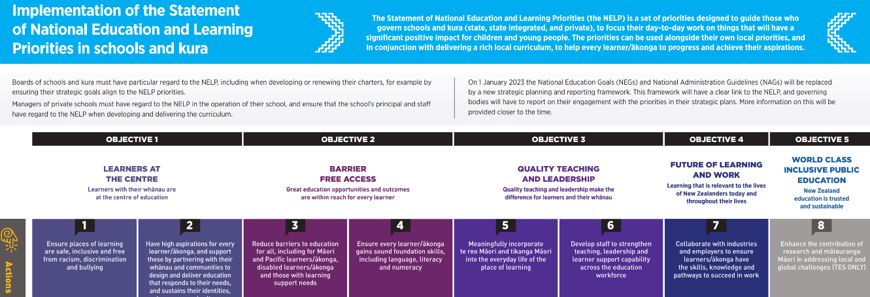
Team cultural capacity building within Māori and Pacific case work through:
- Mana Potential.
- Te Pikinga ki Runga
- Ka Hikitia and cultural self-review
- Te reo, ngā tikanga, Tātaiako, Ka Hikitia and Tapasā opportunities within R4S and wananga.
Continue to explore develop and provide opportunities to deepen our team values of Manaakitanga, Hauora, Whakawhanaungatanga, Ako, Tikanga and Kotahitanga.

Annual Plan Key Tasks and Actions: Selected Current Engagement and Initiatives

Cultural Engagement
RTLB Practice Leader Chris Graham as one of the Pouwhirinakitanga Māngai (Speakers for RTLB Māori) is facilitating the National RTLB 2022 Hui-ā-tau with support from Pouwhirinakitanga and Cluster 8. Several RTLB are completing the Te Ahu o te Reo Māori programme being delivered by Takatū Associates.
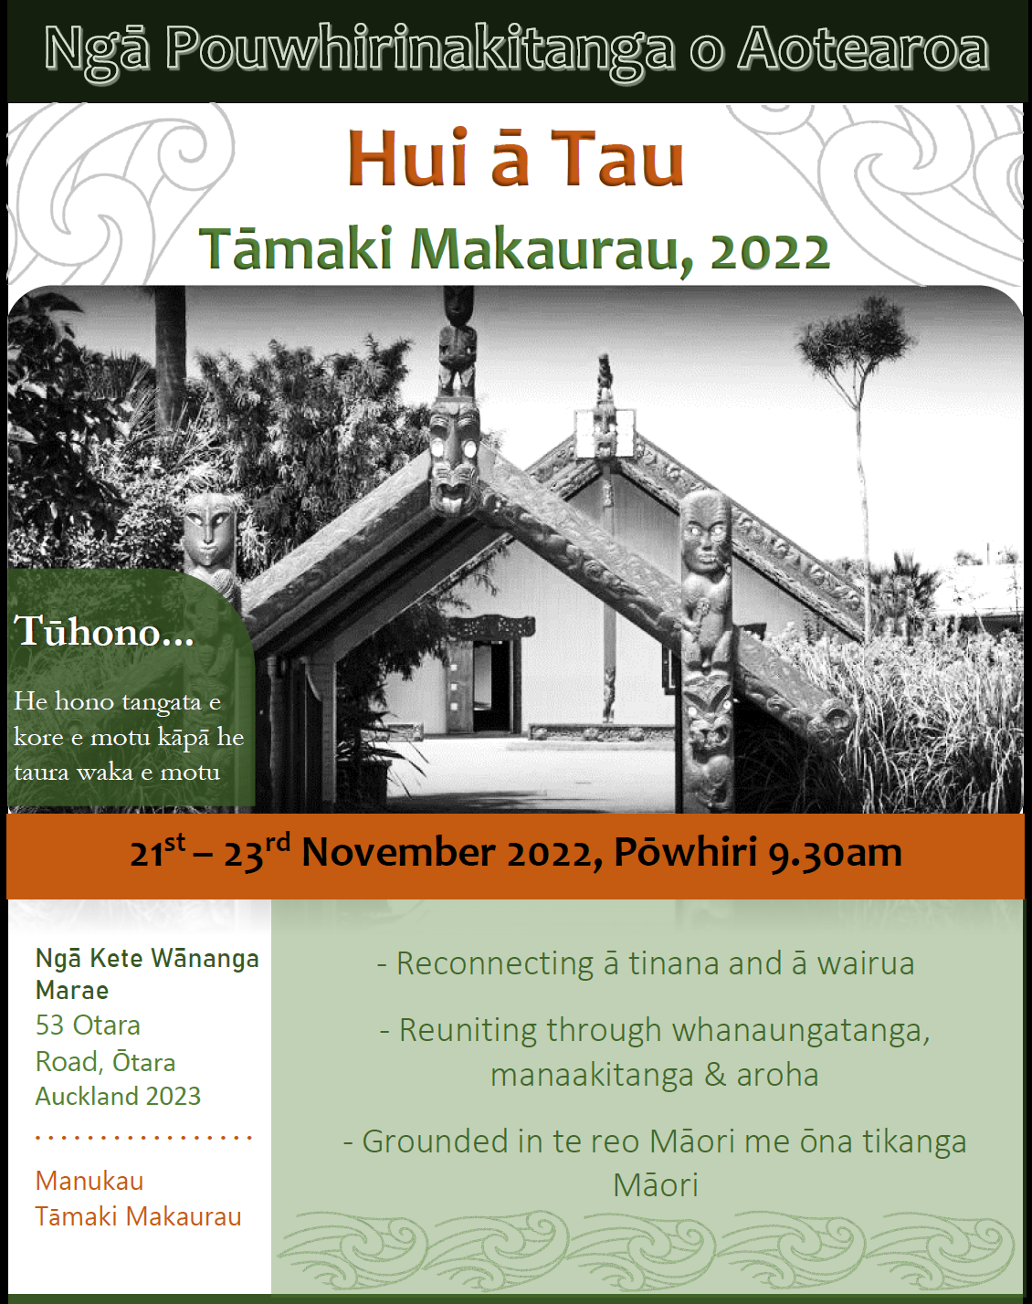
He Pikorua and Te Tūāpapa
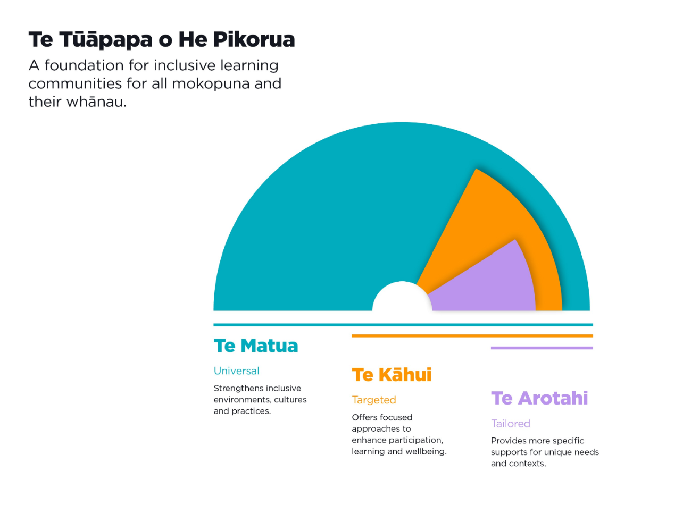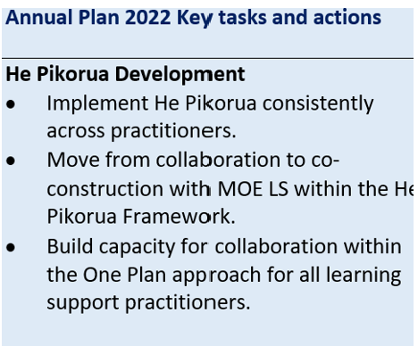
The purpose, intent and overarching practice principles of He Pikorua have been revisited and updated. He Pikorua now incorporates Te Tūāpapa which provides a framework for identifying supports which increase in intensity, depending on the needs and the context. Te Tūāpapa o He Pikorua is also now supported with a hard copy flip chart book of a reflective questions resource for all practitioners. Cluster 8 Practice Leaders Barbara Hannant and Chris Graham continue as the only RTLB who are still part of the National Team assisting with the regional and national delivery, with more MoE and RTLB cluster workshops requested and scheduled recently.
Communities of Practice and Workshops
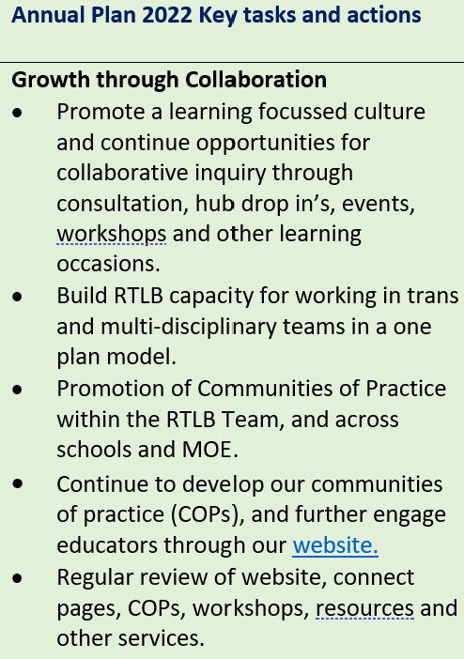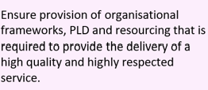
The Secondary Community of Practice have met to discuss and plan for the transition of Year 9 pupils, and a Transition Hui has been scheduled. To inform the contents of the hui Secondary schools were surveyed to ascertain which areas of their transition process they wish to strengthen and discuss. The areas of best practice and available resources to facilitate transition were selected as well as a discussion on an inquiry that explores the challenges Year 9 students face when they start secondary school. There will be a focus on the Te Tūāpapa model to look at different contexts and types of support ranging from universal, targeted, tailored and how we can work together to enhance the time lined processes that are taking place.
Cluster 8 Wellbeing Community of Practice is preparing for an event next year aimed at promoting well-being layers of support for tamariki and rangatahi learners, teachers and schools. A needs analysis survey will be sent to all Cluster 8 schools early in Term 4 to inform topics and speakers.
The Effective Literacy community of practice has growing interest from our schools given recent MoE changes in the way literacy is taught. To resource these changes our community of literacy practitioners are rapidly collating resources and supports for effective literacy teaching. This includes recorded workshops available on the Cluster 8 website, presented and facilitated by RTLB Julie Nugent on the Big 6 Pillars of Effective Literacy.

Service Expectations
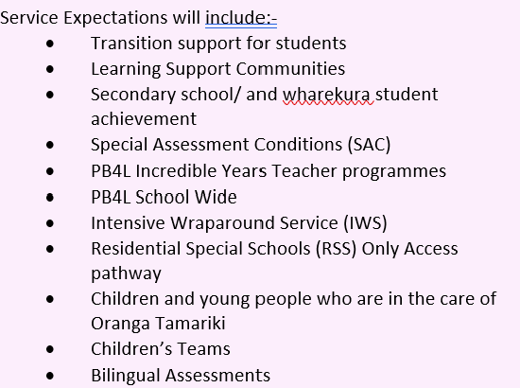

- RTLB have worked with their schools to support and complete bilingual assessments, special assessment conditions (SAC) and In Class Support (ICS) applications.
- PB4L Incredible Years Teachers (IYT) and Incredible Years Autism programmes are currently running, with more programmes scheduled for term 4.
- To date 59 gateway educational profiles have been completed across the cluster in 2022 for children and young people who are in the care of Oranga Tamariki. Currently there are eight students who are under the new RTLB ‘Gateway transition’ project where students with complex issues can access additional RTLB service and support for 6 weeks-3 months.
- Several focus areas have come out of The Education and Health Initiative Project including: -
- Early year transitions from home and ECE
- Models of care and care teams within schools
- Professional development and learning for teachers and support staff
- Service navigation and supporting educational organisations and professionals with this.
RTLB Titania McKenzie continues to work with and alongside several schools and a Kāhui Ako in their work in re-engaging learners, to: -
- Continue to shape the accessible database of support services.
- Partner with school/s wanting to explore the absences and engagement space through a pilot.
- Develop and explore innovative localised responses to absenteeism in schools.

Learning Support Funding

Learning Support Fund (LSF) “supports interventions developed collaboratively with RTLB, targeting students in Years 0-10. It must be used equitably and can be used innovatively.” Learning Support Funding applications are within the context of current active referrals (individual, group, project etc.) and the He Pikorua practice framework. A range of support and/or resources can be applied for dependent on the case/project needs, analysis, goals and plan (if these services/resources are not available from any other source). Learning Support Funding (LSF) for 2022 is $199,101 (GST excl). As of 31 August 2022, total LSF expenditure YTD stands at approximately $125,286 allocated to support students, projects and to employ our specialists.

2022 Request for Support (R4S) and Outcomes to 22.9.2022
Total R4S to 22.9.2022: 318 individual Students, 94 Projects, 6 Gps of Schools, 27 Gps of Students, 51 Individual Schools = 496 R4S
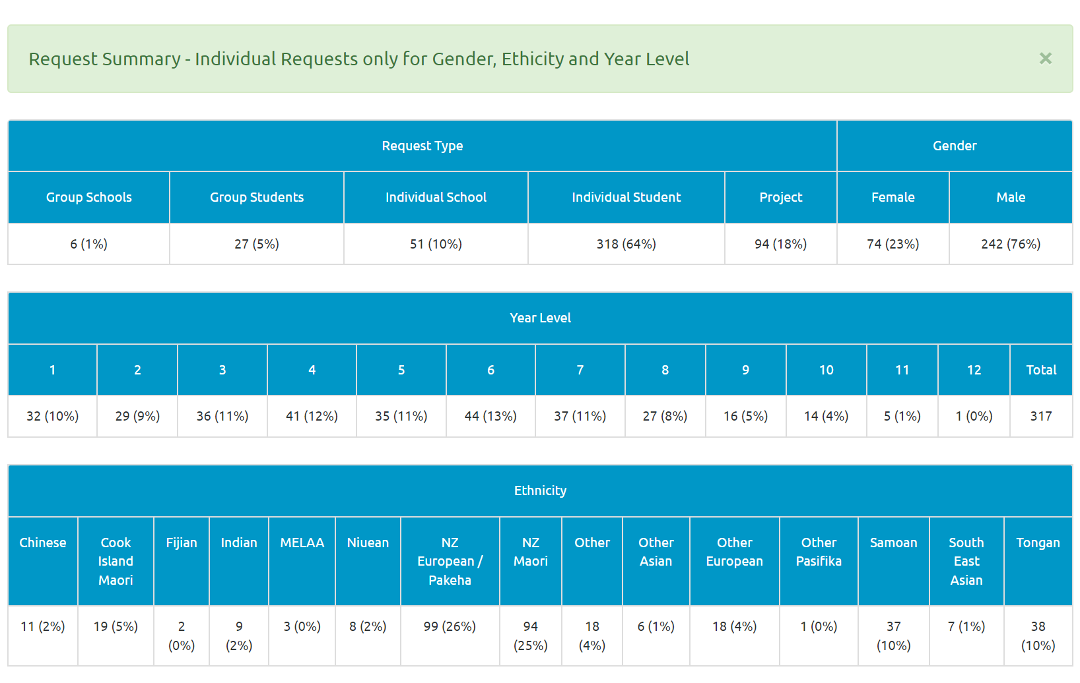

Average Student Outcomes 1.1.2022-22.09.2022





