
Royal Oak Primary School,
Chandler Ave
Royal Oak,
Auckland 1023
New Zealand
Ph: 09 624 2800
Mob: 021966199
Email: manager@rtlbcluster8.ac.nz

CLUSTER 8
Resource Teachers of Learning & Behaviour

Cluster 8 Ngā Manu Ᾱwhina Manager’s Report (Term 2-3, 2025)

It is my pleasure to present the Ngā Manu Ᾱwhina RTLB Cluster 8 report covering:

- RTLB Team and Staffing
- Cluster 8 Ngā Manu Ᾱwhina 2025 Strategic Planning
- Key Tasks and Actions: Selected Current Engagement and Initiatives
- Cluster 8 Requests for Support and Outcomes
- Learning Support Fund
- Other Matters

RTLB Team and Staffing
Royal Oak Primary Office Base | Ōrākei Primary Office Base | Tāmaki College Office Base
Jill Watson | Michelle Grey Lamont | Chris Bush
Owen Robyns | Michele Hucker | Lilly Reynecke
Leslie Dresser-Tu’ugasala | Emily Marurai | Mark Armstrong
Sarah Mariu | Christine Holland .6 | Dianne Ley .8
Maree Stenberg | Cynthia Borne .4 | Michael White
Wendy Florence .8 |  | Robert Rasmussen
Maryanne Manuyag |  | David Blazey
Sarah Pearse |  | Emma Fainu
Jennie Burt |  | Amy Thurston
Jo Turner .6
Cecilia Tian .6
Leadership | Admin | Relievers
Barbara Hannant | Melanie Stuart (16 hours) | Vaughan Spurdle .4
Jake Taplin |  | Adrianne Burke .4
Anne Roborgh .8
Roseanne Gibson Manager

The RTLB team, leadership and staffing consists of : Lead School Principal Megan Clotworthy, 1 Manager, 28 RTLB FTE positions including 3 Practice Leaders. The RTLB are grouped into 3 office bases, Ōrākei, Tāmaki and Royal Oak Hubs. The RTLB in each office base are responsible for providing service to designated schools and Kāhui Ako, however depending on workload, RTLB with specific required expertise are able to work across the cluster. Project and case work are ‘needs driven’ and based on requests for support (R4S) received, presented and discussed at review and intake meetings.
Staffing Changes
- Tracey Richardson and Kylah Drake resigned in Term 2.
- Cecilia Tian returned from parental leave on August 5.
- Elliot Peacock has been appointed to a permanent RTLB position beginning Term 4.
- Sarah Marui has been successful in gaining a 2026 study award and will be studying at Te Wānanga Takiura in a full immersion setting. Her study will focus on improving effective RTLB practice in Māori medium spaces, with an emphasis on practitioner confidence, cultural competency, and te reo Māori.

Strategic Planning

Beginning a new strategic cycle this year, the RTLB team and leadership have refined our values, vision, mission, and action plan, ensuring alignment with our service agreement and Ministry requirements in conjunction with our shared aspirations and daily practice. Our values guide how we work together and with our communities. Our vision and our mission, set the direction for all we do.

Our Values
- Whakawhanaugatanga
- Manaakitanga
- Hauora
- Aroha
- Pono

Our Vision
Empowering every learner to thrive in a dynamic world.

Our Mission
We work together to grow every child's capacity to learn, dream, and thrive. Through shared aspirations, collective action, and inclusive learning environments, we prepare children to flourish in a changing world.

Our Cluster Focus

Our cluster focus is simple and strategic: Knowledge – Impact – Service. This means keeping our practice grounded in up-to-date, evidence-based approaches; ensuring our support delivers tangible, culturally responsive outcomes for mokopuna; and maintaining consistently excellent service across all schools.

The strategic plan identifies eight key objectives, including embedding best practice through He Pikorua, advancing equity through Ka Hikitia and the Pacific Education Action Plan, strengthening curriculum delivery in structured literacy and numeracy, building inclusive and neurodiverse practices, supporting effective transitions, aligning with Ministry priorities, and leading innovation in AI, wellbeing, and professional growth.

Impact for Learners
Through these objectives, Ngā Manu Āwhina Cluster 8 is positioned to:
- Lead with strong, evidence-based professional knowledge.
- Deliver measurable improvements for Māori, Pasifika, and all learners.
- Strengthen inclusive, sustainable practices that support diverse needs.
- Provide a high-quality, responsive service that adds value to schools, kaiako, whānau, and mokopuna.

Annual Plan Key Tasks and Actions
Selected Strategic Engagement and Initiatives

Strengthening Cluster Networks, Understandings and Partnerships:-

Termly cluster events and regular workshops are scheduled for RTLB, DPs, SENCos, MoE LS, teachers and LSCs to build professional relationships and shared understandings, kōrero, inquire, collaborate, provide support and guidance, access and, share expertise and Te Tūāpapa project work.

- Term 1: Cluster SENCo/LSC/DP Open Afternoon
- Term 2: Cluster Neurodiversity Event on June 4 & 5
- Term 3: MoE Learning Support and RTLB Day August 19
- Term 4: Hub Drop Ins Week 6 Term 4

In Term 2, Cluster 8 hosted a highly successful Neurodiversity Event, which was well attended by educators and stakeholders across the cluster. The event featured distinguished speakers, interactive workshops, and networking opportunities, all focused on equipping participants with knowledge and practical tools to better support neurodiverse learners in schools and communities.

Feedback from the approximately 180 attendees was overwhelmingly positive, highlighting the event as both enriching and empowering. Participants reported increased understanding, confidence, and strategies to apply in their practice. The strong engagement and outcomes affirm this event as a cornerstone for Cluster 8 in strengthening inclusive education and fostering environments where all learners can thrive.

In Term 3, MoE Learning Support and RTLB Cluster 8 successfully responded to multiple school requests for support with ORs applications by hosting two well-attended training sessions on 19 August, delivered by Joleen Millward from MoE/Learning Support. Sessions were held at both Royal Oak Primary and Tāmaki College, providing flexible access for participants. Schools engaged positively, bringing current applications or anonymised case information, and feedback highlighted the value of the training in strengthening capability and confidence across the cluster
Cultural Capability and Te Reo Māori
The Māori Rōpū meets regularly to explore, support and enhance best practices for Māori. Culturally appropriate supervision is provided. RTLB and intern psychologist David Blazey recently provided PLD and facilitated a meeting with the Rōpū on integrating Te Ao Pākehā and Te Ao Māori perspectives.
This year, Te Wiki o te Reo Māori carries special significance as we celebrate its 50th anniversary. It provides an opportunity to actively and visibly honour Te Tiriti o Waitangi while strengthening our collective commitment to te reo Māori. Throughout the week, the Māori Rōpū will lead a range of activities designed to foster community, connection, and cultural pride. The 2025 theme, “Ake ake ake – A Forever Language,” underscores the resilience, adaptability, and enduring strength of te reo Māori, reflecting the team’s commitment to embracing, using, and continuing to learn the language as part of our practice.
Pasifika Engagement
Throughout the year’s Pasifika Language Weeks, the Tautai (National Pasifika RTLB) and Cluster 8 Pasifika Community of Practice Tufuga o le Nu'u has shared tailored information and resources for each language. These initiatives have celebrated Pasifika cultures while fostering an environment where all can learn from and connect with the rich diversity of Pasifika languages and heritage. Tufuga o le Nu'u and team members also participate in termly National and Regional RTLB Pasifika fono, strengthening practice and connections across the wider network. This work directly supports Pasifika learners by affirming their identities, promoting a strong sense of belonging, and increasing engagement, which in turn contributes to improved wellbeing and educational outcomes.
Over Term 2 and 3, workshops and communities of practice offered have included:-

Curriculum
The team has now engaged and completed the requirements from their second two-day Structured Literacy PLD. Further inquiry and professional learning has now extended into Structured Mathematics and the Science of Learning. Additional PLD sessions are scheduled to continue this focus and inquiry. This professional learning is critical as it ensures RTLB practice is aligned with current evidence-based approaches. By embedding structured, research-informed strategies, we strengthen both teaching effectiveness and learner outcomes across the curriculum. As specialist teachers, RTLB build on and extend this knowledge to add value in supporting diverse learners across the cluster.
The Mathematics Community of Practice (CoP) has focused on supporting RTLB to stay current with structured numeracy and the refreshed NZ Curriculum. Key work includes:
- Exploring approved Ministry-funded resources for 2026.
- Mapping Cluster schools’ provider and programme choices.
- Sharing research on the four main providers and DMIC (Developing Mathematical Inquiry Communities), a model of ambitious mathematics teaching founded in equity.
- Facilitating Numicon professional learning.
Nonviolent Crisis Prevention and Intervention (CPI)

RTLB and cluster school training has been facilitated by RTLB Jo Turner in Nonviolent Crisis Prevention and Intervention (CPI). Certification programmes introduced this term focus on trauma-informed, person-centred strategies to de-escalate behaviour without physical intervention, and shifting practice towards empathy, regulation, and relationship-building. This comprehensive training program emphasises proactive prevention and equips participants with effective, evidence-based strategies to safely de-escalate anxious, hostile, or violent behaviours at the earliest possible stage. Staff from three schools participated in CPI training, including leaders, SENCo, and teachers. With two new trainers qualified, access for schools has increased. Feedback remains very positive, and Term 4 sessions are already nearing capacity. Escalation Profiles facilitated by RTLB Jo Turner continue to be well used to strengthen collaborative responses to student stress behaviours. Feedback is consistently positive.

Teacher Wellbeing Afternoons

Cluster-wide teacher wellbeing afternoons have been held termly for cluster Kaiako to provide staff with time and strategies to strengthen their own wellbeing. Feedback has been very positive, with several schools requesting additional workshops for their staff and RTLB responding to this need.

Supporting teacher wellbeing is vital, as research shows that teachers who feel well and supported are better able to sustain their practice, manage the demands of their role, and create positive learning environments for ākonga.

Seasons for Growth
The programme continues to thrive across the Cluster. On May 4, RTLB and 7 school staff (including a Principal, SENCo, LSC, teacher, and SWiS) were trained as Companions, with another training planned for November. So far this year, 12 programmes have been delivered (with 2 more starting soon), involving 63 students. Delivery has been supported by 12 RTLB and 10 school personnel as Companions. The increasing involvement of school staff is particularly encouraging, as it supports long-term capacity building within schools.
Additional Specialist Workshops and Service
Workshops delivered have covered:
- Autism and ADHD – understanding overlaps, impacts, and practical strategies.
- Numicon – structured, multisensory maths learning.
- Bilingual Assessment Service (BAS) – six trained assessors, with six referrals this year; continues to be a valuable tool for supporting former refugee and migrant students.
- VIA Character Strengths – using signature strengths to enhance wellbeing and relationships.
- Developing Tamariki Agency in Emotional Regulation – building self-awareness, vocabulary, and de-escalation strategies.
- He Pikorua Beyond the MVP –Understanding the dynamic helix in action while still being responsive to the flexible nature of He Pikorua ensuring SMART, whānau-centred goals in practice.
- Dynamic Ecological Analysis (DEA) – training staff in this collaborative, ecological decision-making model.
- Responding to Psychological Distress and Suicide Risk – training facilitated by Dr Annette Beautrais, with strong secondary and primary school engagement.

2025 Request for Support (R4S) and Outcomes to 12.9.2025

Over 2025,there has been a total of 406 Requests for Support (R4S) to 12.9.2025. The RTLB service supports 52 schools, including the newly added French International School. Services are also extended to Alternative Education Centres and support transitions from Early Childhood settings.
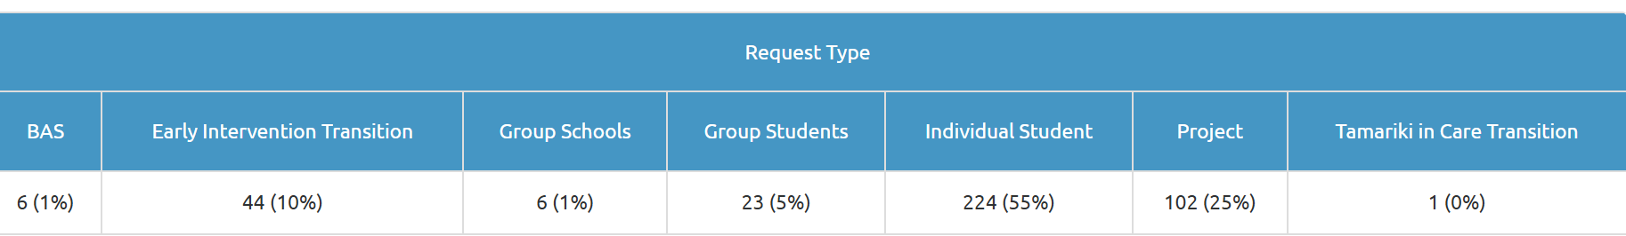
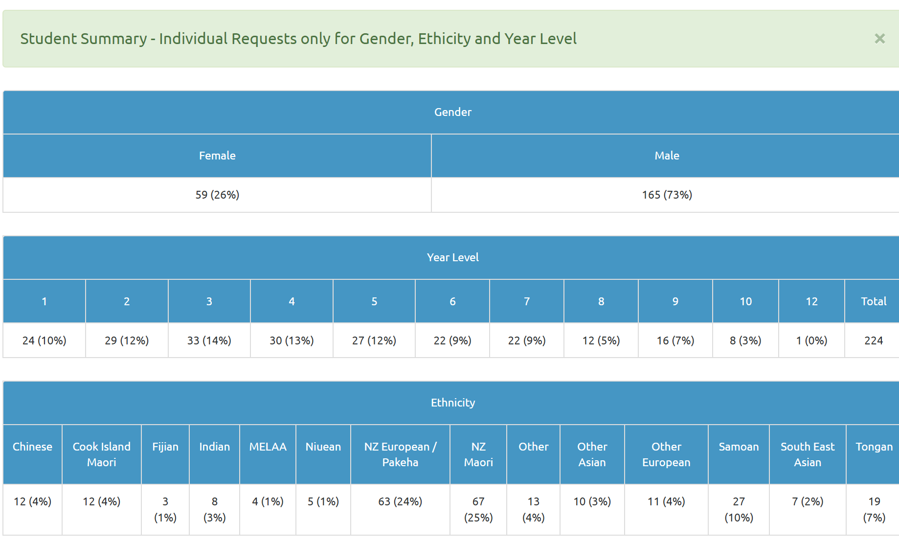

Average Student Outcomes 1.1.2025-12.9.2025

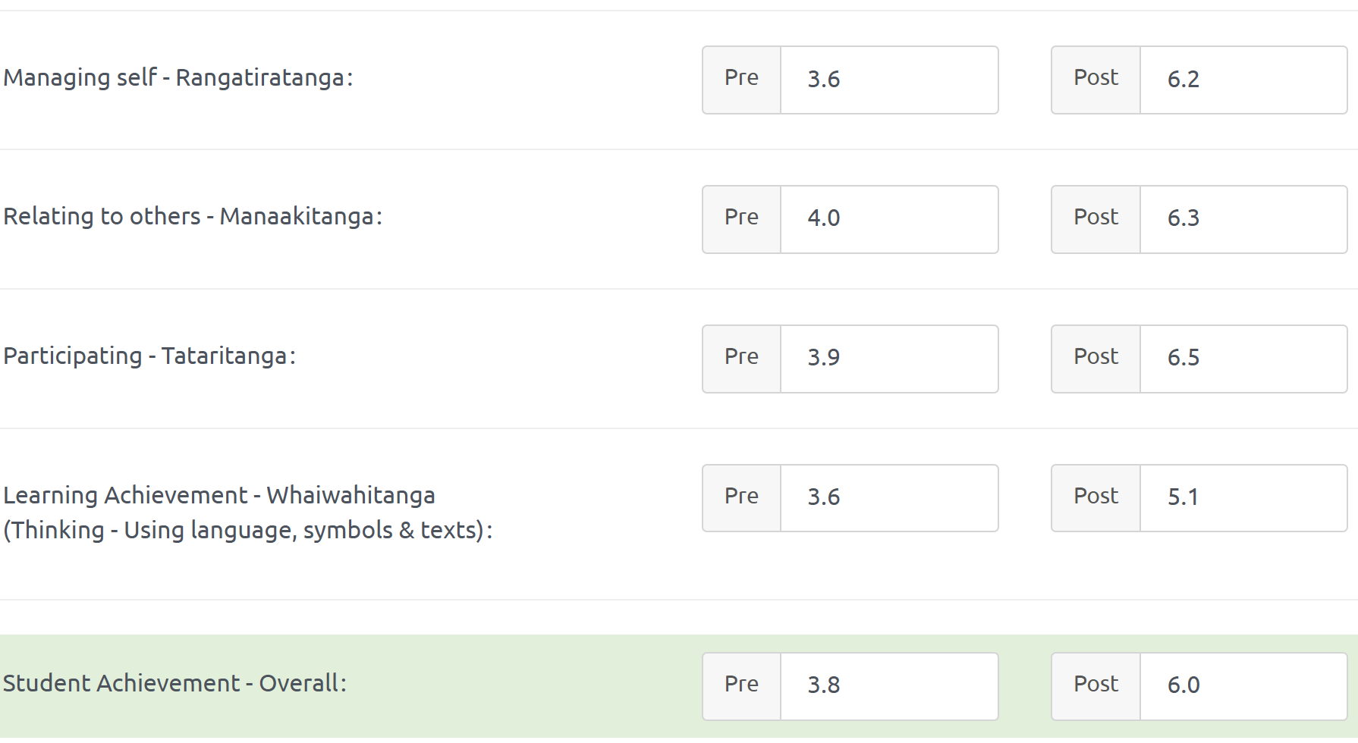

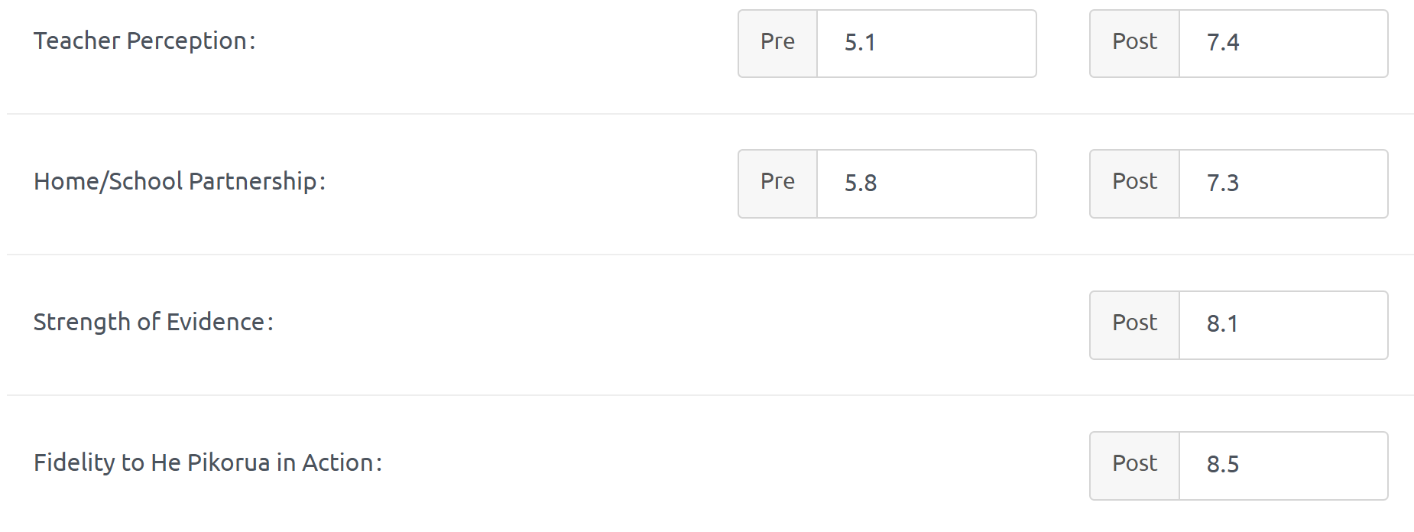
Learning Support Funding

Learning Support Fund (LSF) “supports interventions developed collaboratively with RTLB, targeting students in Years 0-10. It must be used equitably and can be used innovatively.” Learning Support Funding applications are within the context of current active referrals (individual, group, project etc.) and the He Pikorua practice framework. A range of support and/or resources can be applied for dependent on the case/project needs, analysis, goals and plan (if these services/resources are not available from any other source). Learning Support Funding (LSF) for 2025 is $191,617 (GST excl). Please see the financial report for current LSF expenditure allocated to support students, projects and to employ specialists.
---------------------------------------------------------------------------------------------------------------------------------------------

Other Matters:

