
Royal Oak Primary School,
Chandler Ave
Royal Oak,
Auckland 1023
New Zealand

CLUSTER 8
Resource Teachers of Learning & Behaviour

Cluster 8 Ngā Manu Ᾱwhina Manager’s Report (Term 4, 2024)

It is my pleasure to present the Ngā Manu Ᾱwhina report covering:

- RTLB Staffing
- Strategic Engagement with the National Education Learning Priorities and Review
- National Survey
- Cluster 8 Requests for Support and Outcomes
- Learning Support Fund

RTLB Team and Staffing
Royal Oak Primary Office Base | Ōrākei Primary Office Base | Tāmaki College Office Base
Mark Armstrong | Michelle Grey Lamont | Georgia Jensen-Procter (Leave)
Jill Watson | Michele Hucker | Chris Bush
Owen Robyns | Jennie Burt | Lilly Reynecke
Leslie Dresser-Tu’ugasala | Cecilia Tian (Parental Leave) | Jo Turner .6
Tracey Richardson | Irene Jack | Dianne Ley .8
Maree Stenberg .8 | Christine Holland .6 | Michael White
Wendy Florence .8 | Maryanne Manuyag (Leave) | Robert Rasmussen
Sarah Mariu | Cynthia Borne .6 | David Blazey
Emily Marurai |  | Kylah Drake
Sarah Pearse
Emma Fainu
Leadership | Admin | Specialist RTLB
Barbara Hannant (Sabbatical T4) | Melanie Stuart (leave) | Lilly Reynecke (Counsellor)
Titania McKenzie |  | Julie Nugent .4 (Structured Literacy)
Jake Taplin
Anne Roborgh
Roseanne Gibson Manager

The RTLB team, leadership and staffing over Term 4, 2024: Lead School Principal Megan Clotworthy, 1 Manager,4 Practice Leaders, 26 RTLB, 2 Specialists and one administrative support person. The RTLB are grouped into 3 office bases, Ōrākei, Tāmaki and Royal Oak. In October 2024 the Ministry advised the cluster of a staffing reduction for 2025 of one position going from 29FTE to 28 FTE RTLB, this is in addition to the one RTLB 2024 staffing reduction. The reduction of the RTLB staffing for these two positions has been managed by attrition.

At the end of this term, we are farewelling the below RTLB and wish them well in their future endeavours: -
- Titania McKenzie, Practice Leader has been appointed as an MoE IWS Psychologist.
- Irene Jack has been appointed as a classroom teacher at Kaukapakapa School.
2024 Professional Learning Achievements
Owen Robyns, Jennie Burt, and Kylah Drake have completed the requirements for the mandatory Post Graduate Diploma in Specialist Teaching (Learning and Behaviour) and Tracey Richardson who received a study award and worked .5 during the University year has completed the requirements for a Masters in Specialist Teaching.

The following RTLB have been offered study awards to undertake the Post Graduate Diploma in Specialist Teaching (Learning and Behaviour) for 2025.

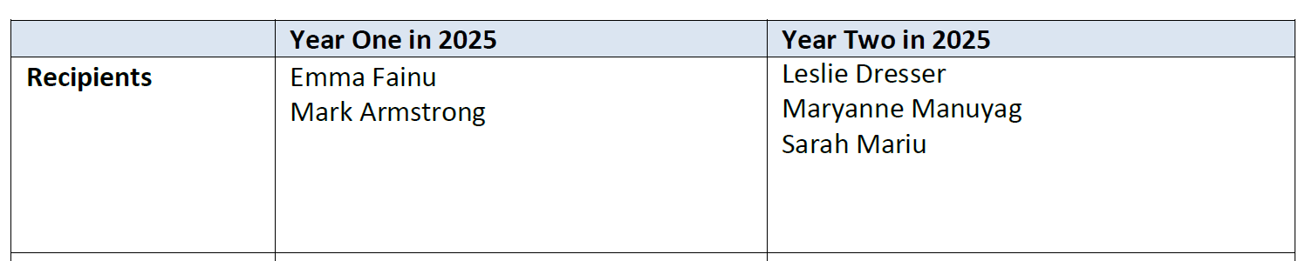

Strategic Engagement with the Priorities and Review
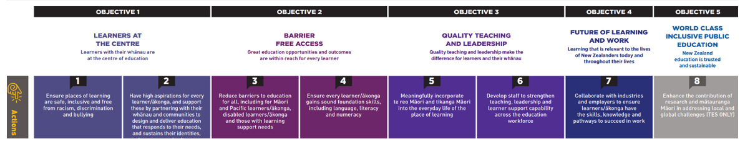
Strategic Cycle 2021-2024 and Annual Plan 2024 Review Summary
The 2021-2024 Strategic Plan aligns with the National Education and Learning Priorities (NELP) and the Learning Support Delivery Model (LSDM). As we come to the end of the strategic cycle, RTLB leadership and the team have reviewed the Strategic Plan and the 2024 annual plan, goals, and actions, achieving significant progress in key areas.
Key Achievements:
- Cultural Competency & Inclusivity:
  - Conducted cultural capacity-building initiatives, including Māori and Pasifika-focused PLD, Te Wānanga o Aotearoa Te Reo course, Hui-a tau, Pasifika Fono and hosting the Tautai regional fono, cultural individual and group supervision, and ongoing engagement with local iwi and communities.
  - Contributed on national working parties in the development of He Pikorua and Te Tuapapa, subsequently supporting other clusters and MoE with PLD to roll out these initiatives.
  - Improved data collection on Māori and Pasifika students’ achievement, incorporating feedback from whānau and communities to enhance practice.
  - Ongoing focus on integrating Tātaiako and Tapasā cultural competencies in casework.
- Wellbeing Focus:
  - Promoted wellbeing across the team and cluster through initiatives such as the "Wayfinding: Waka Waiora Journey" and cluster wide "Dare to Lead" and Wellbeing PLD events.
  - Fostered a culture of manaakitanga, hauora, and collaboration through regular meetings, weekly updates, group supervision, and courage-building leadership opportunities.
  - Incorporated wellbeing principles into casework, supporting educators and practitioners in developing strength-based approaches.
  - Cluster communities of practice with workshops and projects provided on: Bounce Back Resilience, Reciprocal Teaching, Teacher Wellbeing, Trauma Informed Practices, Seasons for Growth, Nonviolent Crisis Prevention and Intervention (CPI) et al.
- Collaboration & Network Expansion:
  - Enhanced partnerships with local services, Kāhui Ako, and other agencies to meet community needs and support local education goals, with leadership and RTLB actively involved and facilitating these partnerships.
  - Encouraged innovation and shared expertise across the RTLB team and Cluster 8 through workshops, Communities of Practice (CoPs), and collaborative inquiries, for e.g. Structured Literacy and the CAPABLE group, mathematics, oral language and foundational skills.
  - Expanded inter-agency cooperation, including partnerships with MoE, to improve outcomes for vulnerable students with leadership and RTLB attending regular termly meetings and collaborating with MoE and Oranga Tamariki to plan approaches and support.
- Leadership & Systems of Support:
  - Implemented the LSDM framework to support inclusive practices, including the use of Te Tūāpapa and He Pikorua to structure layered support for learners.
  - Cluster 8 continues to use a multi-tiered systemic approach across the cluster encompassing the Response to Intervention model through Te Tūāpapa (layered support), Universal Design for Learning, Social Emotional Learning (SEL) and wellbeing support, professional development opportunities, PB4L, Incredible Years (Teacher and Autism) and communities of shared understandings and practice in the cluster to ensure equitable access to resources for all learners, with a tailored and targeted approach for individual and groups of learners.
  - Led the development of collaborative, one-plan models for students with complex needs, involving whānau and educators in flexible decision-making.
- Data-Driven Practice & Teacher Development:
  - Strengthened the use of data in decision-making, focusing on demographic patterns, referral data, and student outcomes to guide interventions and PLD.
  - Enhanced RTLB and cluster teacher agency by providing targeted PLD opportunities and assessment, including training in and implementation of culturally responsive teaching, structured literacy practices, bilingual assessment (BAS), escalation profiles, data gathering and assessment tools.
  - Worked with National MoE to develop and provide whanau/parent questions to be included in the client satisfaction survey on case closure for every cluster in 2025.
  - Promoted and further consolidated peer supervision and mentorship to support professional growth and maintain high-quality service delivery.
Conclusion: The 2021-2024 strategic cycle has successfully advanced the goals of culturally responsive practice, wellbeing, collaboration, leadership, learner (teacher and student) success, achievement, progress and data-driven decision-making. The annual plan for 2024 has seen significant progress, strengthening the RTLB team's capacity to support students, teachers, and whānau, while fostering an inclusive, collaborative, and well-supported learning environment across the cluster.

National Survey Cluster 8 Results
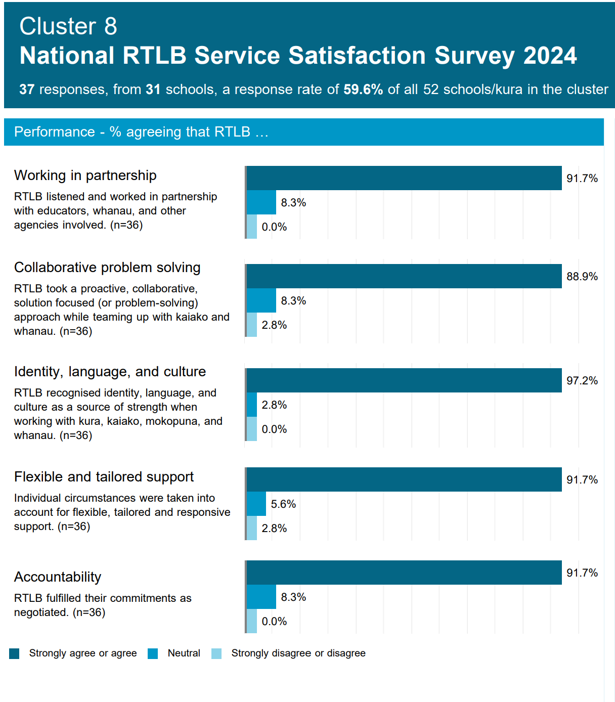
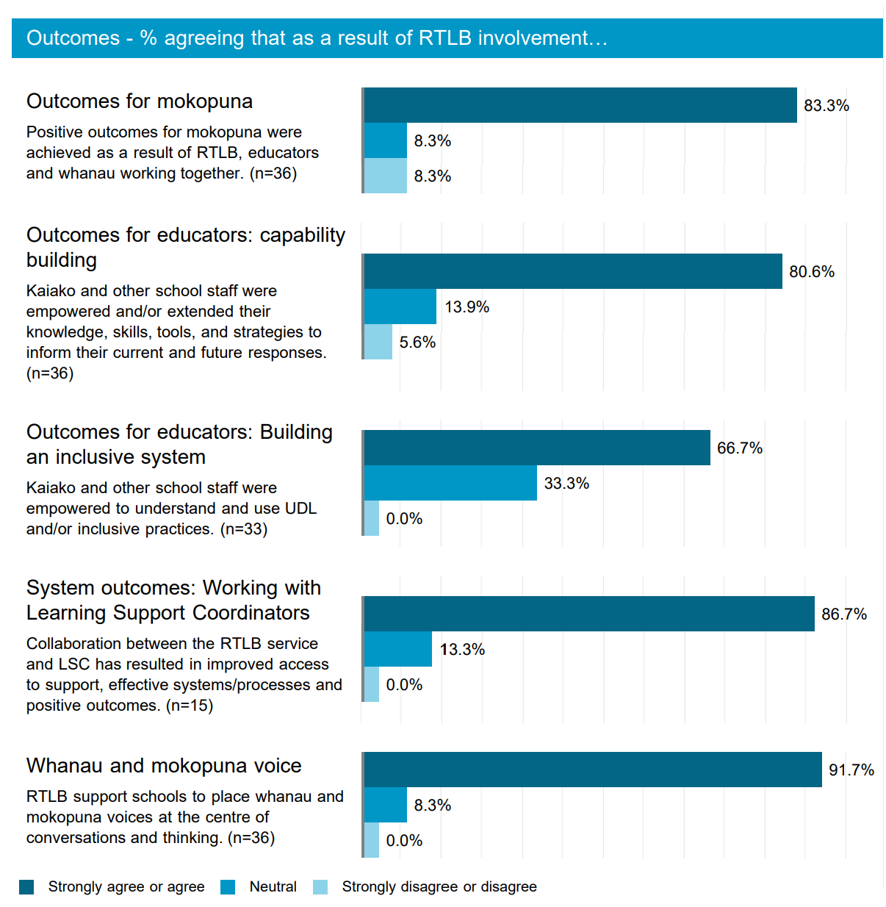

2024 Request for Support (R4S) and Outcomes to 8.12.2024
2024 Total Requests for Support (R4S) to 13.12.2024:- 501
2024: 350 Individual Students, 100 Projects, 1 Gp of Schools, 6 Kāhui Ako, 40 Gps of Students, 4 Ind Schools = 501 R4S
(2023: 342 Individual Students, 90 Projects, 5 Gps of Schools, 31 Gps of Students, 53 Ind Schools = 521 R4S)
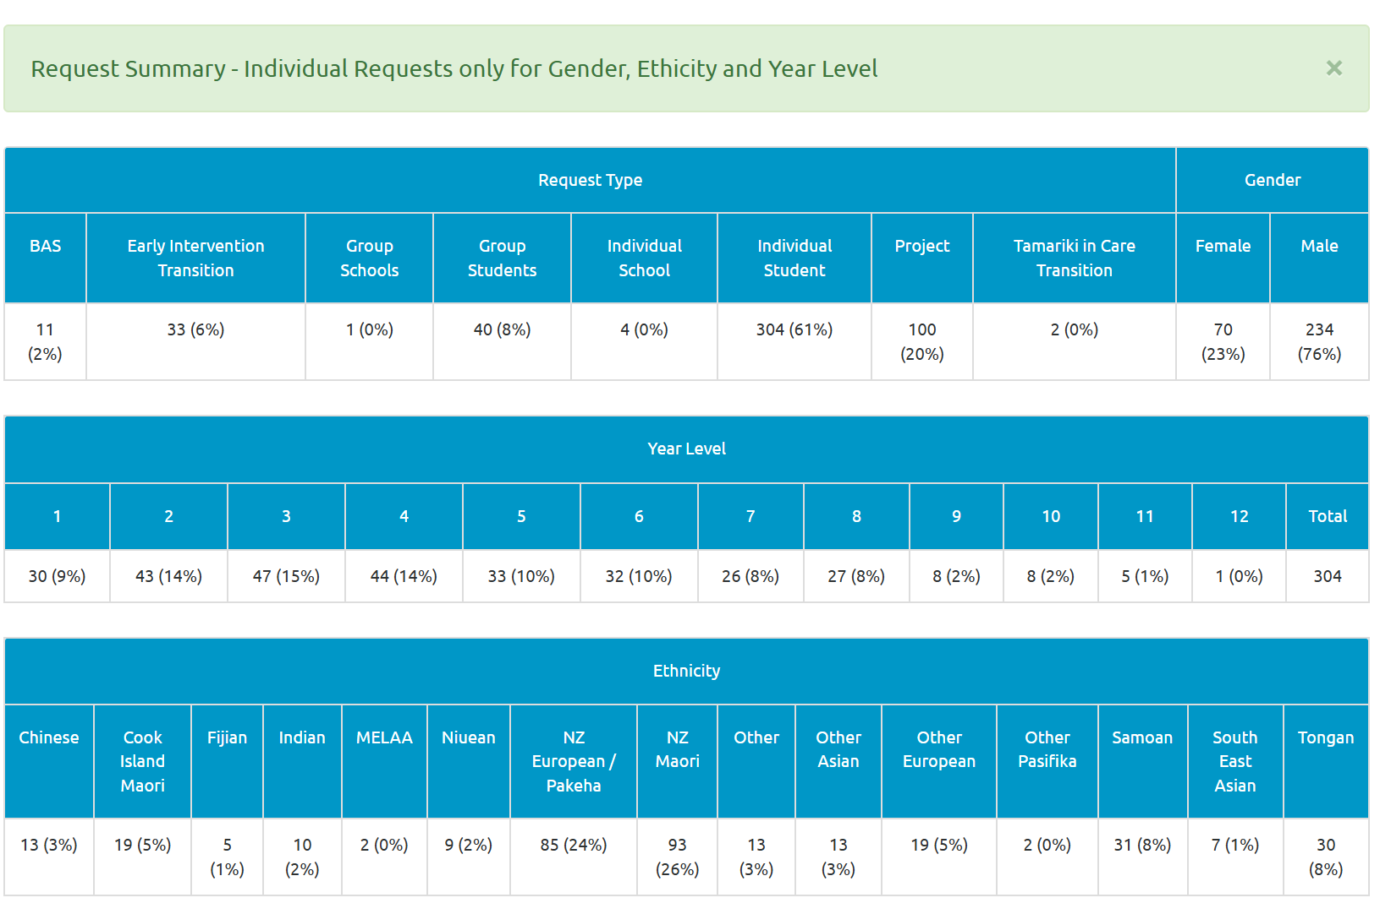
Average Student Outcomes 1.1.2024-13.12.2024

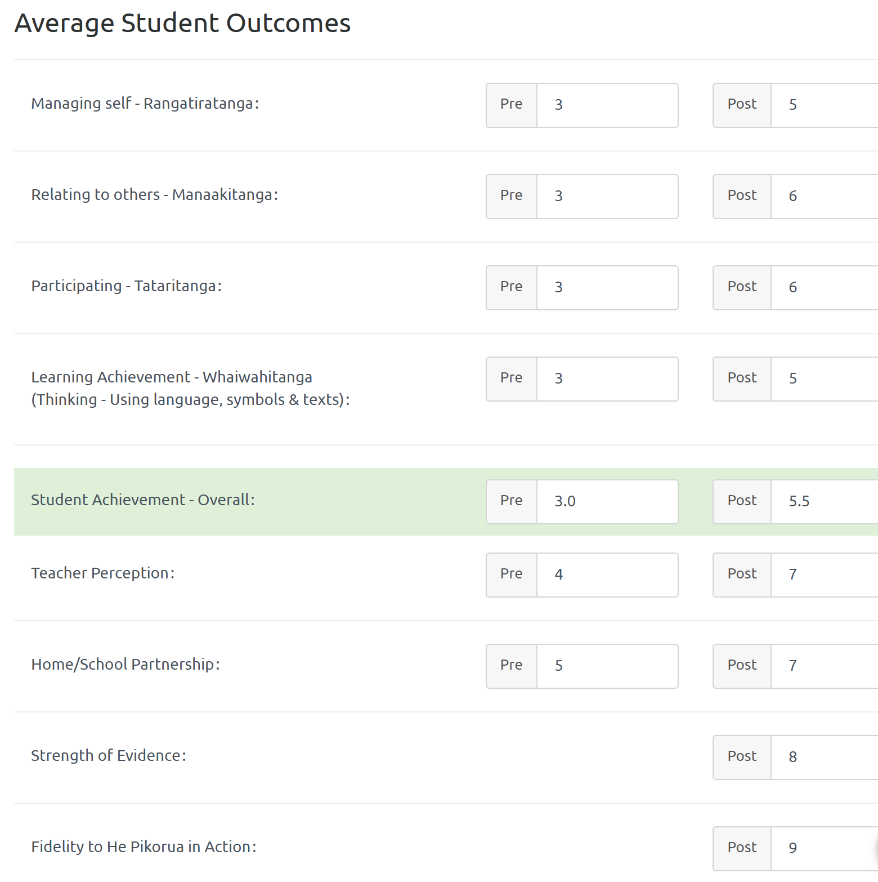

Learning Support Funding

Learning Support Fund (LSF) “supports interventions developed collaboratively with RTLB, targeting students in Years 0-10. It must be used equitably and can be used innovatively.” Learning Support Funding applications are within the context of current active requests for support (individual, group, project etc.) and the He Pikorua and Te Tuapapa practice framework. A range of support and/or resources can be applied for dependent on the case/project needs, analysis, goals and plan (if these services/resources are not available from any other source). Learning Support Funding (LSF) for 2024 is $191,617 (GST excl). Please see the financial report for current LSF expenditure allocated to support students, projects and to employ specialists.

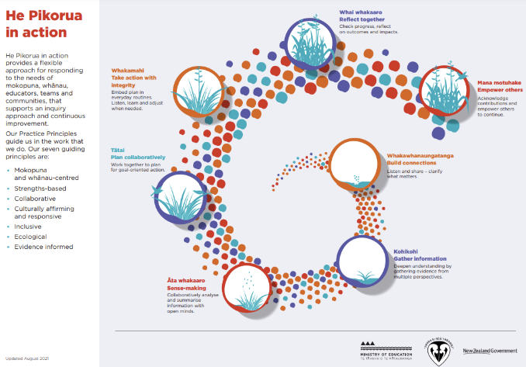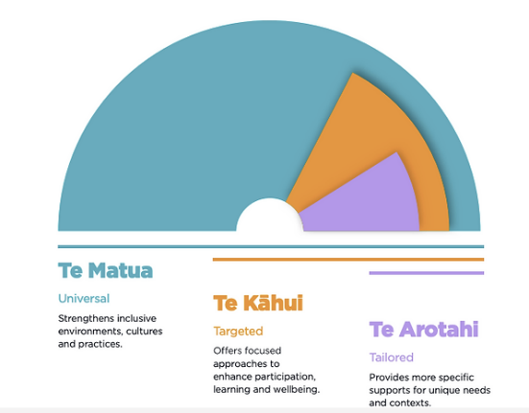

Thank you for your support. You are greatly appreciated. Wishing you happy holidays.

Other Matters

